Horse 2.0: Electric all-rounder LyteHorse withstands desert, forest and water
Lubrication-free igus tribopolymer plain bearings ensure maintenance-free operation even under the most difficult conditions

The Canadian company LyteHorse Labs shows that electric vehicles do not perform poorly. The company has designed a new type of all-terrain electric vehicle that is suitable for a wide range of applications. On board are lubrication-free igus bearings that make the vehicle maintenance-free and corrosion-free, even in the most inhospitable environments.

Brad Bonk has always had a knack for designing unique motorcycles and hot rods. Using his creative talents, he eventually designed a stand-up electric vehicle for golf courses. But he and his brother Allen soon realised that there was much more potential in the small electric vehicle. "After taking it to the golf course, Brad and I decided to hook up the new vehicle to my SUV to see if it could pull the car," Allen Bronk recalls. "And yes, that crazy little scooter thing ended up towing a 2.2 ton SUV across the car park." Because with four independent hub motors, the vehicle has a switchable all-wheel drive for maximum strength and traction, making it the ideal companion in a wide range of applications. Thanks to igus tribopolymers, it is light, lubrication-free, corrosion-free and is particularly low-maintenance.

Electric power pack with modern tribo technology
The LyteHorse can transport 350 kilograms on pavements and stairs in the city. But it can also be used in the great outdoors. For example by the police, for rescue operations in rough terrain, underground in mines, in warehouses or in forestry operations. "In the past, horses were often used in many of these areas. But they are expensive to train as well as to keep and comparatively slow," says Allen Bronk. As a "Horse 2.0", the LyteHorse can go almost anywhere and travel up to 160 kilometres, purely by electric power and completely silently. It is also waterproof up to a height of 60 centimetres. To ensure that it can be used without any problems in these very different environmental conditions, the durability and freedom from maintenance of the installed components were particularly important to the designers. After extensive testing with steel and nylon bushings, LyteHorse Labs turned to lubrication-free and maintenance-free polymer bearing technology from igus and used it in the suspension and steering. "We couldn't achieve our requirements with conventional bearings because they are susceptible to dirt, salt water and extreme temperatures," Allen Bronk explains. "In the end, the flanged bushings we used made of iglidur J convinced us in terms of performance, durability, reliability and cost. Without the advice from igus, we would certainly not be where we already are today with the product." And so the Canadians are optimistic about the future and are currently expanding into the US market, with their main focus on government contracts and building up a distribution network.

You can see the LyteHorse in a video clip here:
https://www.youtube.com/watch?v=z8eILFmDcRU

Caption:

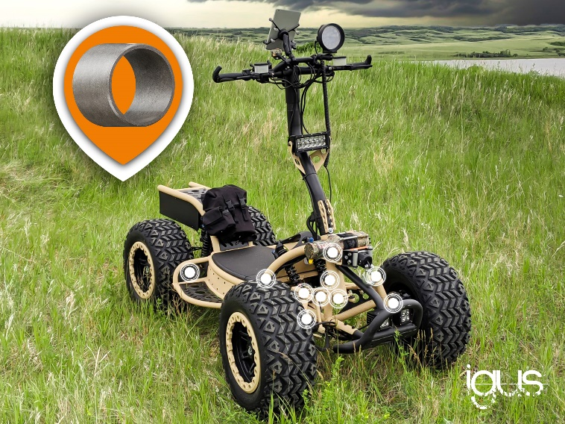
Picture PM4221-1
The lubrication-free and maintenance-free igus tribopolymer plain bearings ensure reliable functioning of the LyteHorse in a wide range of environments. (Source: LyteHorse Labs Inc., igus)
ABOUT IGUS:

igus GmbH develops and produces motion plastics. These lubrication-free, high-performance polymers improve technology and reduce costs wherever things move. In energy supplies, highly flexible cables, plain and linear bearings as well as lead screw technology made of tribo-polymers, igus is the worldwide market leader. The family-run company based in Cologne, Germany, is represented in 35 countries and employs 4,150 people across the globe. In 2020, igus generated a turnover of €727 million. Research in the industry's largest test laboratories constantly yields innovations and more security for users. 234,000 articles are available from stock and the service life can be calculated online. In recent years, the company has expanded by creating internal startups, e.g. for ball bearings, robot drives, 3D printing, the RBTX platform for Lean Robotics and intelligent "smart plastics" for Industry 4.0. Among the most important environmental investments are the "chainge" programme – recycling of used e-chains - and the participation in an enterprise that produces oil from plastic waste (Plastic2Oil).

PRESS CONTACT:

Oliver Cyrus Anja Görtz-Olscher
Head of PR and Advertising Manager PR and Advertising

igus® GmbH igus® GmbH
Spicher Str. 1a Spicher Str. 1a
51147 Cologne 51147 Cologne
Tel. 0 22 03 / 96 49-459 Tel. 0 22 03 / 96 49-7153
ocyrus@igus.net agoertz@igus.net
www.igus.de/presse www.igus.de/presse

The terms "igus", “Apiro”, "chainflex", "CFRIP", "conprotect", "CTD", “drygear”, "drylin", "dry-tech", "dryspin", "easy chain", "e-chain", "e-chain systems", "e-ketten", "e-kettensysteme", "e-skin", "e-spool”, "flizz", “ibow”, “igear”, "iglidur", "igubal", “kineKIT”, "manus", "motion plastics", "pikchain", "plastics for longer life", "readychain", "readycable", “ReBeL”, "speedigus", "tribofilament“, "triflex", "robolink", “xirodur”, and "xiros" are protected by trademark laws in the Federal Republic of Germany and internationally, where applicable.

