Lightweight and lubrication-free iglidur plain bearings make catamarans fly
The iFLY15 sports sailboat won the silver manus award in 2019 –
582 entries for polymer plain bearing award 2021

Sailboats that lift themselves completely out of the water as if by magic. Sounds like a dream, but it is reality. The iFLY15 sports catamaran from CEC Catamarans GmbH lets the sailor fly over the water. For the automatic flight control system, the developers relied on the lubrication-free, lightweight and corrosion-free igus plain bearing technology. An innovative project that won the silver manus award in 2019. The winners of this year's award for the best plain bearing technology application were chosen by the jury from over 580 entries on 9 March 2021.

Eco-friendly and sustainable, powered only by wind energy, the iFLY15 flying sailboat reaches speeds of over 50 km/h on the water. This makes it faster than many motorboats. In order to be able to achieve these speeds, lightweight but also durable components were required above all. The components must be able to withstand a wide range of environmental conditions, such as humidity, strong temperature fluctuations, impact loads from flotsam and much more. The absence of lubricants is of special importance: on the one hand, the bearings should be maintenance-free, as maintenance is practically non-existent in everyday life. On the other hand, lubrication would bind dust and sand and damage the guide shaft in the long run. For the sophisticated flight control system, the engineers therefore use igubal pillow block bearings in the mechanical scanners, amongst other things. Maintenance-free drylin W linear guides are used for the sliding bearing of the flight control system. All axle bearings in the mechanism are cylindrical iglidur J plain bearings, which also work corrosion-free and also have no problems with dirt and dust, thanks to the absence of lubrication. In July 2021, the iFLY15 is poised to set a new world record: the fastest crossing of the English Channel. The distance was successfully mastered in a first attempt in September 2019, but very little wind during the last 20 miles thwarted a new record.

10th manus award: Jury selected the winners on 9th March
With their development of the iFLY15, CEC Catamarans won the silver manus award in 2019. The manus competition is initiated every two years by igus, the specialist for high-performance polymers, and honours exciting and unique projects with polymer plain bearings. For this year's 10th anniversary, over 580 applications were received from users worldwide. On 9th March, the jury consisting of Prof. Dr.-Ing. Wolfgang Boos, CEO of WBA Aachener Werkzeugbau Akademie GmbH, Prof. emer. Dr.-Ing. Dr.h.c. Klaus Friedrich from the Institut für Verbundwerkstoffe GmbH, Paul J. Heney, Editor-in-Chief at WTWH Media, Prof. Dr.-Ing. Peter Krug, Lecturer at the Institute for Automotive Engineering at TH Köln, Hubertus von Monschaw, Global Director Hannover Messe at Deutsche Messe AG and Tobias Vogel, CEO iglidur Plain Bearings & drylin Linear Technology at igus GmbH, selected the winners of the manus awards 2021. This year's patron is Werner Götz, Editor-in-Chief of the Industrieanzeiger.

Caption:
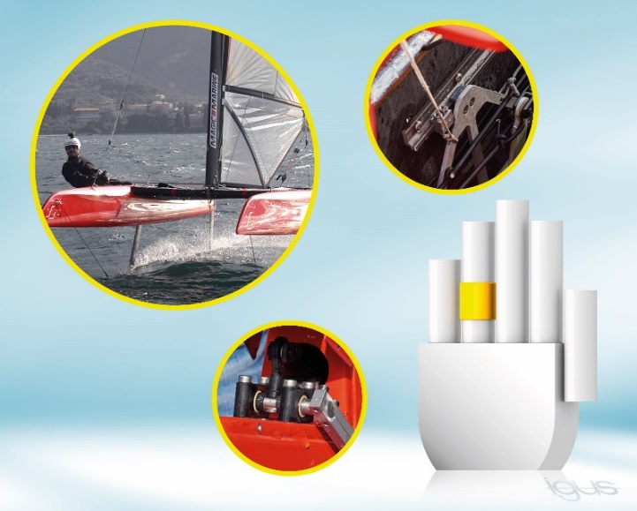
Picture PM0921-1
To make catamarans rise into the air, the engineers of CEC Catamarans relied on the lubrication-free, lightweight and corrosion-free iglidur plain bearing technology. An exciting project that won the silver manus award in 2019. (Source: igus GmbH)
PRESS CONTACT:  Oliver Cyrus  Head of PR and Advertising  Anja Görtz-Olscher  PR and Advertising  igus® GmbH  Spicher Str. 1a  51147 Cologne  Tel. 0 22 03 / 96 49-459 or -7153  Fax 0 22 03 / 96 49-631  ocyrus@igus.net  agoertz@igus.net  www.igus.eu/press | ABOUT IGUS:  igus GmbH develops and produces motion plastics. These lubrication-free, high-performance polymers improve technology and reduce costs wherever things move. In energy supplies, highly flexible cables, plain and linear bearings as well as lead screw technology made of tribo-polymers, igus is the worldwide market leader. The family-run company based in Cologne, Germany, is represented in 35 countries and employs 3,800 people across the globe. In 2019, igus generated a turnover of €764 million. Research in the industry's largest test laboratories constantly yields innovations and more security for users. 234,000 articles are available from stock and the service life can be calculated online. In recent years, the company has expanded by creating internal startups, e.g. for ball bearings, robot drives, 3D printing, the RBTX platform for Lean Robotics and intelligent "smart plastics" for Industry 4.0. Among the most important environmental investments are the "chainge" programme – recycling of used e-chains - and the participation in an enterprise that produces oil from plastic waste. (Plastic2Oil).

The terms "igus", “Apiro”, "chainflex", "CFRIP", "conprotect", "CTD", “drygear”, "drylin", "dry-tech", "dryspin", "easy chain", "e-chain", "e-chain systems", "e-ketten", "e-kettensysteme", "e-skin", "e-spool”, "flizz", “ibow”, “igear”, "iglidur", "igubal", “kineKIT”, "manus", "motion plastics", "pikchain", "plastics for longer life", "readychain", "readycable", “ReBeL”, "speedigus", "tribofilament“, "triflex", "robolink", “xirodur”, and "xiros" are protected by trademark laws in the Federal Republic of Germany and internationally, where applicable.

