Tailor-made solution: first igus e-chain rack from additive manufacturing
Printed in just 36 hours: the readychain p-rack enables customers to benefit even faster from the advantages of a customised transport and assembly rack

In production, downtimes are expensive. For manufacturers of such items as machine tools, it is therefore very important for system assembly work to be as quick and efficient as possible. The readychain rack is a modular assembly and transport rack for harnessed energy supply systems, one that igus has been offering for ten years. Now, igus has developed a solution that is even simpler and faster, with practically unlimited customisation potential: the first 3D-printed readychain p-rack (printed rack). It can be adapted to customer requirements with millimetre precision.

Bringing ready-to-install energy chain systems to the machine quickly and safely is the goal igus was pursuing when developing the readychain rack. It saves many work steps, greatly reducing process costs and assembly time. "More and more companies are looking for new ways of optimising processes to increase efficiency and reduce costs," says Christian Stremlau, Head of Business Unit readychain and readycable at igus. "We want to support our customers by offering them a quick solution for transporting and assembling our ready-to-install energy supply systems that is completely tailored to their needs. Therefore, we have now developed the first e-chain rack from additive manufacturing. It is a very simple, flexible addition for readychain customers, enabling them to benefit from the advantages of a customised solution even faster. All attachments are printed within 36 hours."

Industrial customisation with no minimum batch size
Additive manufacturing offers virtually unlimited possibilities in geometry. Thus, modules precisely tailored to the application can be produced to the millimetre. "This gives customers complete freedom in p-rack design," says Stremlau. "It can have an ergonomic design with rounded shapes - without interfering contours or sharp edges to present an injury hazard. Additional elements, such as holders for tools, small parts or lettering can also be printed as required." Users save not only time and money in advance on such items as design, but also the trouble and effort involved in subsequent adjustments. There is no minimum batch size for this optimal installation solution to pay off. "The great advantage for customers is that we provide everything from a single source - and quickly. Design and production are on site at igus. We have our own design engineers and our own 3D printing department, which means more flexibility combined with short communication channels and throughput times," says Stremlau.

Smooth-operating design reduces installation time by up to 66%
The p-rack is not only manufactured much faster, but is also much lighter than its metal predecessor. The weight reduction (up to 80%) conserves resources and makes handling much safer and easier. The smooth-operating design also reduces installation effort by up to 66%. Assembly and disassembly are carried out entirely without additional hand tools. The weight reduction and modular design also save volume and transport costs for the return. Despite its lightweight construction, the 3D-printed frame is highly resilient. To ensure its strength, the p-rack, like all igus products, is extensively tested in the in-house laboratory. Another special feature of the p-rack is that all attachments can also be printed from cornstarch. The material is very robust and absolutely rustproof. It can also be composted or entirely regranulated and reused.

Caption:
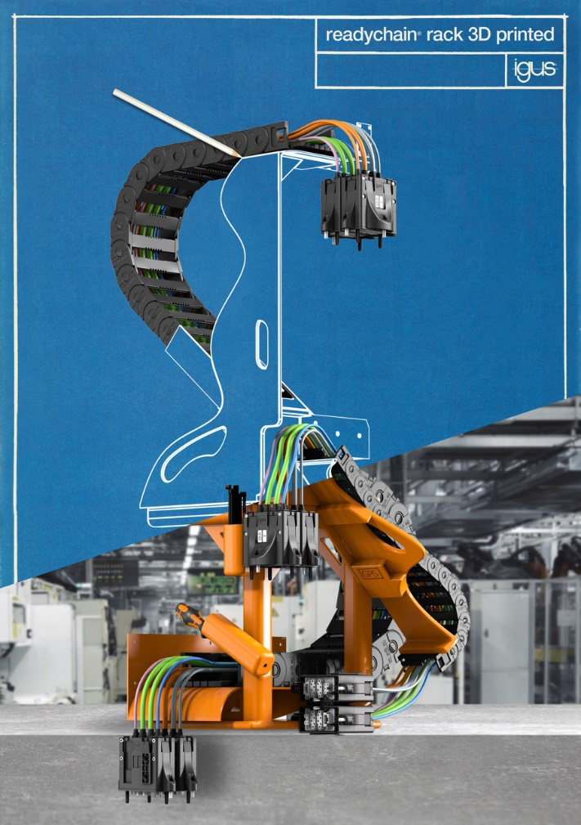
Picture PM3623-1
Installation time reduced by 66%, weight by 80%: the first e-chain rack from additive manufacturing is a fast installation solution for igus energy chain systems with almost unlimited customisability. (Source: igus GmbH)

