Reliable bearings, even in hot environments: new igus material for the food industry
Electrostatically dissipative iglidur AX500 tribo-polymer ensures maintenance-free applications with food contact

In bearing points in the food and packaging industries, temperatures and speeds are frequently high. Ensuring that mechanisms function reliably requires durable plain bearing solutions that can continuously handle friction and heat. Another challenge is electrostatic charges. iglidur AX500 now gives igus, the motion plastics specialist, a new, wear-resistant material for high-temperature applications that also has ESD properties.

How do exactly ten grammes of gummy bears end up in a small bag? With dosing systems equipped with highly sensitive mechanisms. Such mechanisms fill thousands of bags in no time. Slides and belts then move the sweets to a box. At these high speeds, all the packaging mechanisms, and especially their bearings, are subjected to wear. Plain bearings made of the new iglidur AX500 high-performance polymer help make bearing points maintenance-free and durable. The new material is electrostatically dissipative, ensuring that the bags do not stick to each other and employees do not receive electric shocks. In very dusty environments such as flour processing, sparks can also lead to dust explosions. These sparks can take the form of small arcs that occur when moving machine parts do not have an electrically dissipative design.

Safe, wear-resistant bearings, even in high temperatures
iglidur AX500 is also specifically suited to the high-temperature range, allowing it to be used in applications such as ovens and bottle cleaning. Its good chemical resistance means that aggressive cleaning agents will not harm the bearing. Nor is there any problem if iglidur AX500 contacts food, since the tribologically optimised polymer, with its embedded solid lubricants, requires no additional lubrication. The material also complies with Regulation (EU) No. 10/2011. iglidur AX500 plain bearings are not only maintenance-free, unlike stainless steel bearings, but also cost and weigh less than the latter.

On the test rig: wear testing
iglidur AX500 achieves much better wear results than the long-running food material iglidur A500. The wear of the iglidur A500 and iglidur AX500 was tested in a rotation test on stainless steel shafts in the 3,800 square metre in-house laboratory at igus in Cologne. The new material achieved a coefficient of wear that was up to three times as good as those of the old one.
Special dimensions from injection moulding can be supplied in a few days
igus currently offers the new material in standard dimensions (6-20mm diameters), with or without a flange. For special dimensions that are needed quickly, the FastLine service is also available to users. Expanding in-house toolmaking allows igus to manufacture and deliver iglidur polymer plain bearings in special dimensions at low part prices within a few days.

Caption:

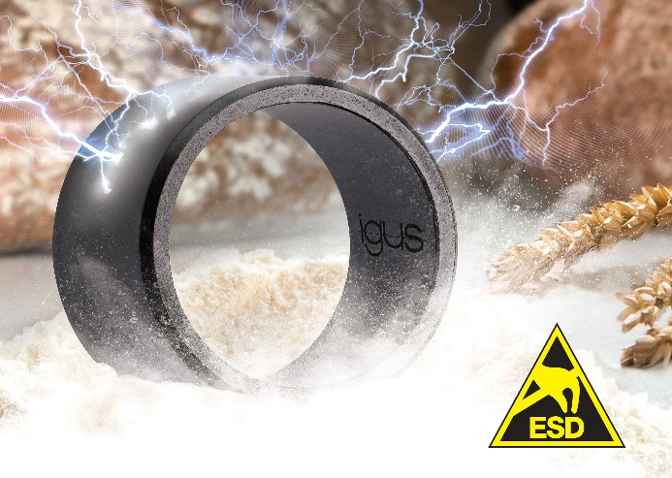
Picture PM3721-1
iglidur AX500 gives igus a new, wear-resistant material for the food industry that is electrically dissipative and can be used at high temperatures. (Source: igus GmbH)

ABOUT IGUS:

igus GmbH develops and produces motion plastics. These lubrication-free, high-performance polymers improve technology and reduce costs wherever things move. In energy supplies, highly flexible cables, plain and linear bearings as well as lead screw technology made of tribo-polymers, igus is the worldwide market leader. The family-run company based in Cologne, Germany, is represented in 35 countries and employs 4,150 people across the globe. In 2020, igus generated a turnover of €727 million. Research in the industry's largest test laboratories constantly yields innovations and more security for users. 234,000 articles are available from stock and the service life can be calculated online. In recent years, the company has expanded by creating internal startups, e.g. for ball bearings, robot drives, 3D printing, the RBTX platform for Lean Robotics and intelligent "smart plastics" for Industry 4.0. Among the most important environmental investments are the "chainge" programme – recycling of used e-chains - and the participation in an enterprise that produces oil from plastic waste (Plastic2Oil).

PRESS CONTACT:

Oliver Cyrus Anja Görtz-Olscher
Head of PR and Advertising Manager PR and Advertising

igus® GmbH igus® GmbH
Spicher Str. 1a Spicher Str. 1a
51147 Cologne 51147 Cologne
Tel. 0 22 03 / 96 49-459 Tel. 0 22 03 / 96 49-7153
ocyrus@igus.net agoertz@igus.net
www.igus.de/presse www.igus.de/presse

The terms "igus", “Apiro”, "chainflex", "CFRIP", "conprotect", "CTD", “drygear”, "drylin", "dry-tech", "dryspin", "easy chain", "e-chain", "e-chain systems", "e-ketten", "e-kettensysteme", "e-skin", "e-spool”, "flizz", “ibow”, “igear”, "iglidur", "igubal", “kineKIT”, "manus", "motion plastics", "pikchain", "plastics for longer life", "readychain", "readycable", “ReBeL”, "speedigus", "tribofilament“, "triflex", "robolink", “xirodur”, and "xiros" are protected by trademark laws in the Federal Republic of Germany and internationally, where applicable.

