At a glance: igus shows the CO₂ footprint for lubrication-free tribo plain bearings
Transparent information on carbon footprints in the online shop facilitates customer CO₂ accounting

How much CO₂ is released into the atmosphere as a result of a plastic bearing's production? For the first time, igus, the motion plastics specialist, is publishing precise CO₂ footprints for a large number of its lubrication-free, maintenance-free iglidur polymer plain bearings. Users can use these values as Scope 3 emissions in CO₂ accounting for climate-neutral products.

In times of climate change, both manufacturers and their customers are increasingly faced with the question of how sustainable the products they manufacture and use are. One focus is on CO₂ emissions. Companies account for, reduce and offset so-called Scope 1 emissions, which arise locally, e.g. from operating delivery vans and machinery. The same applies to Scope 2 emissions, which are indirect emissions from purchased energy, and Scope 3 emissions those generated by suppliers. "However, accounting across company boundaries is often a real challenge - when machines are assembled from hundreds of components from different manufacturers, for example," says Stefan Loockmann-Rittich, Head of Business Unit iglidur Plain Bearings at igus. "We are starting to make this task easier for customers by displaying the CO₂ footprints for 16 materials from the iglidur plain bearing series in the online shop. Users can see at a glance how much carbon dioxide emissions the production of a plastic bearing entails."
Ambitious goal: production at igus is to become CO₂-neutral by 2025
But igus is striving for transparency not only in terms of environmental offsetting, but also for continuous CO₂ reduction in their own production. In 2021, the company managed to reduce CO₂ emissions by 31.2% from the previous year's level - primarily by switching to green electricity and climate-neutral gas. The Cologne-based motion plastics specialist is gradually investing in injection-moulding machines that require 40% less energy than older models. The ambitious goal: to produce components made of high-performance plastic in a CO₂-neutral manner by 2025.
Plastic instead of metal: more than 250,000 customers trust iglidur
The iglidur plain bearing series is one of the most firmly established igus products. More than 250,000 companies worldwide rely on plastic bearings from Cologne - including carmakers, bicycle manufacturers, the aviation industry and mechanical engineering companies. By switching from classic metal to polymer bearings, they are all improving their products' life cycle assessment. There are several reasons for this. One is that plastic plain bearings weigh only a fraction of what their metal counterparts do. This reduces the required drive energy. Another is that users can dispense with lubricants. This is due to the fact that microscopically small solid lubricants are integrated into iglidur materials. They are released during use and allow for low-friction, environmentally friendly dry operation. Says Loockmann-Rittich, "Our plain bearings, for example, are available for just 20 cents - right from stock. This allows customers to quickly reduce their maintenance costs, increase service life and eliminate additional lubricants. It is a big win for your wallet and the environment."

Caption:

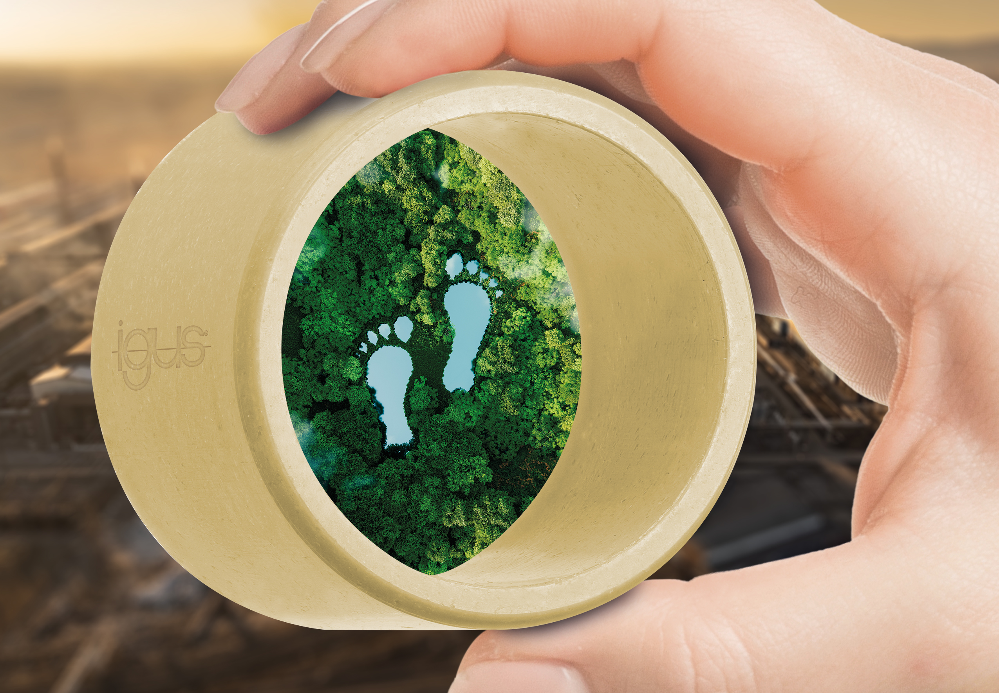
Picture PM5322-1
Customers in the igus online shop can see the carbon dioxide footprint for the selected iglidur tribo-polymer plain bearing at a glance. This facilitates CO₂ accounting for their application. (Source: igus GmbH)

PRESS CONTACT:

Alexa Heinzelmann
Head of International Marketing

igus® GmbH
Spicher Str. 1a
51147 Cologne
Tel. 0 22 03 / 96 49-7272
aheinzelmann@igus.net
www.igus.eu/press

ABOUT IGUS:

igus GmbH develops and produces motion plastics. These lubrication-free, high-performance polymers improve technology and reduce costs wherever things move. In energy supplies, highly flexible cables, plain and linear bearings as well as lead screw technology made of tribo-polymers, igus is the worldwide market leader. The family-run company based in Cologne, Germany, is represented in 35 countries and employs 4,900 people across the globe. In 2021, igus generated a turnover of €961 million. Research in the industry's largest test laboratories constantly yields innovations and more security for users. 234,000 articles are available from stock and the service life can be calculated online. In recent years, the company has expanded by creating internal startups, e.g. for ball bearings, robot drives, 3D printing, the RBTX platform for Lean Robotics and intelligent "smart plastics" for Industry 4.0. Among the most important environmental investments are the "chainge" programme – recycling of used e-chains - and the participation in an enterprise that produces oil from plastic waste.

The terms "igus", “Apiro”, "chainflex", "CFRIP", "conprotect", "CTD", “drygear”, "drylin", "dry-tech", "dryspin", "easy chain", "e-chain", "e-chain systems", "e-ketten", "e-kettensysteme", "e-skin", "e-spool”, "flizz", “ibow”, “igear”, "iglidur", "igubal", “kineKIT”, "manus", "motion plastics", "pikchain", "plastics for longer life", "readychain", "readycable", “ReBeL”, "speedigus", "tribofilament“, "triflex", "robolink", “xirodur”, and "xiros" are protected by trademark laws in the Federal Republic of Germany and internationally, where applicable.

