Quick access to a customised interface with the new igus online shop for Module Connect
180 individual parts offer new configuration options for energy chain connections

igus has developed Module Connect, a space-saving plug-in connector for connecting electric cables, fibre optic cables, and pneumatic hoses. It is primarily used wherever a large number of cables are connected in energy chains and space is at a premium. For free, individual plug-in module configuration, igus has now added 180 individual parts for Module Connect to its online shop.

A single connector for everything instead of many individual ones is the principle of Module Connect. The name stands for a modular system for plug-in modules developed by igus. Customers can select suitable modules from a variety of different connectors, combine them, select the right housings, and connect them, and thus achieve almost unlimited module variations with individual widths and heights. The result is a space-saving, individual plug connection. For its connector system, igus uses Harting's "Han-Modular" product range. "Module Connect gives the customer a ready-to-connect assembly with a defined interface that reduces assembly time by 80%," says Markus Hüffel, readycable and readychain Product Manager at igus GmbH. To allow customers to design their modules as they wish and buy them directly, igus now offers not only finished sets with three or four cable entries, but also 180 individual parts from Module Connect in the web shop. You can find anything from individual housing parts and locking mechanisms to power, signal, data transmission, and pneumatic modules and contacts. "This gives users complete freedom to customise their interface," says Hüffel. "We are constantly expanding our range."

A strong and reliable connection
Accessories, such as the locking and strain relief elements integrated into the housing, ensure maximum reliability. They enclose the connector and provide for a strong connection, even when there are tens of thousands of movements. The Module Connect housing components are made of fibre-reinforced high-performance plastic that weighs 50% less than classic rectangular connectors. The Module Connect adapter joins the Module Connect plug-in connector and the energy chain to form a coherent assembly. The Module Connect adapter can be added even to existing energy supply systems.

Learn more about Module Connect at:
https://www.igus.eu/module-connect

Explore the new Module Connect shop at:
https://www.igus.eu/connectors/module-connect

Caption:

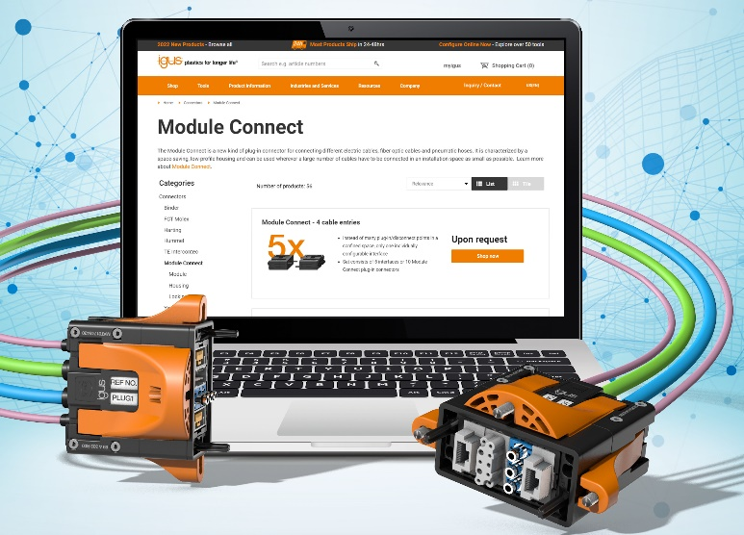
Picture PM6722-1
Users can order custom interfaces in the igus Module Connect online shop. (Source: igus GmbH)

PRESS CONTACT:

Alexa Heinzelmann
Head of International Marketing

igus® GmbH
Spicher Str. 1a
51147 Cologne
Tel. 0 22 03 / 96 49-7272
aheinzelmann@igus.net
www.igus.eu/press

ABOUT IGUS:

igus GmbH develops and produces motion plastics. These lubrication-free, high-performance polymers improve technology and reduce costs wherever things move. In energy supplies, highly flexible cables, plain and linear bearings as well as lead screw technology made of tribo-polymers, igus is the worldwide market leader. The family-run company based in Cologne, Germany, is represented in 31 countries and employs 4,900 people across the globe. In 2021, igus generated a turnover of €961 million. Research in the industry's largest test laboratories constantly yields innovations and more security for users. 234,000 articles are available from stock and the service life can be calculated online. In recent years, the company has expanded by creating internal startups, e.g. for ball bearings, robot drives, 3D printing, the RBTX platform for Lean Robotics and intelligent "smart plastics" for Industry 4.0. Among the most important environmental investments are the "chainge" programme – recycling of used e-chains - and the participation in an enterprise that produces oil from plastic waste.

The terms "igus", “Apiro”, "chainflex", "CFRIP", "conprotect", "CTD", “drygear”, "drylin", "dry-tech", "dryspin", "easy chain", "e-chain", "e-chain systems", "e-ketten", "e-kettensysteme", "e-skin", "e-spool”, "flizz", “ibow”, “igear”, "iglidur", "igubal", “kineKIT”, "manus", "motion plastics", "pikchain", "plastics for longer life", "readychain", "readycable", “ReBeL”, "speedigus", "tribofilament“, "triflex", "robolink", “xirodur”, and "xiros" are protected by trademark laws in the Federal Republic of Germany and internationally, where applicable.

