igus roller e-chain for targeted irrigation with savings potential
New precision irrigation carriage reduces water and fertiliser consumption by 75% - e-chain in a trough guides hoses with additional energy saving

The aim of the precision irrigation carriage from Rathmakers Gartenbautechnik is to use water resources sensibly whilst protecting the groundwater at the same time. With the new automatic irrigation system, the water reaches exactly where it should: directly to the plants. For the safe and compact guidance of hoses and cables, the developers rely on an igus energy chain system consisting of roller chain and guide trough.

Water shortage is a major problem worldwide, which is why solutions are needed, especially in agriculture, which bring water in a targeted manner to the plant. For this purpose, Rathmakers Gartenbautechnik has developed a precision irrigation carriage together with Landwirtschaftskammer NRW. Whereas conventional irrigation carriages with a continuous jet stream waste a lot of water, the precision watering carriage irrigates and fertilises in a stipulated way. The unique system is especially suitable for outdoor potted plant cultivation and ensures that water is delivered precisely into the middle of the plant's growing pot. By using this new technology, savings of 50 to 75 per cent are possible in irrigation water, plant protection and fertiliser, depending on the pot size. This also reduces the nitrogen input into the groundwater. The precision irrigation carriage has a span of 40m and a travel of 208m. The cables and hoses for the water supply were pulled behind the carriages until now. A loop was created, which required about 2m of space between the carriage guide and the plants. A safe and space-saving hose with cable guidance was required. Therefore, Ralf Hormes, CEO at Rathmakers Gartenbautechnik, contacted igus. "Together with the igus experts, we decided to design a roller energy chain in a guide trough", explains Ralf Hormes.

343 sqm of more usable space
The main advantage of the system: by guiding the hoses and cables, the usable area is increased by 343 square metres. It also increases the service life of the supply components in the system. A 3500R series roller chain with a width of only 35cm is used in a guidelite guide trough. The technical basis of the energy chain is the integration of rollers into the chain links to reduce the coefficient of friction on long travels. Thereby, up to 57 per cent of the required drive energy can be saved while moving the energy chain system. The guidelite guide trough is a cost-effective and quickly installable solution made of corrosion-resistant and durable high-performance polymer. "An all-round system that has proven itself technically and also from a cost perspective", says Hormes. Since November 2019, igus has taken back plastic energy chains and troughs when the system has reached the end of its service life and guarantees segregated recycling. In return, the user receives a credit note based on the net weight.

Caption:

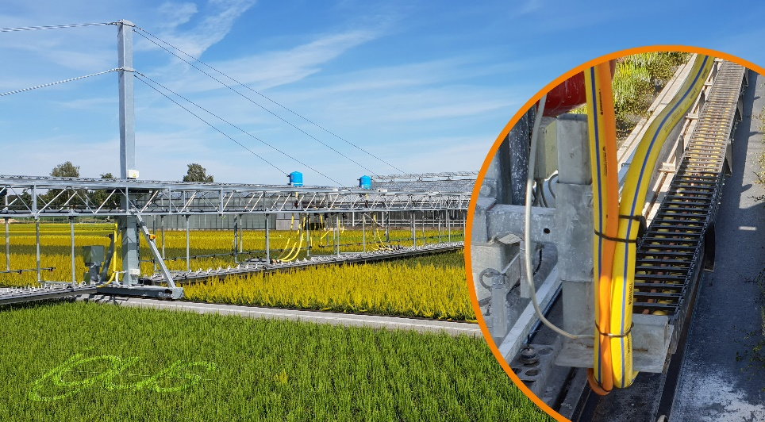
Picture PM4220-1
A roller energy chain in a guidelite guide trough ensures safe guidance of the hoses and cables in the precision irrigation carriage. (Source: igus GmbH)

PRESS CONTACT:  Oliver Cyrus  Head of PR and Advertising  Anja Görtz-Olscher  PR and Advertising  igus® GmbH  Spicher Str. 1a  51147 Cologne  Tel. 0 22 03 / 96 49-459 or -7153  Fax 0 22 03 / 96 49-631  ocyrus@igus.net  agoertz@igus.net  www.igus.eu/press | ABOUT IGUS:  igus GmbH is a global leading manufacturer of energy chain systems and polymer plain bearings. The Cologne-based family business has offices in 35 countries and employs 4,150 people around the world. In 2019, igus generated a turnover of 764 million euros from motion plastics, plastic components for moving applications. igus operates the largest test laboratories and factories in its sector to offer customers quick turnaround times on innovative products and solutions tailored to their needs.

The terms "igus", “Apiro”, "chainflex", "CFRIP", "conprotect", "CTD", “drygear”, "drylin", "dry-tech", "dryspin", "easy chain", "e-chain", "e-chain systems", "e-ketten", "e-kettensysteme", "e-skin", "e-spool”, "flizz", “ibow”, “igear”, "iglidur", "igubal", “kineKIT”, "manus", "motion plastics", "pikchain", "plastics for longer life", "readychain", "readycable", “ReBeL”, "speedigus", "triflex", "robolink", “xirodur”, and "xiros" are protected by trademark laws in the Federal Republic of Germany and internationally, where applicable.

