igus modular linear axis for travels of any length
Easy to install and almost infinitely extendable: drylin EGW offers new design freedom on long travels
igus is launching the drylin Endless Gear linear module (EGW), a modular, lubrication-free linear guide with rack and pinion drive. The modular system can be extended to any travel length, costs little and is almost as light as the guide for a toy train. Several carriages can travel on it in different directions and at different speeds. Users can also extend the linear guide after installation and add more carriages.

Linear axes with toothed belt drive are suitable for many handling and positioning tasks. The problem is that if they are longer than ten metres, they start to sag, and lengthening the belt makes it difficult to engage the teeth. A second problem is the lack of flexibility. Multiple carriages cannot travel at different speeds on the rail, nor can they travel in different directions. "To offer more options to everyone who requires long travels, we developed drylin EGW - a modular linear guide with rack and pinion drive," says Stefan Niermann, Head of the igus drylin Linear and Drive Technology Business Unit. "Users are no longer limited in the lengths of their travels. They can assemble additional rails at any time - it's almost as simple as putting together rails for a toy train. Thanks to the system's modularity, the kit consists of just two pieces, each two meters long, which also significantly simplifies handling and transport." Unlike a toothed belt drive, the system can also be used with several carriages, each with its own electric motor, travelling in different directions and at different speeds. The drylin EGW modular kit gives users everything from a single source, from linear guidance and carriages to chains and cables for energy supply - ready to install upon request, including motor and control system.
Precisely repeatable process even over long travels
The drylin EGW consists of several components: the basis is the WS-20 from the drylin W series, a guide rail made of hard-anodised aluminium with a round profile, on which the carriages slide. In the middle between the two, there's a profile to receive the polymer rack modules. The second component is the drive carriage. It is supported on the rail by four plain bearing bushings made of iglidur J200 high-performance plastic. An electric motor in the carriage drives a gear that engages in the gear rack. The motor cable moves in an energy chain running parallel to the rail. The third component is directly attached to the drive carriage: a towing carriage, on which such elements as a camera, picking robots, or sensors can be mounted. Due to the modularly expandable linear guide, it is possible to carry out testing or monitoring tasks, for example, with precise repeatability even over very long travels. This ensures greater quality and safety in train roof inspection or automotive part production, for example. "In such applications, drylin EGW operates more quietly and with much less vibration than linear guides with classical ball recirculating systems," says Niermann. "Thanks to the principle of plastic instead of metal, the linear guide's weight and thus the required drive energy are reduced as well. And corrosion is also no longer an issue."

Tests show 45,000 cycles without significant wear
The drylin EGW linear guide is durable, as tests in the in-house igus laboratory prove. Engineers loaded a carriage to 200N and moved it at a speed of 1m/s along a stroke length of 15,000mm. The result was that even after 45,000 cycles, there was no significant wear on the rails or plain bearing bushings. If the linear guide does reach its wear limit at some point, users can simply replace the liners directly on the rail in just a few minutes, without disassembling the bearing mounts. Another advantage is that it requires no external lubrication because the high-performance plastic contains solid lubricants that are released over time, allowing for low-friction dry operation. Maintenance costs are correspondingly low.
Find out how easy it is to install the drylin EGW linear module here:
https://www.igus.eu/info/n22-endless-gear-egw

Caption:

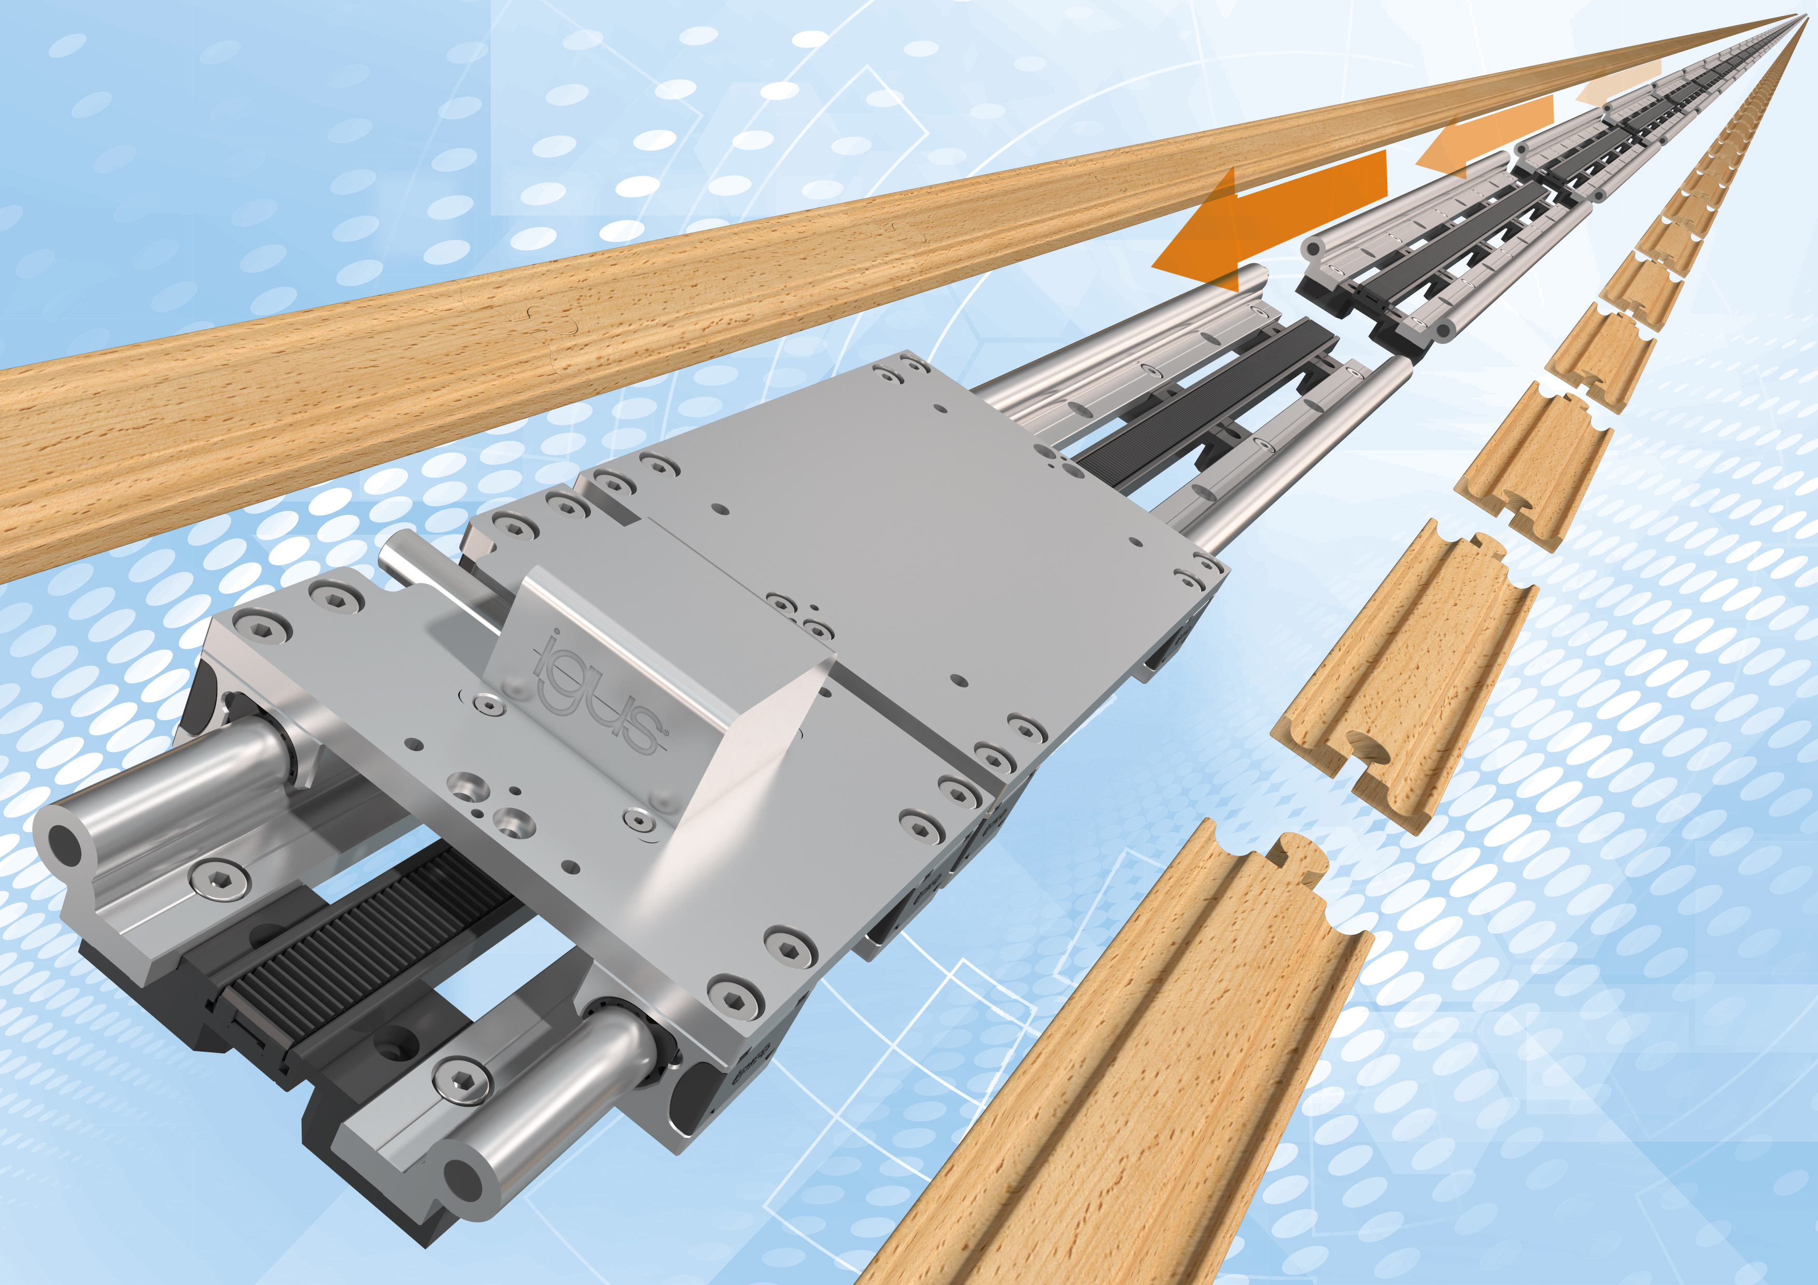
Picture PM7222-1
The new, lubrication-free drylin Endless Gear linear module extends travel distances simply and cost-effectively with a plug-in principle similar to that of a toy train. (Source: igus GmbH)

PRESS CONTACT:

Alexa Heinzelmann
Head of International Marketing

igus® GmbH
Spicher Str. 1a
51147 Cologne
Tel. 0 22 03 / 96 49-7272
aheinzelmann@igus.net
www.igus.eu/press

ABOUT IGUS:

igus GmbH develops and produces motion plastics. These lubrication-free, high-performance polymers improve technology and reduce costs wherever things move. In energy supplies, highly flexible cables, plain and linear bearings as well as lead screw technology made of tribo-polymers, igus is the worldwide market leader. The family-run company based in Cologne, Germany, is represented in 31 countries and employs 4,900 people across the globe. In 2021, igus generated a turnover of €961 million. Research in the industry's largest test laboratories constantly yields innovations and more security for users. 234,000 articles are available from stock and the service life can be calculated online. In recent years, the company has expanded by creating internal startups, e.g. for ball bearings, robot drives, 3D printing, the RBTX platform for Lean Robotics and intelligent "smart plastics" for Industry 4.0. Among the most important environmental investments are the "chainge" programme – recycling of used e-chains - and the participation in an enterprise that produces oil from plastic waste.

The terms "igus", “Apiro”, "chainflex", "CFRIP", "conprotect", "CTD", “drygear”, "drylin", "dry-tech", "dryspin", "easy chain", "e-chain", "e-chain systems", "e-ketten", "e-kettensysteme", "e-skin", "e-spool”, "flizz", “ibow”, “igear”, "iglidur", "igubal", “kineKIT”, "manus", "motion plastics", "pikchain", "plastics for longer life", "readychain", "readycable", “ReBeL”, "speedigus", "tribofilament“, "triflex", "robolink", “xirodur”, and "xiros" are protected by trademark laws in the Federal Republic of Germany and internationally, where applicable.

