Compact rotation with plastic: igus develops a new cost-effective rotary energy chain
Small new rotary module for robots and handling and camera systems reduces costs by up to 73%

It is light, compact, and made entirely of plastic: the new PRM (Polymer Rotation Module) rotary energy supply system from igus. Specifically for tight rotational movements in cables and hoses, igus has now developed a system consisting of a polymer energy chain and a low-friction plastic guide trough. Users can increase the service life of their machines and systems with buying costs up to 73% less than those of a comparable steel guide trough. The new e-chain system expands the igus range of complete sets that can be ordered directly online.

If cameras, robots, and even handling systems are to work in 24/7 production operation, their cables must be well protected. So, in addition to slip rings, rotary energy supply systems are often used to rotate cables and hoses safely through 360 degrees. "In our previous rotary modules, the chain always settled into a steel channel," says Michael Berteit, Engineering Projects and Assembly Service Sales Manager for igus GmbH. "The trough was a major cost factor and wasn't always attractive to users, especially in smaller applications." So igus has now developed a trough specifically for compact rotary movements, made entirely of plastic. The motion plastics specialist uses wear-resistant, durable high-performance plastics. The result is a system that costs up to 73% less and is up to 85% lighter than a steel trough. An additional advantage of a plastic trough is protection against corrosion. Also, the plastic complete system demonstrated its long service life in the test laboratory. It withstood more than three million double strokes.

The energy chain system can be ordered directly online as a complete system.
igus rotary energy supply systems score particularly well against slip rings because the cables have a defined movement. In addition, several forms of media can be guided at the same time. The chain can be adjusted at any time, and cables can be quickly replaced during maintenance. igus currently offers the new PRM rotary energy supply system for outer diameters ranging from 200 to 500 millimetres directly in the online shop as a complete set. Users can also deploy ready-made kits for linear travels of 8 to 200 metres. These kits consist of an energy chain from the proven, E4.1 series, corresponding mounting brackets, strain relief elements, separators, a guide trough with or without a glide bar, suitable installation sets, and an igus screwdriver. If the energy chain is no longer in use due to the service life of the machine and system, igus will take it back and guarantee to recycle it. The user receives a voucher based on the net weight.
Learn more about rotating energy supplies at: www.igus.eu/PRM

Caption:

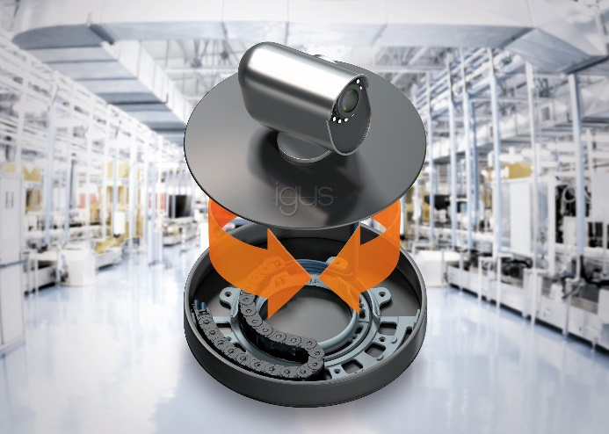
Picture PM4821-1
Cost-effective and compact: the new PRM rotary energy supply system from igus moves cables and hoses with extremely tight bend radii safely in a plastic guide trough. (Source: igus GmbH)

ABOUT IGUS:

igus GmbH develops and produces motion plastics. These lubrication-free, high-performance polymers improve technology and reduce costs wherever things move. In energy supplies, highly flexible cables, plain and linear bearings as well as lead screw technology made of tribo-polymers, igus is the worldwide market leader. The family-run company based in Cologne, Germany, is represented in 35 countries and employs 4,150 people across the globe. In 2020, igus generated a turnover of €727 million. Research in the industry's largest test laboratories constantly yields innovations and more security for users. 234,000 articles are available from stock and the service life can be calculated online. In recent years, the company has expanded by creating internal startups, e.g. for ball bearings, robot drives, 3D printing, the RBTX platform for Lean Robotics and intelligent "smart plastics" for Industry 4.0. Among the most important environmental investments are the "chainge" programme – recycling of used e-chains - and the participation in an enterprise that produces oil from plastic waste (Plastic2Oil).

PRESS CONTACT:

Oliver Cyrus Anja Görtz-Olscher
Head of PR and Advertising Manager PR and Advertising

igus® GmbH igus® GmbH
Spicher Str. 1a Spicher Str. 1a
51147 Cologne 51147 Cologne
Tel. 0 22 03 / 96 49-459 Tel. 0 22 03 / 96 49-7153
ocyrus@igus.net agoertz@igus.net
www.igus.de/presse www.igus.de/presse

The terms "igus", “Apiro”, "chainflex", "CFRIP", "conprotect", "CTD", “drygear”, "drylin", "dry-tech", "dryspin", "easy chain", "e-chain", "e-chain systems", "e-ketten", "e-kettensysteme", "e-skin", "e-spool”, "flizz", “ibow”, “igear”, "iglidur", "igubal", “kineKIT”, "manus", "motion plastics", "pikchain", "plastics for longer life", "readychain", "readycable", “ReBeL”, "speedigus", "tribofilament“, "triflex", "robolink", “xirodur”, and "xiros" are protected by trademark laws in the Federal Republic of Germany and internationally, where applicable.

