J&M Manufacturing from the US wins the golden manus award 2023
Four unique projects receive the international prize from igus for their creative use of lubrication-free plastic bearings

Beaming faces at J&M Manufacturing: the US company won the golden manus award 2023 at the Hannover Messe 2023. The competition honours creative projects with plastic plain bearings. This year's winner was able to impress with the sustainable and economical use of lubrication-free polymer bearings in a new type of agricultural implement. The other award winners were also in the mood to celebrate: the French company Aufratech won the silver manus award with an exoskeleton. Fiedler Maschinenbau came in third with a telescopic high-pressure cleaner for municipal vehicles. The German company Rockinger Agriculture GmbH is delighted with the green manus award for its lubrication-free ball coupling.

Wednesday evening, at 6pm, the igus trade show stand at the Hannover Messe 2023 is in a state of rising excitement. Only a few more minutes before they are announced: the winners of the manus award 2023 - a competition with which a community initiative honours companies every two years that technically improve their applications with light and lubrication-free plain bearings while making them more sustainable. 480 entries from 36 countries participated in the eleventh edition of the competition. A jury consisting of experts from industry, research, business and the trade press examined the submissions. In focus: the plain bearing. A machine element that is often underestimated. Their evaluation criteria were: idea, function of the plain bearing, savings, effect and differentiation. From these points of view, four companies were able to stand out from their competitors.

Gold for US ploughshare for nitrogen fertilisation
J&M Manufacturing accepted the golden manus award 2023 and €5,000 in prize money. The US company developed a plough with a so-called para-linkage coulter. Farmers use the system to apply liquid nitrogen fertiliser to crops such as maize, potatoes and wheat. The problem so far: the industry standard uses coulters with only one pivot point. The knife sits behind the coulter and swings up out of the ground faster than the blade. This can cause some of the nitrogen to volatilise and be lost as fertiliser. To solve this problem, J&M Manufacturing engineers developed a spring-loaded system. The parallel design keeps the knife and blade at the same level with respect to the ground when engaging, so more nitrogen stays in the soil. The designers use igus polymer plain bearings in all five coulter pivot points. The bearings are not only corrosion-free in contact with liquid nitrogen fertiliser and reliably withstand oscillating movements. They also allow low-friction dry operation without a single drop of lubricating oil. This saves money on lubricants and makes the machine fail-safe.

Silver for a French exoskeleton in a slim design
The food industry, landscaping and agriculture: those who work with high-pressure cleaners in industry are familiar with equipment that is so heavy that backache is inevitable. This is where Aufratech provides relief. The French company has won the silver manus award 2023 and €2,500 in prize money for its EXO N exoskeleton. At the core of the exoskeleton design is a control system that enables users to guide the attached lances while keeping their back straight. The engineers have succeeded in implementing a slim design. They have grouped as many functions as possible around an aluminium shaft with linear slide bearings and corrosion-free polymer plain bearings of the iglidur J3 series from igus - including the transmission and rotation guidance.

Bronze for a telescopic high-pressure cleaner from Germany
Fiedler Maschinenbau und Technikvertrieb GmbH was delighted to receive the bronze manus award 2023 and €1,000 in prize money. The company has built a high-pressure cleaner that municipal vehicles use to clean dirty streets, pavements and squares. Its core is the FSB 1500/2600 double spray boom mounted in front of the vehicle. It is equipped with side nozzles, a middle section and electronically switchable high-pressure underfloor nozzles for cleaning surfaces with high water pressure. What is special is that the high-pressure cleaner's working area can be changed at the touch of a button. The double spray boom can be infinitely telescoped up to 500mm on each side. This adaptability enables the driver to clean large areas faster. The engineers use profile guides and pillow blocks of the drylin W series for the telescopic function. The corrosion-free components are wear-resistant and insensitive to water and spray mist, sand, gravel and brake dust. They are also robust enough to withstand severe impacts and vibrations from crossing curbs and cobblestones.

Green manus award for lubrication-free coupling from Germany
Lubricating oil and agriculture: a controversial combination. There is always a risk of soil contamination. To prevent this, Rockinger Agriculture GmbH has developed a lubrication-free ball coupling called KS80 for loader wagons, manure spreaders, tippers and field sprayers. And with this sustainability idea, they won the green manus award and €1,000 in prize money. The coupling consists of a coupling ball and a claw, which are installed in the height adjustment. What is special about this coupling only becomes apparent when you look into the coupling claw. Inside is the wear insert made of robust high-performance plastic of the iglidur series, which igus developed specifically for the company. Thanks to integrated solid lubricants, it enables low-friction and environmentally friendly dry operation without lubricating oil. The company calculates that if a third of the tractors in Germany were equipped with a KS80 and wear insert, around 8,300 couplings would require no lubrication. Eight tons of grease per year could be saved.

All information about the winners and the manus catalogue with all 480 entries is available at www.igus.eu/manus.

Caption:
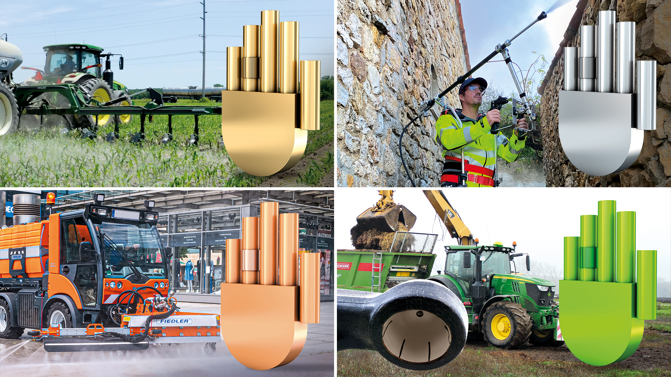
Picture PM2423-1
The winners of the 11th manus award: gold for the para-linkage coulter from J&M Manufacturing (US), silver goes to the exoskeleton from Aufratech (France), bronze for Fiedler Maschinenbau und Technikvertrieb GmbH (Germany) for its telescopic high-pressure cleaner for municipal vehicles. Rockinger Agriculture GmbH (Germany) won the green manus for their lubrication-free ball coupling. (Source: igus GmbH)

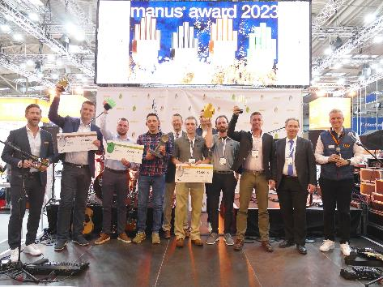
Picture PM2423-2
Happy faces among the winners. They received their manus award at the Hannover Messe 2023. (Source: igus GmbH)

PRESS CONTACT:

Alexa Heinzelmann
Head of International Marketing

igus® GmbH
Spicher Str. 1a
51147 Cologne
Tel. 0 22 03 / 96 49-7272
aheinzelmann@igus.net
www.igus.eu/press

ABOUT IGUS:

igus GmbH develops and produces motion plastics. These lubrication-free, high-performance polymers improve technology and reduce costs wherever things move. In energy supplies, highly flexible cables, plain and linear bearings as well as lead screw technology made of tribo-polymers, igus is the worldwide market leader. The family-run company based in Cologne, Germany, is represented in 31 countries and employs 4,600 people across the globe. In 2022, igus generated a turnover of €1,15 billion. Research in the industry's largest test laboratories constantly yields innovations and more security for users. 234,000 articles are available from stock and the service life can be calculated online. In recent years, the company has expanded by creating internal startups, e.g. for ball bearings, robot drives, 3D printing, the RBTX platform for Lean Robotics and intelligent "smart plastics" for Industry 4.0. Among the most important environmental investments are the "chainge" programme – recycling of used e-chains - and the participation in an enterprise that produces oil from plastic waste.

The terms "igus", “Apiro”, "chainflex", "CFRIP", "conprotect", "CTD", “drygear”, "drylin", "dry-tech", "dryspin", "easy chain", "e-chain", "e-chain systems", "e-ketten", "e-kettensysteme", "e-skin", "e-spool”, "flizz", “ibow”, “igear”, "iglidur", "igubal", “kineKIT”, "manus", "motion plastics", "pikchain", "plastics for longer life", "readychain", "readycable", “ReBeL”, "speedigus", "tribofilament“, "triflex", "robolink", “xirodur”, and "xiros" are protected by trademark laws in the Federal Republic of Germany and internationally, where applicable.

