RBTXpert from igus: remote integration for cost-effective automation at a fixed price
New service helps customers quickly implement their automation project and ensures fast ROI

Automate cheaply and benefit from a quick return on investment - but how? This question is often faced not only by newcomers to automation. The RBTXpert provides immediate support in making your planned project a success. The new service helps to select the right low-cost components, checks feasibility and provides support during commissioning.

To bundle all possibilities of low-cost robotics on one platform and make it transparent and easy to use: that is the goal of RBTX.com. On the online platform, users have the opportunity to put together their own cost-effective robot solution with just a few clicks. But not all users know from the outset exactly what they need for their automation project. "For the customer, the focus is first on their individual application. And they know which tasks should be automated", says Jens Klärner, RBTX product owner. "The new RBTXpert now helps find the right components for this and the most affordable solution that works safely."

Automation made easy with the RBTXpert
At the beginning of every consultation is the question: "What do I want to automate?" To do this, the interested party simply selects a free desired appointment using RBTXpert and subsequently describes the project during the video call. The expert then takes care of the "how". In the remote appointment, the feasibility is tested together in a live session by evaluating the advantages of different robot kinematics and accessories. The RBTXpert then prepares a binding fixed price offer. For this purpose, igus has set up a "customer testing area" on 400 square metres. Here, the implementation of the planned automation can be tested and optimised. The customer can participate via video. It gets even better when the part to be moved is sent to igus for further tests. At the end of the free consultation, there is certainty about the feasibility of the automation project and an offer with a fixed price. If the customer decides in favour of an implementation, the components are subsequently delivered. During commissioning, the RBTXpert service helps again as part of the project. "Our typical projects have hardware costs of 8,000 euros and about 20 hours of integration work", explains Alexander Mühlens, Head of the Low Cost Automation Business Unit at igus. "With the service, we are targeting applications with hardware costs between 3,000 to 25,000 euros and an integration input of less than 100 hours. ​"More complex projects that cannot yet be implemented with Low Cost Automation and the RBTXpert will be included in our development plan", Alexander Mühlens adds.

Online marketplace offers large low-cost robotics selection
A wide selection of low-cost automation products is available on RBTX.com. The electro-mechanical basic framework is made up of articulated arm robots, delta robots and Cartesian robots from igus, amongst others, and also robots from other suppliers. In the next step, this basic structure is supplemented by individual components from different manufacturers such as grippers, cameras and control systems. The product range is being continuously expanded: for example, with igus innovations such as the fully integrated ReBeL tribo strain wave gear with motor, absolute encoder, force regulation and controller. With the drylin Scara robots, a modular robot with four degrees of freedom will be available from summer onwards. "This shows that: RBTX is getting bigger and more attractive for customers as well as providers of low-cost automation and brings both sides together", Jens Klärner underlines. "The customer can always be sure that all the different components will work together without any problems. The RBTXpert expands this range and helps to ensure that it is the right choice for the individual. This makes it even easier for many to get started with cost-effective automation with a quick return on investment."

Caption:

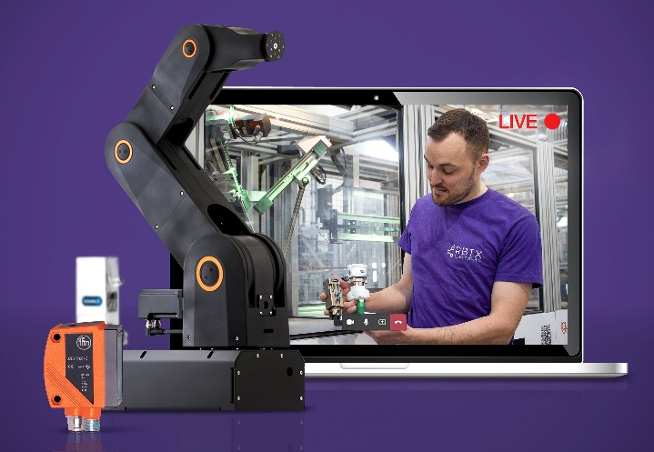
Picture PM2721-1
RBTX, the marketplace for Low Cost Automation, now with RBTXpert service and remote integration for simple automation solutions at a fixed price. (Source: igus GmbH)

PRESS CONTACT:  Oliver Cyrus  Head of PR and Advertising  Anja Görtz-Olscher  PR and Advertising  igus® GmbH  Spicher Str. 1a  51147 Cologne  Tel. 0 22 03 / 96 49-459 or -7153  Fax 0 22 03 / 96 49-631  ocyrus@igus.net  agoertz@igus.net  www.igus.eu/press | ABOUT IGUS:  igus GmbH develops and produces motion plastics. These lubrication-free, high-performance polymers improve technology and reduce costs wherever things move. In energy supplies, highly flexible cables, plain and linear bearings as well as lead screw technology made of tribo-polymers, igus is the worldwide market leader. The family-run company based in Cologne, Germany, is represented in 35 countries and employs 3,800 people across the globe. In 2019, igus generated a turnover of €764 million. Research in the industry's largest test laboratories constantly yields innovations and more security for users. 234,000 articles are available from stock and the service life can be calculated online. In recent years, the company has expanded by creating internal startups, e.g. for ball bearings, robot drives, 3D printing, the RBTX platform for Lean Robotics and intelligent "smart plastics" for Industry 4.0. Among the most important environmental investments are the "chainge" programme – recycling of used e-chains - and the participation in an enterprise that produces oil from plastic waste. (Plastic2Oil).

The terms "igus", “Apiro”, "chainflex", "CFRIP", "conprotect", "CTD", “drygear”, "drylin", "dry-tech", "dryspin", "easy chain", "e-chain", "e-chain systems", "e-ketten", "e-kettensysteme", "e-skin", "e-spool”, "flizz", “ibow”, “igear”, "iglidur", "igubal", “kineKIT”, "manus", "motion plastics", "pikchain", "plastics for longer life", "readychain", "readycable", “ReBeL”, "speedigus", "tribofilament“, "triflex", "robolink", “xirodur”, and "xiros" are protected by trademark laws in the Federal Republic of Germany and internationally, where applicable.

