iglidur I151 for FDA-compliant, detectable, wear-resistant parts in food technology
igus develops a blue, food-compatible tribo-filament for cost-effective 3D printing of special parts

iglidur I151 is blue, prints easily, and has an optimal coefficient of friction and wear. The new tribo-filament is a refinement of the easy-to-machine igus iglidur I150 all-rounder filament. Because it is blue, it can be used to manufacture special parts that are optically detectable in the food industry. Food compatibility according to the FDA and to EU Regulation 10/2011 also qualifies the high-performance polymer for use in the food and cosmetics industries.

igus has included iglidur I150, its all-rounder material, in its 3D printing materials range since 2017. The filament is very easy to use with conventional 3D printers. This allows special parts to be manufactured quickly and cost-effectively with the FDM process. "Many customers, primarily from the food industry, have requested a blue, FDA-compliant filament with properties similar to those of iglidur I150. That is why we have now developed iglidur I151", says Tom Krause, Head of the igus GmbH Additive Manufacturing Business Unit. The new tribo-filament is suitable for printing components with great wear resistance. Because the material is enriched with solid lubricants, no additional lubrication is necessary. This rules out any contamination hazard. The printed components comply with the requirements of the FDA and of EU Regulation 10/2011, making them ideal for use in the food and cosmetics industries. The blue colour provides the required optical detectability. iglidur I151 can be used with any 3D printer that can be set to a nozzle temperature of 250 degrees Celsius.

Print food-compliant special parts yourself or order them online
iglidur I151 exhibits mechanical properties comparable to those of iglidur I150 with respect to stability, toughness and layer adhesion. iglidur I151 was also impressive in wear testing in igus' in-house test laboratory with a service life that is one hundred times that of such standard plastics as ABS and nylon. The new filament can be ordered from igus in the online shop as roll material. Users can also commission the igus 3D printing service to manufacture their wear-resistant special parts. Just upload the STEP data, choose the material, calculate prices, and order the customised wear-resistant part directly. igus will introduce the new tribo-filament for the food industry from 20th-23rd April 2021 at the Ultimaker Transformation Summit. iglidur I151 will also be available shortly at the Ultimaker Marketplace. Here, users of Ultimaker 3D printers have an advantage because the material profiles are already included, allowing printing to begin immediately without any preliminary adjustments.

Caption:

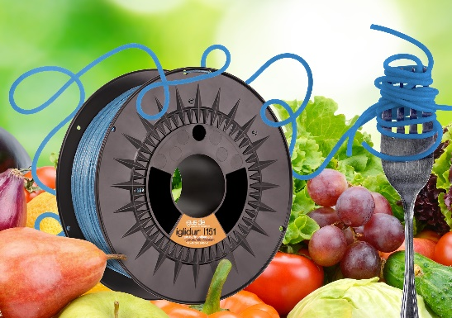
Picture PM1821-1
The new iglidur I151 tribo-filament is FDA-compliant and especially well-suited to food contact. (Source: igus GmbH)

PRESS CONTACT:  Oliver Cyrus  Head of PR and Advertising  Anja Görtz-Olscher  PR and Advertising  igus® GmbH  Spicher Str. 1a  51147 Cologne  Tel. 0 22 03 / 96 49-459 or -7153  Fax 0 22 03 / 96 49-631  ocyrus@igus.net  agoertz@igus.net  www.igus.eu/press | ABOUT IGUS:  igus GmbH develops and produces motion plastics. These lubrication-free, high-performance polymers improve technology and reduce costs wherever things move. In energy supplies, highly flexible cables, plain and linear bearings as well as lead screw technology made of tribo-polymers, igus is the worldwide market leader. The family-run company based in Cologne, Germany, is represented in 35 countries and employs 3,800 people across the globe. In 2019, igus generated a turnover of €764 million. Research in the industry's largest test laboratories constantly yields innovations and more security for users. 234,000 articles are available from stock and the service life can be calculated online. In recent years, the company has expanded by creating internal startups, e.g. for ball bearings, robot drives, 3D printing, the RBTX platform for Lean Robotics and intelligent "smart plastics" for Industry 4.0. Among the most important environmental investments are the "chainge" programme – recycling of used e-chains - and the participation in an enterprise that produces oil from plastic waste. (Plastic2Oil).

The terms "igus", “Apiro”, "chainflex", "CFRIP", "conprotect", "CTD", “drygear”, "drylin", "dry-tech", "dryspin", "easy chain", "e-chain", "e-chain systems", "e-ketten", "e-kettensysteme", "e-skin", "e-spool”, "flizz", “ibow”, “igear”, "iglidur", "igubal", “kineKIT”, "manus", "motion plastics", "pikchain", "plastics for longer life", "readychain", "readycable", “ReBeL”, "speedigus", "tribofilament“, "triflex", "robolink", “xirodur”, and "xiros" are protected by trademark laws in the Federal Republic of Germany and internationally, where applicable.

