Cables weighing tons guided by quickly mounted igus energy chain
Harnessed and tested e-loop energy supply system increases safety and reduces procurement and installation time

It guides cables safely at a defined bend radius and even withstands shocks and impacts: the e-loop. The energy chain system is specifically designed for hanging applications, such as in deep drilling rigs and is already replacing service loops worldwide. In order to offer users a complete ready-to-connect system from a single source that operates safely even in extreme application scenarios, such as in explosion zones, igus now offers its energy chains with special connectors and cables as tested readychains.

To guide cables safely in hanging applications, igus has developed the e-loop as an alternative to the service loop. This is because the service loop often causes a number of problems: the cables have no guide, have no defined bend radius, cannot move and, in the worst case, break. When servicing or repairing the service loop, the complete system must be replaced, as the cables are sealed together. "With the e-loop we have developed an alternative to the service loop. The three-dimensional energy supply system combines the advantages of a polymer energy chain with a high-strength pull rope. The rope absorbs the tensile forces inside the chain and transmits them to the mounting brackets. This means that the cables remain completely strain-relieved", says Tim Schneebeck, Industry Manager Oil & Gas at igus GmbH. The modular e-chain made of high-performance polymer offers a defined bend radius at all times and withstands vibrations and shocks thanks to PU protectors.
Save procurement time and costs
The e-loop successfully replaces the service loop, especially in deep drilling rigs. But the e-loop is also used in shore power supply or open-cast mining: "We have already won many projects. Customers often wanted a complete energy supply system with the appropriate essential tests in accordance with VDE and IEC", says Schneebeck. "For low voltage cables, for example for top drive systems, we were able to supply a completely tested readychain system with chainflex cables right from the start. We now have the right partners on board for high-voltage cables and special connectors", says Markus Hüffel, Product Manager readychain & readycable at igus GmbH. All e-loops can now also be provided by igus with special cables and special connectors for shore power supply and explosive zones as a finished system. The energy supply system is harnessed by igus and tested with a Megger VLF Sinus 34kV. The readychain system saves the user almost 90% procurement time and 68% of the assembly time. In addition, igus gives a guarantee of up to 36 months depending on the configuration of the e-loop.
e-loop series also expanded for stationary applications
Due to the success of the system, igus has now expanded the e-loop series to include a version with crossbars every 2nd link. The new version has been specifically developed for stationary applications, for example in shore power supply, for the energy supply from the mast to the power container; it is lightweight and cost-effective. The e-loop is also available with rollers and handle modules so that it can be easily moved from A to B over the floor at quay facilities. When the machine and system reaches the end of their service life and is no longer in use, igus will take it back and guarantee pure recycling. In return, the user receives a credit note based on the net weight.
You can find more information and videos about the e-loop at: https://www.igus.eu/info/e-loop?L=en
PRESS CONTACT:  Oliver Cyrus  Head of PR and Advertising  Anja Görtz-Olscher  PR and Advertising  igus® GmbH  Spicher Str. 1a  51147 Cologne  Tel. 0 22 03 / 96 49-459 or -7153  Fax 0 22 03 / 96 49-631  ocyrus@igus.net  agoertz@igus.net  www.igus.eu/press | ABOUT IGUS:  igus GmbH is a global leading manufacturer of energy chain systems and polymer plain bearings. The Cologne-based family business has offices in 35 countries and employs 4,150 people around the world. In 2019, igus generated a turnover of 764 million euros from motion plastics, plastic components for moving applications. igus operates the largest test laboratories and factories in its sector to offer customers quick turnaround times on innovative products and solutions tailored to their needs.

The terms "igus", “Apiro”, "chainflex", "CFRIP", "conprotect", "CTD", “drygear”, "drylin", "dry-tech", "dryspin", "easy chain", "e-chain", "e-chain systems", "e-ketten", "e-kettensysteme", "e-skin", "e-spool”, "flizz", “ibow”, “igear”, "iglidur", "igubal", “kineKIT”, "manus", "motion plastics", "pikchain", "plastics for longer life", "readychain", "readycable", “ReBeL”, "speedigus", "triflex", "robolink", “xirodur”, and "xiros" are protected by trademark laws in the Federal Republic of Germany and internationally, where applicable.
Caption:

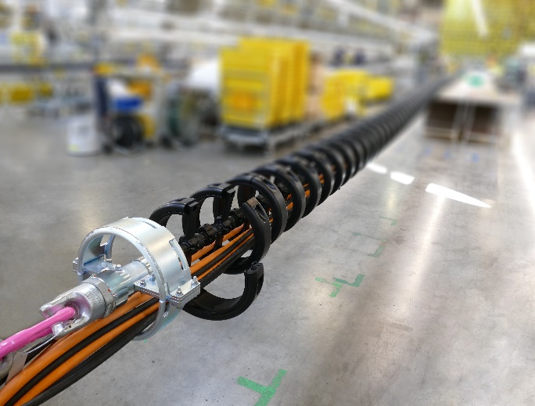
Picture PM4320-1
igus now offers the e-loop with special connectors and cables as a tested and ready-to-connect readychain. (Source: igus GmbH)

