From Munich to Cairo without lubrication: sliding instead of rolling with durable igus linear carriage
The linear carriage T20 of the drylin W series makes switching from ball guides to sliding linear guides even easier
With the T20 of the drylin W series, igus is launching a new linear carriage on the market, which has the same dimensions as most classic carriages with recirculating ball bearing guides. This enables a quick 1:1 replacement - without any structural adjustments. By using drylin W, applications benefit from freedom from lubrication, a long service life, less cleaning effort and reduced weight.

Whether it is the sliding door of a cabinet, the seat adjustment of fitness equipment or the bottle dispenser of a beverage machine: more and more designers are saying goodbye to classic ball circulation systems when it comes to linear guides, and rely on linear systems from the drylin W series from igus. A paradigm shift. This is due to the fact that the carriage does not roll, but slides very quietly over the rail - on liners made of high-performance plastic. "Durability, freedom from maintenance and lubrication, hygiene and lightweight: the advantages of drylin W are so great that more and more designers are even making complex technical changes to their machines to implement the changeover," says Michael Hornung, Product Manager for drylin Linear Technology at igus. "An effort that we would like to spare our designers in future." The company is therefore launching the new linear carriage T20 on the market. A robust and corrosion-free monoblock made of aluminium with linear plain bearing liners made of iglidur J200 for an exceptionally long service life on hard-anodised aluminium rails.

Connection dimensions identical to the ones of recirculating ball bearing guides
Visually, the linear carriage T20 is reminiscent of a classic carriage with rolling guide. "The carriage has the same dimensions as most recirculating ball bearing guides on the market - with the same system height and identical connection dimensions. This enables an instant 1:1 replacement of the carriage and thus a convenient change from rolling guide to sliding guide - without any design changes." Up to now, a comparably fast replacement with linear carriages of the same dimensions has only been possible on the drylin T system. However, in this case, users were limited to a T-guide rail. "With the new linear carriage T20, the leap from recirculating ball bearing guides to lubrication-free and maintenance-free linear technology is significantly easier."

T20 achieves a running performance of 2,500 to 18,000 kilometres in the test
The drylin W range is characterised by a high degree of flexibility. This allows users to choose between different rail models. One of the most popular ones is the drylin W standard rail WS-10-40 - a robust hard-anodised and corrosion-free linear rail made of aluminium. A rail characterised by a flat construction and a torsion-resistant double shaft geometry. This has been demonstrated by tests in the igus test laboratory. A linear carriage of the T20 series moved back and forth on a rail length of 1,000 millimetres in 24-hour operation - with a load of 250N and an acceleration of 10m/s². The system achieved a running performance of 2,500 kilometres in completely dry operation. This corresponds to the distance between Munich and Cairo. With a load of 2 kilograms and a slow travel speed, a running performance of 18,000 kilometres was achieved.

Tribo-liners - low-maintenance, sustainable and hygienic
In addition to durability, switching to a linear guide with a liner made of high-performance plastic offers further advantages. Unlike rolling systems, the liner does not require any external lubrication. Integrated, microscopic solid lubricants ensure a low-friction dry operation. The advantage is obvious: eliminating lubricants saves time and costs for maintenance work, while having a positive effect on the life cycle assessment. Equally sustainable: the service life of the linear carriage is virtually unlimited, as the liners can be replaced again and again with little effort. The cleaning effort is also low, as the liner simply pushes the dirt and grime off the rail. In rolling systems, on the other hand, there is often the risk that the dirt will combine with lubricating oil to form a mixture that reduces smooth running and increases the risk of contamination. "Our various drylin liners make it possible to get the most out of every application," says Michael Hornung. "In addition to the aluminium version, we have also developed a linear carriage made of stainless steel. In combination with double rails made of VA stainless steel and linear liners, for example made of the FDA- and EU-compliant material iglidur A160, exceptionally hygienic and cleaning-intensive applications are also possible in the food, medical and pharmaceutical sectors."

Caption:

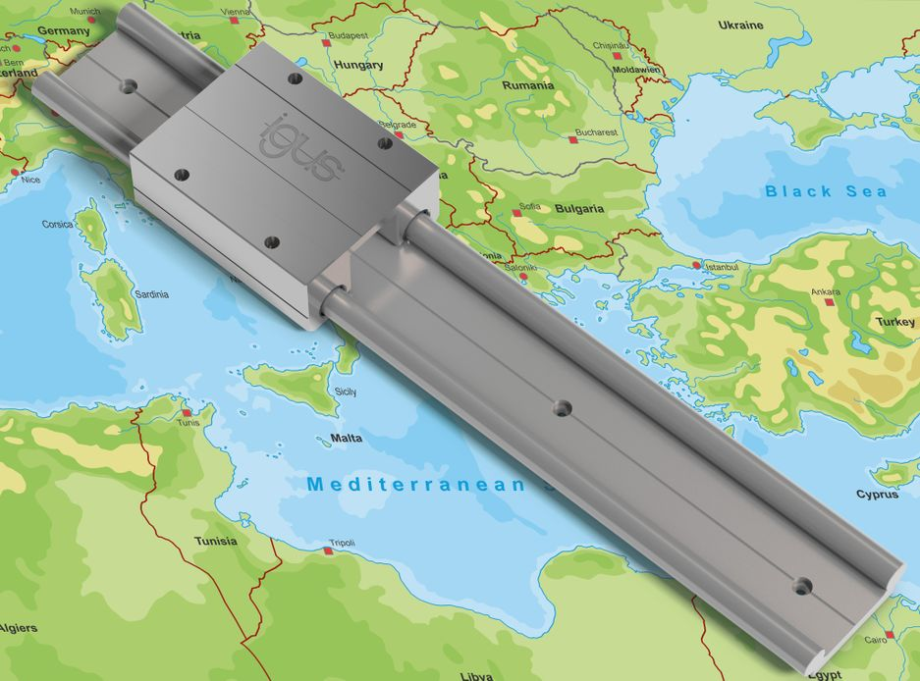
Picture PM3222-1
Sliding instead of rolling - and in a reliable way: the lubrication-free drylin W linear carriage of the T20 series facilitates the 1:1 replacement of ball guides with sliding linear guides and achieved a running performance of 2,500 to 18,000 kilometres in the test. (Source: igus GmbH)

PRESS CONTACT:

Alexa Heinzelmann
Head of International Marketing

igus® GmbH
Spicher Str. 1a
51147 Cologne
Tel. 0 22 03 / 96 49-7272
aheinzelmann@igus.net
www.igus.eu/press

ABOUT IGUS:

igus GmbH develops and produces motion plastics. These lubrication-free, high-performance polymers improve technology and reduce costs wherever things move. In energy supplies, highly flexible cables, plain and linear bearings as well as lead screw technology made of tribo-polymers, igus is the worldwide market leader. The family-run company based in Cologne, Germany, is represented in 35 countries and employs 4,900 people across the globe. In 2021, igus generated a turnover of €961 million. Research in the industry's largest test laboratories constantly yields innovations and more security for users. 234,000 articles are available from stock and the service life can be calculated online. In recent years, the company has expanded by creating internal startups, e.g. for ball bearings, robot drives, 3D printing, the RBTX platform for Lean Robotics and intelligent "smart plastics" for Industry 4.0. Among the most important environmental investments are the "chainge" programme – recycling of used e-chains - and the participation in an enterprise that produces oil from plastic waste.

The terms "igus", “Apiro”, "chainflex", "CFRIP", "conprotect", "CTD", “drygear”, "drylin", "dry-tech", "dryspin", "easy chain", "e-chain", "e-chain systems", "e-ketten", "e-kettensysteme", "e-skin", "e-spool”, "flizz", “ibow”, “igear”, "iglidur", "igubal", “kineKIT”, "manus", "motion plastics", "pikchain", "plastics for longer life", "readychain", "readycable", “ReBeL”, "speedigus", "tribofilament“, "triflex", "robolink", “xirodur”, and "xiros" are protected by trademark laws in the Federal Republic of Germany and internationally, where applicable.

