Fast set-up of motor control systems from igus: no lengthy programming
igus accelerates the commissioning of drylin E motor control systems with free motion sample programmes
The programming of motor control systems and the integration into machine environments often takes several days, amounting to costs of several thousand euros. A barrier that the Cologne-based company igus is now removing. With the free motion sample programmes, it is possible to commission the dryve series motor control systems in just a few minutes, and connect them to higher-level programmable logic controllers (PLC). This benefits automation newcomers and professionals alike.
The level of automation is rising rapidly in many companies. The workload for technicians and engineers responsible for programming and synchronising automation movements is increasing accordingly. "To ease the burden, you can download sample programmes for our dryve motor control systems for free," says René Erdmann, Head of Business Unit drylin E Drive Technology at igus. Customers worldwide mostly use the cost-effective control systems for comparatively simple automation tasks - such as for controlling DC, EC and stepper motors in single axes, line robots, flat linear robots, room linear robots and delta robots. "Thanks to the ready-made sample codes, users can now integrate our motor control systems into higher-level PLCs and machine environments in a flash, and define motion sequences in a time- and cost-saving manner." The sample programmes are compatible with PLC manufacturer Siemens, but also with industrial PCs, microcontrollers, such as Arduino, and single-board computers, e.g. Raspberry Pi. Further sample programmes for Beckhoff, Wago and Eaton are already being planned.

User saves several days of programming work
Access to the sample programmes is barrier-free: users can find videos on the igus website that show the most common automation movements - such as a trolley moving to different target positions on a linear axis. If the motion programme seems suitable, the user can download the software code and load it into the master control system. The motor's actions can then be parametrised and adapted to individual requirements via an intuitively understandable graphic interface. No programming knowledge is required to set travels, target positions and accelerations. The advantage is obvious. "Initial customer feedback confirms this: with some sample programmes that map more complex motion sequences, users save several days of programming work," says Erdmann. So far, the range includes 19 sample programmes that are suitable for positioning tasks, testing and experimenting devices, pick-and-place handling, automatic assembly machines and feeding systems. "In future, we will continuously add motion programmes to the range that customers need most frequently. If users can't find a sample programme, e.g. for a special application or for a different master control system, they can request it at the igus website."

Instructional videos accelerate commissioning of the motor control systems
In order to further accelerate the commissioning of the motor control system, igus has also implemented the so-called dryve experience in addition to the sample programmes - an online world as a supplement to classic analogue media. Instead of reading printed operating instructions, customers can learn how to use the motor control systems with videos. Erdmann: "The short films deal with topics that customers most often ask our telephone hotline about, such as connecting brakes to the motor control system. With the videos, they now have new, easy-to-understand 24/7 support." All relevant digital documents for a smooth commissioning of the motor control systems - including firmware, EPLAN macros and 3D drawings - are also available online.

Caption:

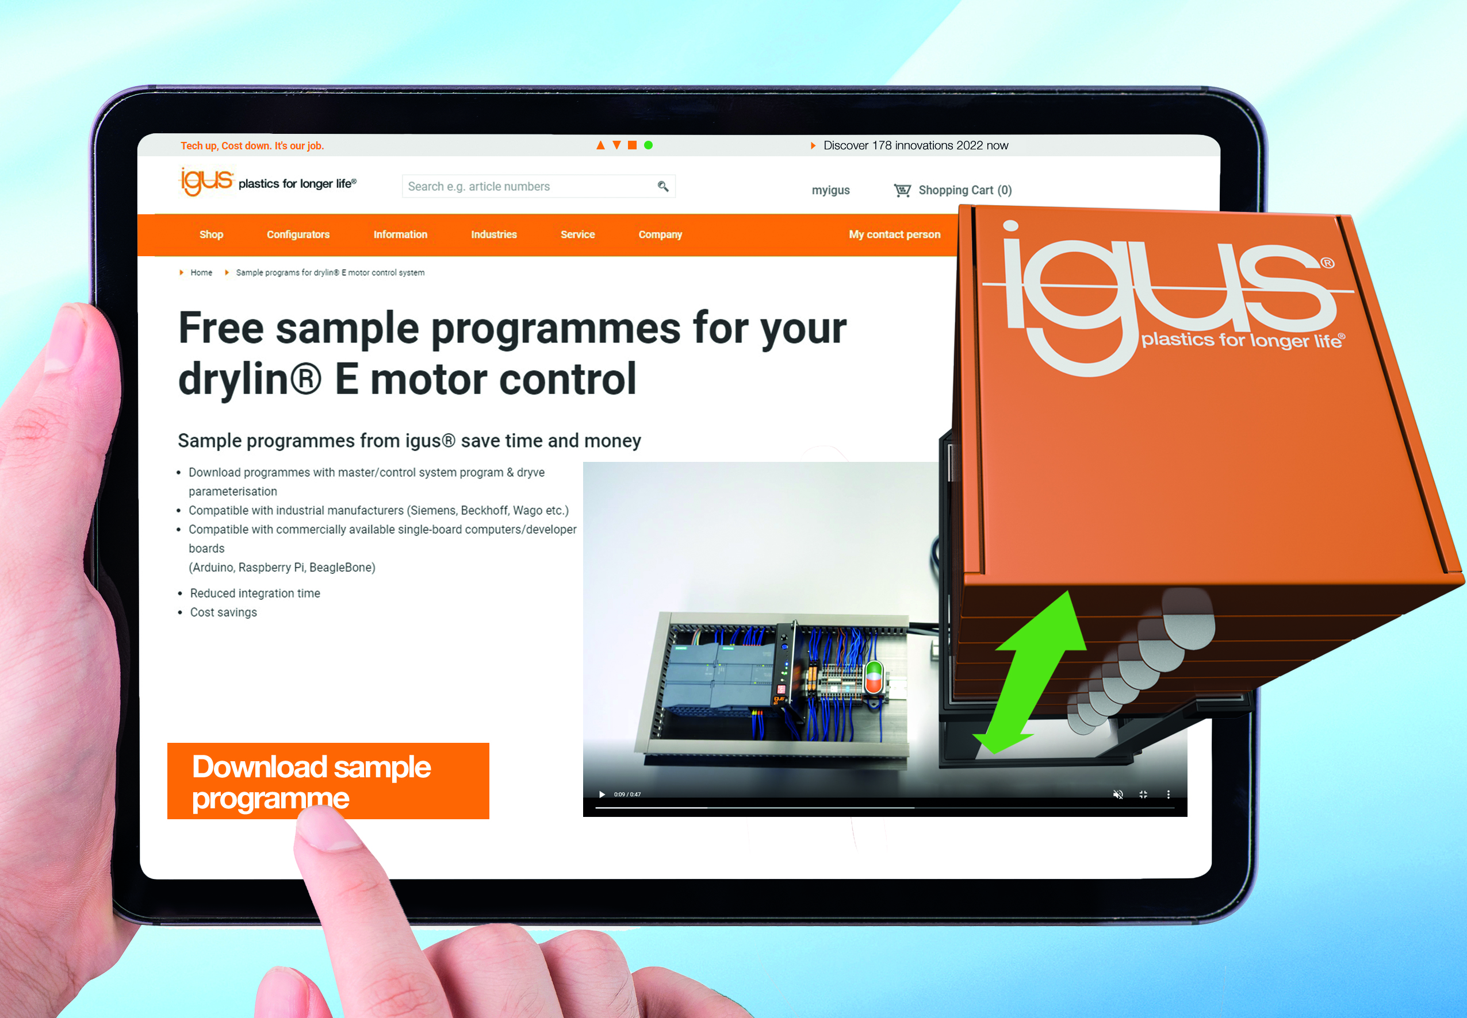
Picture PM0223-1
Free motion sample programmes enable the commissioning of drylin E motor control systems from igus in just a few minutes. (Source: igus GmbH)

PRESS CONTACT:

Alexa Heinzelmann
Head of International Marketing

igus® GmbH
Spicher Str. 1a
51147 Cologne
Tel. 0 22 03 / 96 49-7272
aheinzelmann@igus.net
www.igus.eu/press

ABOUT IGUS:

igus GmbH develops and produces motion plastics. These lubrication-free, high-performance polymers improve technology and reduce costs wherever things move. In energy supplies, highly flexible cables, plain and linear bearings as well as lead screw technology made of tribo-polymers, igus is the worldwide market leader. The family-run company based in Cologne, Germany, is represented in 31 countries and employs 4,900 people across the globe. In 2021, igus generated a turnover of €961 million. Research in the industry's largest test laboratories constantly yields innovations and more security for users. 234,000 articles are available from stock and the service life can be calculated online. In recent years, the company has expanded by creating internal startups, e.g. for ball bearings, robot drives, 3D printing, the RBTX platform for Lean Robotics and intelligent "smart plastics" for Industry 4.0. Among the most important environmental investments are the "chainge" programme – recycling of used e-chains - and the participation in an enterprise that produces oil from plastic waste.

The terms "igus", “Apiro”, "chainflex", "CFRIP", "conprotect", "CTD", “drygear”, "drylin", "dry-tech", "dryspin", "easy chain", "e-chain", "e-chain systems", "e-ketten", "e-kettensysteme", "e-skin", "e-spool”, "flizz", “ibow”, “igear”, "iglidur", "igubal", “kineKIT”, "manus", "motion plastics", "pikchain", "plastics for longer life", "readychain", "readycable", “ReBeL”, "speedigus", "tribofilament“, "triflex", "robolink", “xirodur”, and "xiros" are protected by trademark laws in the Federal Republic of Germany and internationally, where applicable.

