480 applicants compete for the manus award
International competition offers prizes of up to €5,000 for unique polymer plain bearing projects

Small, corrosion-free and made of plastic: the plain bearing. An unimposing machine element, it is rarely in the limelight, so a joint initiative started by igus, the motion plastics specialist, awards up to €5,000 to the most exciting and creative plain bearing projects every two years. This year, 480 entries were received from 36 countries.

A miniature lawnmower the size of a puppy, a fully automated robotic miniature kitchen, a foldable dog car step and a 24/7 beer bottling plant are just four of the 480 applications for the 11th manus competition. "We received a colourful variety of entries again this year - from 36 countries around the world," says Tobias Vogel, CEO Plain Bearings and Linear Technology at igus GmbH and a member of the manus award panel of judges. "The competition shows us how wide the range of applications for plain bearings can be and what problems their particular specifications solve." From highly hygienic areas in medical technology to very dirty heavy-duty applications - there are a lot of different requirements for the plastic bearing. The panel of judges, consisting of experts from research, business and the specialist press, will now evaluate the entries. The winners will be selected based on five categories - idea, plain bearing function, savings, effect and differentiation. The final placing decision will be reached at a judge panel meeting in mid-March.

Awards ceremony at the Hannover Messe
Due to Corona, the last manus award in 2021 was presented as a digital live event to which the international specialist press and all manus award participants were invited. "We are very much looking forward to presenting the trophies again in 2023 as part of the Hannover Messe at the igus trade show stand on 19th April, and to celebrating the 11th manus award with the winners," says Vogel.

Find out more about the winners of the last manus award at https://www.igus.eu/info/manus-award

Caption:
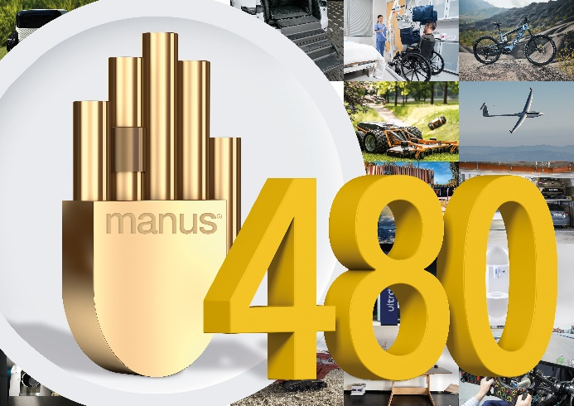
Picture PM1023-1
This year, 480 plain bearing projects from 36 countries have a chance to win a manus award and up to €5,000. (Source: igus GmbH)

PRESS CONTACT:

Alexa Heinzelmann
Head of International Marketing

igus® GmbH
Spicher Str. 1a
51147 Cologne
Tel. 0 22 03 / 96 49-7272
aheinzelmann@igus.net
www.igus.eu/press

ABOUT IGUS:

igus GmbH develops and produces motion plastics. These lubrication-free, high-performance polymers improve technology and reduce costs wherever things move. In energy supplies, highly flexible cables, plain and linear bearings as well as lead screw technology made of tribo-polymers, igus is the worldwide market leader. The family-run company based in Cologne, Germany, is represented in 31 countries and employs 4,900 people across the globe. In 2021, igus generated a turnover of €961 million. Research in the industry's largest test laboratories constantly yields innovations and more security for users. 234,000 articles are available from stock and the service life can be calculated online. In recent years, the company has expanded by creating internal startups, e.g. for ball bearings, robot drives, 3D printing, the RBTX platform for Lean Robotics and intelligent "smart plastics" for Industry 4.0. Among the most important environmental investments are the "chainge" programme – recycling of used e-chains - and the participation in an enterprise that produces oil from plastic waste.

The terms "igus", “Apiro”, "chainflex", "CFRIP", "conprotect", "CTD", “drygear”, "drylin", "dry-tech", "dryspin", "easy chain", "e-chain", "e-chain systems", "e-ketten", "e-kettensysteme", "e-skin", "e-spool”, "flizz", “ibow”, “igear”, "iglidur", "igubal", “kineKIT”, "manus", "motion plastics", "pikchain", "plastics for longer life", "readychain", "readycable", “ReBeL”, "speedigus", "tribofilament“, "triflex", "robolink", “xirodur”, and "xiros" are protected by trademark laws in the Federal Republic of Germany and internationally, where applicable.

