Metal out, plastic in: igus presents new tribological plain bearings for medium load range
iglidur M210 and M260 make bearing points on construction and agricultural machinery free of lubrication and maintenance

igus extends its range of iglidur tribological plain bearings for applications with special loads. The materials iglidur M210 and M260 are new to the range. They enable a quick changeover from thick-walled metal bearings to plastic bearings without any structural modifications. The advantage of a change is that the bearing points no longer require lubrication and are almost maintenance-free. They offer a significant time and cost advantage, especially in harsh environments in the daily operation of construction, agricultural and municipal machines.

The new polymer plain bearings iglidur M210 and M260 offer wall thicknesses of up to 5mm and inner diameters of 20, 25, 30, 40, 50 and 60mm. They are particularly suitable for applications with pivoting movements in the medium load range from 20N/mm², where a quick replacement of thick-walled metal bushings is required without structural modifications- for example in construction machines, agricultural machines and municipal vehicles that have to withstand harsh environmental conditions on a daily basis. The materials differ slightly but display their different strengths when in interaction with various shafts. For example, the M260 variant achieves excellent wear results in combination with shafts made of St37 steel.

Less maintenance and cleaning effort, more environmental protection
The switch from metal to polymer bearings means significant cost and time savings, especially for machines and vehicles with many bearing points as lubrication is no longer required. The tribological plain bearings M210 and M260 are self-lubricating. Solid lubricants ensure a low friction and dry operation. This significantly reduces the cleaning effort. Because without lubricants, dirt and dust do not have a chance stick. Another advantage: As no lubricants are entering the environment this allows users to contribute to environmental protection. Additionally, the energy consumption of machines and systems is reduced because the plastic bearings are lighter than metal bearings.

Robust and lightweight at the same time
To guarantee sufficient robustness of the iglidur M210 and M260 plain bearings, the material experts at igus work with fibres and fillers. These components strengthen the materials so that they withstand high surface pressures of up to 40MPa and edge loads even under continuous loads - even at extreme temperatures between -100°C and +140°C. Tests in the in-house igus laboratory prove that the polymer bearings show limited visible wear in pivoting movements at medium loads, even after several thousand cycles. "For this purpose, the front loader test stand on the outdoor premises is used. In addition to the standard tests, application tests are vital in material development," says Stefan Loockmann-Rittich, Head of the Business Unit iglidur plain bearings at igus. "All test results then flow into the iglidur online experts, with which the service life of M210 and M260 can be precisely calculated under specific specifications."

Caption:

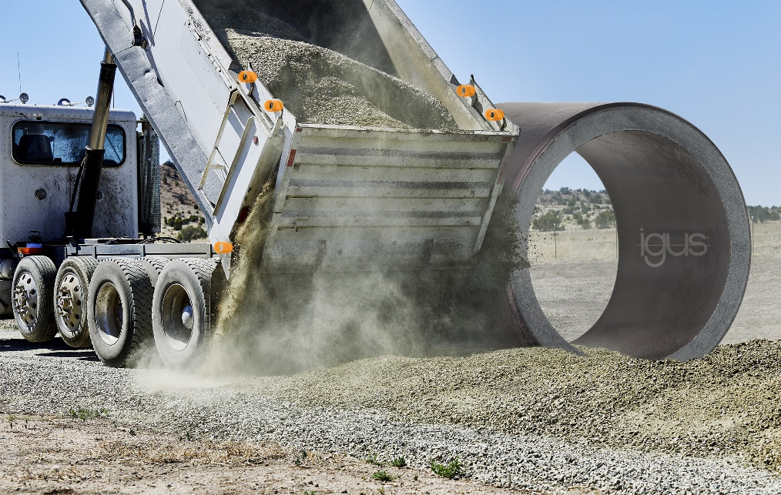
Picture PM6721-1
iglidur M210 and M260: with the two high-performance plastics for the medium load range, users make bearing points on their vehicles for construction, agricultural or municipal purposes free of lubrication and maintenance.
(Source: igus GmbH)
PRESS CONTACT:

Alexa Heinzelmann
Head of International Marketing

igus® GmbH
Spicher Str. 1a
51147 Cologne
Tel. 0 22 03 / 96 49-7272
aheinzelmann@igus.net
www.igus.eu/press

ABOUT IGUS:

igus GmbH develops and produces motion plastics. These lubrication-free, high-performance polymers improve technology and reduce costs wherever things move. In energy supplies, highly flexible cables, plain and linear bearings as well as lead screw technology made of tribo-polymers, igus is the worldwide market leader. The family-run company based in Cologne, Germany, is represented in 35 countries and employs 4,150 people across the globe. In 2020, igus generated a turnover of €727 million. Research in the industry's largest test laboratories constantly yields innovations and more security for users. 234,000 articles are available from stock and the service life can be calculated online. In recent years, the company has expanded by creating internal startups, e.g. for ball bearings, robot drives, 3D printing, the RBTX platform for Lean Robotics and intelligent "smart plastics" for Industry 4.0. Among the most important environmental investments are the "chainge" programme – recycling of used e-chains - and the participation in an enterprise that produces oil from plastic waste (Plastic2Oil).

The terms "igus", “Apiro”, "chainflex", "CFRIP", "conprotect", "CTD", “drygear”, "drylin", "dry-tech", "dryspin", "easy chain", "e-chain", "e-chain systems", "e-ketten", "e-kettensysteme", "e-skin", "e-spool”, "flizz", “ibow”, “igear”, "iglidur", "igubal", “kineKIT”, "manus", "motion plastics", "pikchain", "plastics for longer life", "readychain", "readycable", “ReBeL”, "speedigus", "tribofilament“, "triflex", "robolink", “xirodur”, and "xiros" are protected by trademark laws in the Federal Republic of Germany and internationally, where applicable.

