Blue laser sintering material for 3D printing from igus ensures even greater food safety
The new iglidur i6-BLUE laser sintering powder is extremely abrasion-resistant, lubrication-free and food-safe according to FDA and EU 10/2011 regulations
igus, the motion plastics specialist based in Cologne, is launching a new laser sintering material for 3D printers: the powdered iglidur i6-BLUE is easy to detect thanks to its blue colouring, and also complies with FDA and EU 10/2011 regulations. The new material thus increases the safety of machines and systems in the food and beverage industry. iglidur i6-BLUE is in no way inferior to the proven iglidur i6 in terms of strength and sliding properties, and is particularly suitable for printing worm gears, toothed gears and snap-on connections in 3D.

Fast production, low costs and high design flexibility: manufacturers of machines and systems for the food and beverage industry have long used 3D printers as an alternative to conventional technologies, such as turning and milling. More and more design engineers want blue printing material. Why? Because blue is easy to see and therefore increases food safety. If a 3D-printed component breaks, blue fragments in the product are easy to see and can be quickly identified with detectors. The problem is that, for the selective laser sintering manufacturing process, there are still very few blue printing materials on the market that are both robust and food-compliant. "To meet the high demand, we have now developed iglidur i6-BLUE, a blue-coloured printing powder that is compatible with all common laser sintering printers," says Tom Krause, Head of the igus Additive Manufacturing Business Unit. "The blue high-performance plastic is easy to detect and is also food-compliant. Unlike conventionally manufactured laser-sintered components, iglidur i6-BLUE complies with the hygiene guidelines of the US Food and Drug Administration (FDA) and EU 10/2011 regulations." What makes the component special is that it is completely blue, and doesn't just have coloured surfaces. This ensures that all possible fragments are blue and therefore easy to detect.

At least nine times as abrasion-resistant as PA12
Thanks to its special material composition, iglidur i6-BLUE is also tough and abrasion-resistant with excellent sliding properties, making it especially suitable for printing worm gears and toothed gears in 3D that are intended for machines in the food and beverage industry. The material is resistant to temperatures between -40°C and +80°C. "Tests in our in-house laboratory have also shown that 3D-printed gears made of iglidur i6-BLUE have a much longer service life than milled wheels made of polyoxymethylene (POM), and are at least nine times as abrasion-resistant as PA12 (SLS)," says Krause. Due to the high elongation at break, the laser sintering printing material is also suitable for the additive manufacturing of snap-on connections. In addition, iglidur i6-BLUE increases the hygiene of machines for the food and beverage industry. Microscopic solid lubricants are integrated into the laser sintering material and released automatically during movement, allowing low-friction dry operation. This eliminates the need for lubricants, which attract dust and dirt and can become a contamination risk.
Available with the 3D printing service in just five days
Machine manufacturers who do not have their own 3D printer can use the igus 3D printing service - with no minimum order quantity. All they have to do is submit a 3D model of their component. The laser sintering printer then produces it in layers from the new iglidur i6-BLUE printing material - this works significantly faster than classic manufacturing technologies, such as turning or milling. "For special components, prototypes and series of up to 10,000 pieces, we can reduce delivery time from several weeks to five days," says Krause. "More and more customers are grateful to accept this deal in the face of faltering supply chains worldwide."

Caption:
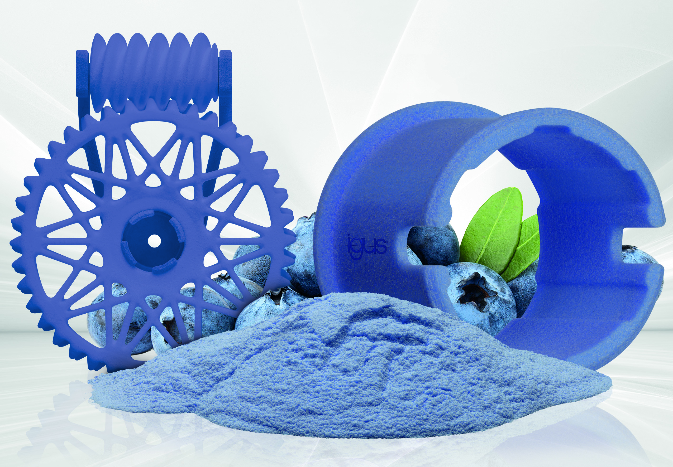
Picture PM4922-1
The iglidur i6 laser sintering material, which is food-safe according to FDA and EU 10/2011 regulations, is now also available in blue, ensuring the required optical detectability in applications in the food and beverage industry.
(Source: igus GmbH)

PRESS CONTACT:

Alexa Heinzelmann
Head of International Marketing

igus® GmbH
Spicher Str. 1a
51147 Cologne
Tel. 0 22 03 / 96 49-7272
aheinzelmann@igus.net
www.igus.eu/press

ABOUT IGUS:

igus GmbH develops and produces motion plastics. These lubrication-free, high-performance polymers improve technology and reduce costs wherever things move. In energy supplies, highly flexible cables, plain and linear bearings as well as lead screw technology made of tribo-polymers, igus is the worldwide market leader. The family-run company based in Cologne, Germany, is represented in 35 countries and employs 4,900 people across the globe. In 2021, igus generated a turnover of €961 million. Research in the industry's largest test laboratories constantly yields innovations and more security for users. 234,000 articles are available from stock and the service life can be calculated online. In recent years, the company has expanded by creating internal startups, e.g. for ball bearings, robot drives, 3D printing, the RBTX platform for Lean Robotics and intelligent "smart plastics" for Industry 4.0. Among the most important environmental investments are the "chainge" programme – recycling of used e-chains - and the participation in an enterprise that produces oil from plastic waste.

The terms "igus", “Apiro”, "chainflex", "CFRIP", "conprotect", "CTD", “drygear”, "drylin", "dry-tech", "dryspin", "easy chain", "e-chain", "e-chain systems", "e-ketten", "e-kettensysteme", "e-skin", "e-spool”, "flizz", “ibow”, “igear”, "iglidur", "igubal", “kineKIT”, "manus", "motion plastics", "pikchain", "plastics for longer life", "readychain", "readycable", “ReBeL”, "speedigus", "tribofilament“, "triflex", "robolink", “xirodur”, and "xiros" are protected by trademark laws in the Federal Republic of Germany and internationally, where applicable.

