Enjoyneering: igus drives engineering forward with 190 physical and digital new products
“Unleash your engineering power with play” – the latest motion plastics technology, lubrication-free app, low-cost automation online and sustainable

A low-cost robot operated via a VR headset. Spare parts identified and ordered in seconds using AI on a smartphone. A mobile app that immediately identifies potential applications for lubrication-free parts on an excavator. igus launches a selection of digital tools in 2023, as well as products and services which are easy to use and reduce cost. The goal: provide easy access to the right motion plastics product and have fun on the way, while being carbon-neutral and without plastic waste.

Visitors to the 2023 Hannover Messe can experience the new possibilities of a virtual parallel world at the igus exhibition stand in Hall 17, where they can use VR glasses and control a robot arm in virtual reality. The highlight: next to them, a robot that can mirror their exact movements. A bridge has been built between VR and reality; an insight of what will be possible in the future in the so-called iguverse, the igus metaverse.

The iguverse makes collaboration easy and fun
In this digital space, engineers, material experts and project planners meet and build 3D models of new machines, systems and assemblies on a 1:1 scale. No long boring meetings or expensive journeys, this also reduces CO2 emissions. The result: products are developed faster, sustainably, reliably and at a lower cost and problems can be ironed out at an early stage. The digital twin in iguverse can also be used for training. "The possibilities of virtual reality for mechanical engineering design are absolutely fascinating. We want to be a part of this technology right from the start," emphasizes igus CEO Frank Blase. "We want to develop new solutions that even small companies with limited budgets can easily use." For example, igus plans to open iguverse in the future; companies can then benefit from this platform, which is fully managed by igus, with no development outlay. Also new for 2023; a cloud-based app called igusGO. The user takes a photo of a machine, for example an excavator, and artificial intelligence analyses where lubrication-free parts from igus could be used cost-effectively.

Voice control system, "superwise" and "kopla" - new services for Industry 4.0
The igus range of low-cost robotics, intended to promote automation in SME's, is also growing. A new, smaller cobot - the ReBeL KID - will be available from May 2023 for only 3,999 euros, and has optional voice control. The online marketplace RBTX, showcases over 350 automation projects, all of which can be copied for similar applications. 98 percent of these complete solutions are already available with prices ranging from 1,974 to 12,000 euros. In addition to low-cost robotics, igus expands the range of smart plastics. These are standard parts such as energy chains and plain bearings, which are equipped with sensors and integrated into IoT networks. This allows SME's to implement Industry 4.0 trends, such as condition monitoring and predictive maintenance. The smart plastics can be expanded with a new service called "superwise", a digital product which links to igus field service team. A completely new service is the igus managed platform "kopla". This allows companies to create their own online expert systems and calculation tools. It is aimed specifically at medium-sized companies who operate internationally and would like to explain their products online. "Our own experience with the development and use of online tools, using a cloud based modular principle, is now available for others to use, massively reducing the implementation lead time compared with conventional software solutions”.

igus continues to expand - on the way to the millionth customer
The last few years had many challenges, but igus continues to grow. Now with over 188,000 customers, igus has around 5000 employees at 31 locations globally. Annual sales exceeded €1billion for the first time in 2022. Now the next goal has been set; by 2030 igus is aiming for one million active customers. To get there igus continues to invest in the development of motion plastics and in fast local logistics. The aim is to make all moving applications in the world maintenance-free and long-lasting. Many online tools help engineers to calculate the life of igus products, giving a reliable and sustainable solution. Blase: "No matter if an engineer needs a tiny bearing or the world’s largest plastic energy chain, the life can be calculated online. The new digital tools make motion plastics easy for everyone to access."

All this new technology does not mean the environment is forgotten; igus shares a new solution for re-using factory energy
"Unleashing your engineering power with play" is green. The aim is that by the end of 2025 the igus factory will be carbon neutral. One of the latest achievements is a new igus developed system which uses the spent coolant water from the injection moulding machines to heat the factory. "With this new heating system, we will drive our gas consumption to zero in the future," explains Blase. This is not only good for the environment, but also for the finances in times of rising energy costs. This is why igus has decided to make this energy solution available to other industrial companies under the name MHRS (Machine Heat Recovery System). Frank continues, "we searched for weeks for a solution and could not find one anywhere. So we built our own and we want to share this with others." Also, igus has been improving the environmental balance of plastics for years, and one key area is recycling. This year, igus has expanded the popular "Chainge" recycling program. Since 2019, any disused energy chains have been collected and reprocessed by customers in exchange for credit vouchers. The Chainge online platform now covers all technical plastics, from polyamide to PEEK. The igus:bike made from recycled ocean waste (fishing nets) is also scheduled for commercial launch in August; from ocean plastics to motion plastics. Frank Blase concludes, "Our growth must be linked to the sustainable use of resources. The creativity and energy of my igus colleagues impresses and motivates me. The fact I work with these people makes me humble and excited about what the future holds."

Caption:

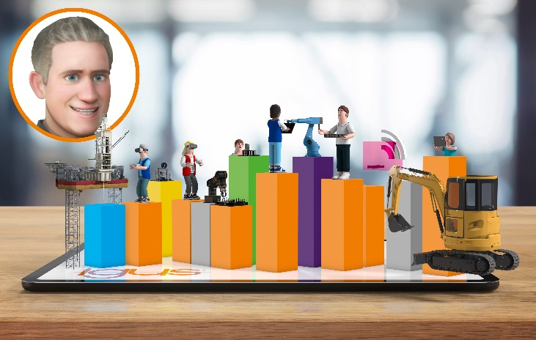
Picture PM2123-1
igus CEO Frank Blase as an avatar in the iguverse: " 'Enjoyneering - unleashing your engineering power with play', igus launches new digital products at the Hannover Messe, including the iguverse which can revolutionise the development of machines." (Source: igus GmbH)

PRESS CONTACT:

Alexa Heinzelmann
Head of International Marketing

igus® GmbH
Spicher Str. 1a
51147 Cologne
Tel. 0 22 03 / 96 49-7272
aheinzelmann@igus.net
www.igus.eu/press

ABOUT IGUS:

igus GmbH develops and produces motion plastics. These lubrication-free, high-performance polymers improve technology and reduce costs wherever things move. In energy supplies, highly flexible cables, plain and linear bearings as well as lead screw technology made of tribo-polymers, igus is the worldwide market leader. The family-run company based in Cologne, Germany, is represented in 31 countries and employs 4,600 people across the globe. In 2022, igus generated a turnover of €1,15 billion. Research in the industry's largest test laboratories constantly yields innovations and more security for users. 234,000 articles are available from stock and the service life can be calculated online. In recent years, the company has expanded by creating internal startups, e.g. for ball bearings, robot drives, 3D printing, the RBTX platform for Lean Robotics and intelligent "smart plastics" for Industry 4.0. Among the most important environmental investments are the "chainge" programme – recycling of used e-chains - and the participation in an enterprise that produces oil from plastic waste.

The terms "igus", “Apiro”, "chainflex", "CFRIP", "conprotect", "CTD", “drygear”, "drylin", "dry-tech", "dryspin", "easy chain", "e-chain", "e-chain systems", "e-ketten", "e-kettensysteme", "e-skin", "e-spool”, "flizz", “ibow”, “igear”, "iglidur", "igubal", “kineKIT”, "manus", "motion plastics", "pikchain", "plastics for longer life", "readychain", "readycable", “ReBeL”, "speedigus", "tribofilament“, "triflex", "robolink", “xirodur”, and "xiros" are protected by trademark laws in the Federal Republic of Germany and internationally, where applicable.

