snapchain 2.0: small, compact and cost-effective energy supply system
The new igus energy chain made entirely of recyclate can be installed in seconds and guides cables reliably

Things don't have to be expensive. This is true not only of groceries, but also of energy chains. The simplest products often not only cost the least, but also represent the best technology. igus has now developed the snapchain 2.0 especially for low-stress and flat cable packages. The energy supply system consists of just one side link, to which cables can be fixed with cable tiewraps. It is made entirely of recyclate, so it is a sustainable solution.

In cash register and drawer systems, office furniture and even gaming machines, there is very little space for reliable energy supply to cables. To remedy this problem, igus developed the snapchain 20 years ago. It consists of just one side link, to which the cables are attached and guided in a defined bend radius. It can fit in the tightest of spaces and has proven itself in thousands of applications worldwide. Now igus has refined the snapchain. "We would like to give our customers even more flexibility in chain harnessing. This is why we changed the design so that the cables can now be easily fixed with standard cable ties," explains Kira Weller, Product Manager for e-chains at igus. The cable tiewrap is simply inserted into the side link, routed around the cable package and closed. Another special feature of the snapchain 2.0 is that its standard version is made of the igumid CG recycling material.

From old to new
The igumid CG material comes entirely from recycled energy chains. As part of the Chainge program, igus has been taking back used energy chains, regardless of manufacturer, since 2019. The material is then sorted according to type, cleaned and returned to new quality in a single process. The material then becomes igumid CG, which has been used successfully in the E2.1 cradle-chain energy chain series since the spring of 2022. Numerous test series in the 3,800-square-metre in-house laboratory at the igus location in Cologne have confirmed its tensile force and breaking moment. The e-chains from recycled material make a valuable contribution to resource conservation, promoting the circular economy. According to the Environment Product Declaration, this sustainable raw material cycle also reduces CO₂ by 28%. "The snapchain 2.0 is a cost-effective all-round package. It provides our customers with a product that is reliable, sustainable and quick to assemble. It is the second chain series the standard version of which we make from our recycled material. At the end of its life, it can also be entirely recycled," says Weller.

Find out more about the snapchain 2.0 at:
https://www.igus.eu/info/snapchain-2-0

Caption:

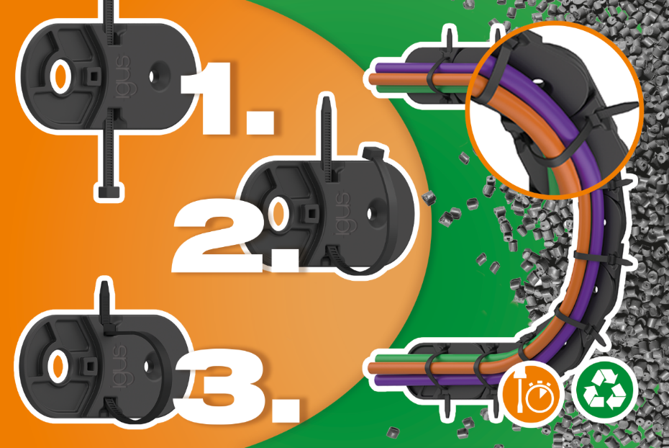
Picture PM3523-1
The snapchain 2.0 is a cost-effective, quick-to-install energy supply system for cables not subject to much stress. It is also made entirely of recyclate, so it is a sustainable solution. (Source: igus GmbH)

