Maintenance free pull-out solutions! New igus telescopic rails for the camper van
Black rails from igus expand the range of lightweight and dirt-resistant pull-outs

They ensure that the kitchen unit, provisions and bed are safely stowed away and easily accessible: compact pull-outs in camper vans. To ensure that professionals and fitters can enjoy their interior fittings for a long time, igus now also offers black anodised durable telescopic rails with plastic sliding elements. So travel enthusiasts not only get a durable and lightweight solution, but also visually appealing and lubrication-free pull-outs for their drawers, table, kitchen or bed.

Motor homes and camper vans have become increasingly popular in recent years. Above all, designing and converting one's own van into a camper has become a real hobby for many adventurers in recent years. This is also demonstrated by the number of exhibitors and visitors at the 2021 Caravan Salon. In order to be able to make optimum use of the space and storage space in the cars, pull-outs in custom special dimensions are particularly in demand. With an eye on such and similar projects, igus has now expanded its range of linear guides with compact telescopic rails. "With the new drylin NT rail in black, we now offer a smooth-running and maintenance-free pull-out," says Michael Hornung, International Product Manager of drylin at igus GmbH. Its main advantage, besides the very low weight: the rail works completely without external lubricants and is therefore durable and clean. Due to the use of maintenance-free plastic sliding elements instead of metallic balls, it operates quietly both indoors and outdoors. Dirt, dust, water or even vibrations cannot harm the rail. "The black anodised aluminium rail fits unobtrusively but elegantly into any application environment and simply works reliably," says Michael Hornung. Depending on the vehicle interior, the telescopic rail is also available in anodised silver. It can be used as a partial extension, full extension or over-extension pull-out - configurable in millimetre increments.

A lot of weight? No problem!
The drylin telescopic rails have a high load capacity, which igus proved in its in-house laboratory. The drylin NT-60 series was tested in a drawer with two telescopic rails installed with a length of 500 millimetres and withstood 180 Newton. The corrosion-free rails also passed the rust test without any problems in an NSS salt spray test according to DIN EN 9227 / ASTM-B-117. igus currently supplies the telescopic rail in sizes 35 and 60 with an extension length of up to 2,000 millimetres. There is the option for a latching in the end positions. For lower loads of up to 2.5 kilograms, igus has developed the cost-effective drylin NTP telescopic rails. They are made entirely of plastic. This allows users to save even more weight.

Find out more about igus products for camper van conversions at:
https://www.igus.eu/info/diy-caravaning-vehicles

More information about the new drylin telescopic rail can be found at:
https://www.igus.eu/info/n21-telescopic-rail-in-black

Caption:

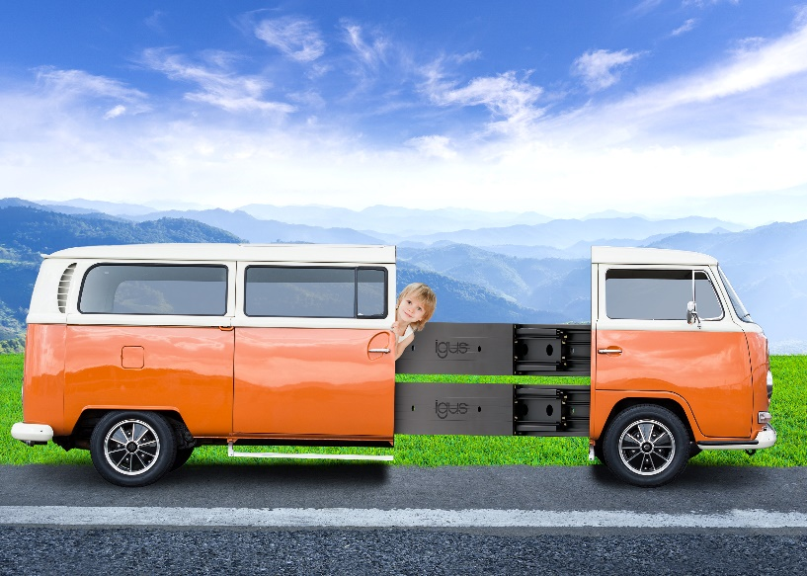
Picture PM4321-1
New lightweight drylin NT telescopic rail from igus provides more design freedom in small installation spaces. (Source: igus GmbH)
ABOUT IGUS:

igus GmbH develops and produces motion plastics. These lubrication-free, high-performance polymers improve technology and reduce costs wherever things move. In energy supplies, highly flexible cables, plain and linear bearings as well as lead screw technology made of tribo-polymers, igus is the worldwide market leader. The family-run company based in Cologne, Germany, is represented in 35 countries and employs 4,150 people across the globe. In 2020, igus generated a turnover of €727 million. Research in the industry's largest test laboratories constantly yields innovations and more security for users. 234,000 articles are available from stock and the service life can be calculated online. In recent years, the company has expanded by creating internal startups, e.g. for ball bearings, robot drives, 3D printing, the RBTX platform for Lean Robotics and intelligent "smart plastics" for Industry 4.0. Among the most important environmental investments are the "chainge" programme – recycling of used e-chains - and the participation in an enterprise that produces oil from plastic waste (Plastic2Oil).

PRESS CONTACT:

Oliver Cyrus Anja Görtz-Olscher
Head of PR and Advertising Manager PR and Advertising

igus® GmbH igus® GmbH
Spicher Str. 1a Spicher Str. 1a
51147 Cologne 51147 Cologne
Tel. 0 22 03 / 96 49-459 Tel. 0 22 03 / 96 49-7153
ocyrus@igus.net agoertz@igus.net
www.igus.de/presse www.igus.de/presse

The terms "igus", “Apiro”, "chainflex", "CFRIP", "conprotect", "CTD", “drygear”, "drylin", "dry-tech", "dryspin", "easy chain", "e-chain", "e-chain systems", "e-ketten", "e-kettensysteme", "e-skin", "e-spool”, "flizz", “ibow”, “igear”, "iglidur", "igubal", “kineKIT”, "manus", "motion plastics", "pikchain", "plastics for longer life", "readychain", "readycable", “ReBeL”, "speedigus", "tribofilament“, "triflex", "robolink", “xirodur”, and "xiros" are protected by trademark laws in the Federal Republic of Germany and internationally, where applicable.

