Evolution of the trapezoidal thread: new igus standard achieves 82 percent efficiency
Harmonised lead screws and lubrication-free lead screw nuts extend service life by 30 percent

Even tried and tested structures have potential for improvement. One example is the classic trapezoidal thread, which igus has refined. Thanks to a special geometric interaction between the lead screw nut, which requires no lubrication or maintenance, and the metal lead screw, dryspin technology promises a long service life, improved efficiencies, low wear and less movement noise. Now dryspin lead screw technology is available in eight new installation sizes.

Trapezoidal threads have been mechanical engineering classics for decades. The machine elements convert rotary motion into linear motion - in such applications as window and door drives, format adjustments in production plants and laboratory technology. However, almost every classic has potential for improvement. "We have tackled a market standard, and are able to say that we can do even better", says Thorben Hendricks, Head of the dryspin Lead Screw Drive Business Unit at igus. The motion plastics specialist relies on optimised interaction between the metal lead screw and the plastic lead screw nut geometries.
30 percent longer service life, 82 percent efficiency
At igus, the nut's thread flanks are larger than those of classic trapezoidal threads, as is the width of the lead screw. This is a small change, but it has major consequences: enlarging the thread flank results in more high-performance plastic being used for power transmission. This means more material that is tribologically optimised, i.e. regarding friction and wear. "The asymmetry has enabled us to extend the service life so that it is about 30 percent longer than that of symmetrical trapezoidal threads", Hendricks says. Optimising the flank angle also increases the amount of energy supplied that can actually be used. We have flattened the flank angles of the lead screw nut and lead screw. This gives us above-average efficiency - up to 82 percent at high pitches."

Lead screws work almost noiselessly and with low vibration
However, the new dryspin thread technology is not only durable and efficient, but also quieter than many conventional trapezoidal threads. This is due to the fact that the tooth flanks are not angular, but rounded, reducing the contact area between lead screw nut and lead screw. This leads to less vibration, which can take the form of rattling or squeaking. Hendricks remarks: "The rounded tooth flanks allow the lead screws to move without vibration and almost silently. The lead screw manufacturing tolerance is tighter than that specified in DIN 103 7e, ensuring more precise operating behaviour and allowing for much higher speeds in the application."

Eight installation sizes added to the dryspin lead screw technology portfolio
igus began establishing its own lead screw technology on the market in 2013, initially as an alternative to high helix threads. Now there are eight new installation sizes - harmonised lead screws and lead screw nuts, including dimensions with low pitches that enable quick one-to-one replacement of installed trapezoidal threads. The new lead screws are available with pitches of 6.35x6.35 RH, 8x40 RH, 10x3 LH, 12x25 LH, 14x4 RH, 16x5 RH, 18x4 RH and 20x10 RH. The lead screws are made of stainless steel or aluminium; the lead screw nut material can be selected from seven high-performance plastics and several geometries - from a cylindrical design with flange or spanner flats to a version with spring pre-load.

Caption:

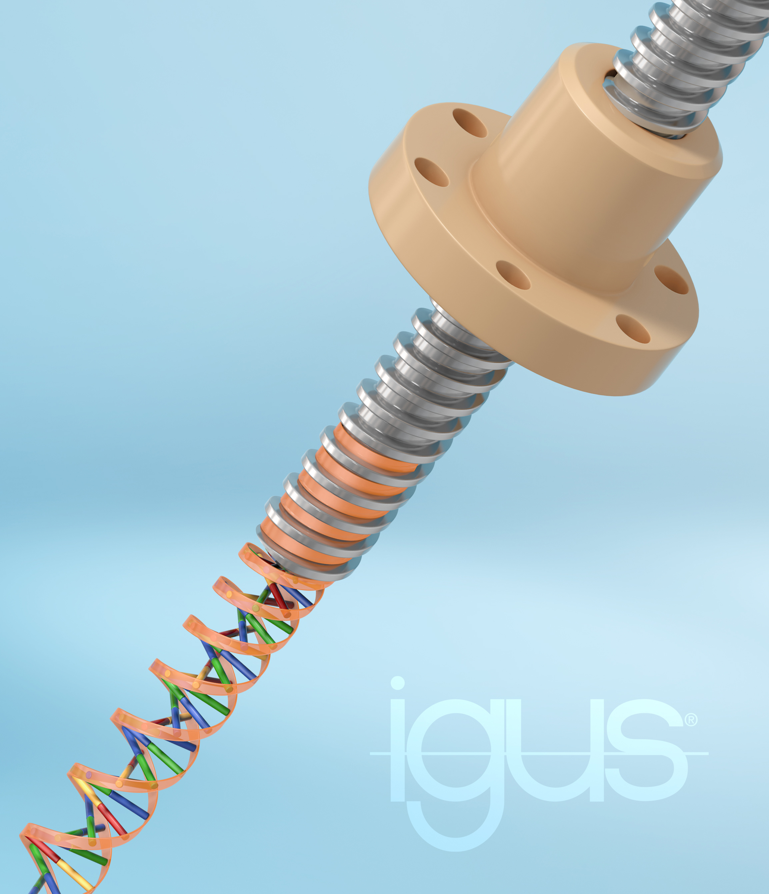
Picture PM1022-1
The evolution of the trapezoidal thread: low wear and noise, but instead a long service life and high efficiency. That is what igus promises with its dryspin technology (Source: igus GmbH)

PRESS CONTACT:

Alexa Heinzelmann
Head of International Marketing

igus® GmbH
Spicher Str. 1a
51147 Cologne
Tel. 0 22 03 / 96 49-7272
aheinzelmann@igus.net
www.igus.eu/press

ABOUT IGUS:

igus GmbH develops and produces motion plastics. These lubrication-free, high-performance polymers improve technology and reduce costs wherever things move. In energy supplies, highly flexible cables, plain and linear bearings as well as lead screw technology made of tribo-polymers, igus is the worldwide market leader. The family-run company based in Cologne, Germany, is represented in 35 countries and employs 4,900 people across the globe. In 2020, igus generated a turnover of €727 million. Research in the industry's largest test laboratories constantly yields innovations and more security for users. 234,000 articles are available from stock and the service life can be calculated online. In recent years, the company has expanded by creating internal startups, e.g. for ball bearings, robot drives, 3D printing, the RBTX platform for Lean Robotics and intelligent "smart plastics" for Industry 4.0. Among the most important environmental investments are the "chainge" programme – recycling of used e-chains - and the participation in an enterprise that produces oil from plastic waste.

The terms "igus", “Apiro”, "chainflex", "CFRIP", "conprotect", "CTD", “drygear”, "drylin", "dry-tech", "dryspin", "easy chain", "e-chain", "e-chain systems", "e-ketten", "e-kettensysteme", "e-skin", "e-spool”, "flizz", “ibow”, “igear”, "iglidur", "igubal", “kineKIT”, "manus", "motion plastics", "pikchain", "plastics for longer life", "readychain", "readycable", “ReBeL”, "speedigus", "tribofilament“, "triflex", "robolink", “xirodur”, and "xiros" are protected by trademark laws in the Federal Republic of Germany and internationally, where applicable.

