Record year exceeded thanks to 188,000 active customers - igus increases delivery capacity and grows by 32%

Cologne, Germany, 22nd March 2022 - Customers of motion plastics products - from drive cables to gears - continued to receive a very high proportion of their orders quickly in 2021. The 2019 plan to invest in production and supply chain helped meet the surge in demand. This intense scale-up will continue until 2023, also with a view to the Ukraine conflict. The enterprise's goal gained focus: improve what moves in a CO2-neutral manner, with zero plastic waste and become "the easiest company to deal with."

"234 million Euro more sales in one year, with almost the same selling prices until the end of the year, and everything produced as well as sourced in-house - we've never had that before", says Frank Blase, CEO. "Our colleagues achieved miracles. And we were lucky to realise our investment plans even in the weak year 2020." The turnover in 2021 amounted to 961 million Euros.

32% more turnover than in 2020 also means 26% more than in the record year 2019. This year also saw the beginning of the implementation of the plan that is internally referred to "No. 1 Catalogue": more than 80,000 items have since been in stock additionally or in higher quantities. In 15 global distribution centres, the rate of catalogue products shipped the same day or within 24 hours increased to at least 25%. "That's probably why the sales growth is almost the same across all product lines", Blase said. The online shops also experienced improvements. Online sales increased by 55% in 2021. "Customers need to be able to decide immediately on the web whether the plastic solution is usable, and then have it delivered quickly. That's part of the ‘easiest company to deal with’ goal”, according to Frank Blase.

500 new injection-moulding machines - major investments continue
The war in Ukraine and the shortages in many markets are causing igus to invest even more in material availability in the short term. At the same time, the company continues to invest in higher production capacities. Since 2020, production in Cologne has been increased or modernized by 300 injection-moulding machines. A further 200 have been ordered. The new production building in Cologne with an additional 20,000m² of production space is expected to be completed on May 1st, 2023. New storage locations for 12,000 pallet positions were already built in 2021. Plans for a further expansion of the "igus Campus Cologne", for which igus acquired adjacent areas of 20,000m², are currently in progress. At the 35 foreign subsidiaries, the expansions amounted to a total area of 60,000m².

168 innovations - higher output in chip production
Customers from over 50 industries constantly approach igus with new challenges. One example are cleanroom cables for chip production: "Novel flexible cable solutions such as the e-skin flat are in high demand, especially in the booming semiconductor industry", says Peter Mattonet, Industry Manager Cleanroom at igus. "Being able to replace a cable in a matter of minutes is a revolution for manufacturing, and increases much-needed output."

The speed of innovation at igus did not slow down in the second year of home office and remote work - this is demonstrated by 168 product developments, such as the motion plastics gears manufactured via injection moulding, with 740 different items available in the online shop. The four-year-old smart plastics Business Unit launched twelve new products for condition monitoring, preventive maintenance and IoT in 2021 alone. In combination with real-time cable monitoring for Ethernet cables and the integrated, solar-powered "EC.I" condition sensor, customers can now completely avoid unexpected machine shutdowns.

Digitisation - do-it-yourself engineering on the web 5,000 times a day
Low-cost robot integration via online consultation and at a fixed price - this promise is fulfilled by RBTXpert, which igus launched in 2021 as digital + human service. In a 400m² customer testing area, experts check customer requirements before they are offered. Costs for typical solutions amount to €8,500 for hardware and 20 hours of integration work, which means a few months' worth payback time. Internationally, the service is already available in seven countries, with another 14 in the pipeline. Three new online tools brought the total of these online services to 58. "Our customers' do-it-yourself engineering in the web doubled last year to 5,000 value-added uses per day", says Frank Blase.

Progress - climate-neutral, resource-saving, recycled
On the way to a climate-neutral production by 2025 - now at 95% in Scope 1 and 2 (Greenhouse Gas Protocol) - igus tackled various projects last year: a total of 100 older injection-moulding machines were replaced with 40% more energy-efficient models; energy management was further optimised and an ISO certificate for this will follow end of March. igus planted 15,687 trees in 23 countries. Plastic waste in production that cannot be directly recycled was reduced by 21%. The global energy chain recycling programme chainge also grew in recent years, and was rolled out internationally. This spring, igus will present its first energy chain product made from 100% recycled materials from the chainge programme.

A lubrication-free world
The company will be presenting these and over 100 other motion plastics innovations of spring 2022 from April onwards, when the igus motion plastics show enters Year 3.

Says Frank Blase: "At the moment, of course, we are all moved by the plight of people at war and the immense political struggle in the world. But in addition to many relief efforts, we're trying to continue focussing on technical progress." Improving the world of motion with motion plastics - that is the dream of igus. For example, with freedom from lubrication. According to company figures, one litre of oil in the environment contaminates one million litres of drinking water. 22.7 million tons of lubricants pollute soils and waters worldwide each year, says a 2006 figure. More and more customers are approaching igus in search of a lubrication-free solution. "We hope to see each other at trade shows, and we look forward to finding many igus innovations there - including very different ones, in mobility."

Captions:
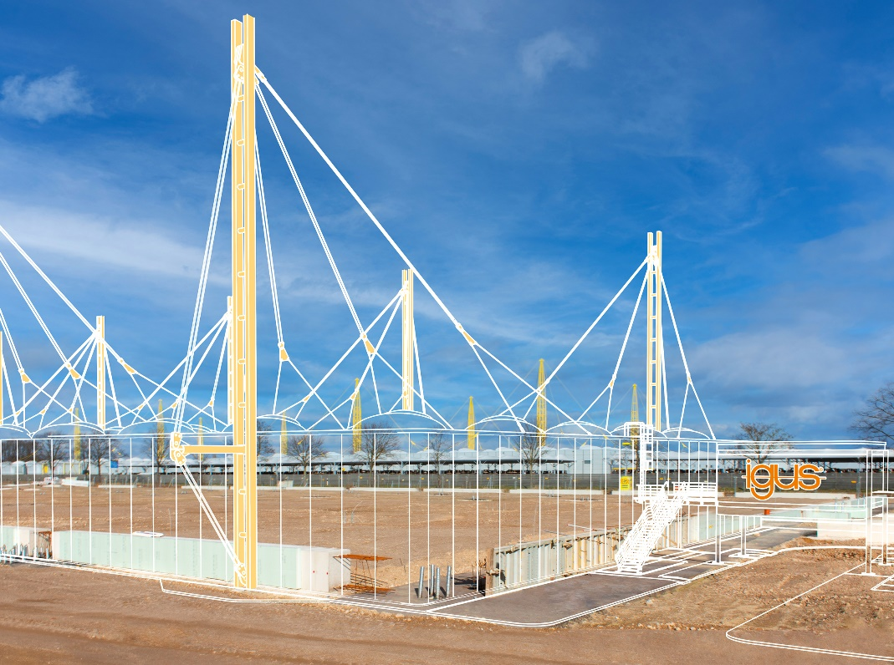
Picture PM1322-1
32% growth and 80,000 more products available from stock - igus GmbH continues to invest in production and delivery capacity: another 20,000m² factory space are under construction at the igus Campus Cologne (see picture, completion May 2023). (Source: igus GmbH)

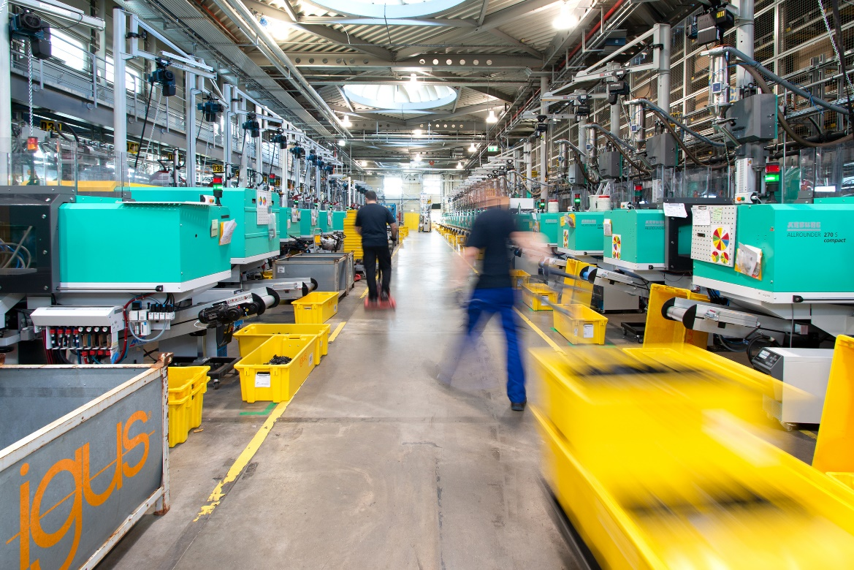

Picture PM1322-2
A total of 500 new injection-moulding machines are being installed at igus GmbH in Cologne, while 100 older ones have been replaced with 40% more energy-efficient models. By 2025, igus wants its production to be climate-neutral – 95% have been reached already. (Source: igus GmbH)

