Play before Pay: igus increases the simplicity of Low Cost Automation with apps, metaverse and new cobots
igus will present next-level engineering through digital innovation at Hannover Messe 2023

igus is stepping up the pace of Low Cost Automation and making entry into automation easier and more affordable than ever before. The interaction of inexpensive hardware and digital innovation puts the future of automation within reach. Here is some evidence for this: the ReBeLmini, a cobot for 3,999 euros and the RBTXperience software for easy commercial robot programming. The virtual iguversum offers the perfect playground to get robot applications and programming up and running with ease and then make them a reality.

The Hannover Messe is always an important meeting place for the latest developments in the industry. This year, too, igus is presenting digital products and solutions that help companies improve their products and cut costs. An example of Low Cost Automation: New cobots, software, and virtual parallel worlds ensure that even robotics novices can get started with inexpensive automation in a very short time. The hardware starting point is an igus plastic robot, such as the new ReBeLmini, a real plug-and-play cobot at a price of only 3,999 euros, including control software and power supply. This robot works with five axes, weighs 4kg, has a reach of 310mm, moves loads of up to 0.5kg, and achieves seven picks per minute with a repeatability of +/- 1mm. The ReBeLmini is particularly suitable for use in restricted space such as those in test automation or camera quality control, and can also be used overhead.

Next-level engineering with digital tools
Newly developed igus digital tools help companies configure, integrate, and control their individual robotics hardware quickly and easily. According to the "Play before you pay" idea, the new RBTXperience software enables users to combine and test cameras, grippers, and robots, but also machine frames and conveyor belts, in with 3D model – as simply as in a computer game. The components and superstructures can be dragged and dropped however the designer wishes, always with a compatibility guarantee and an instant price. CAD files can be downloaded to your own planning software with a single click. "At the start of the Hannover Messe, we will save to our database every automation solution configured in the online tool and make them available to other customers as a design template. This gives us a huge design community," says Alexander Mühlens, Head of Low Cost Automation Business Unit at igus. More than 300 solutions are already available on the RBTX online marketplace as a source of inspiration for immediate imitation, 95 percent of which have an investment cost of less than 12,000 euros. But igus simplifies not only the configuration, but also the control of Low Cost Automation. igus offers intuitive software for defining ReBeL robot movement sequences within 30 to 60 minutes – even without programming knowledge. The new AnyApp software will also be presented at Hannover Messe 2023. It allows this intuitive programming for other robots as well. AnyApp is particularly well-suited to companies that combine robots from different manufacturers into automation solutions, but do not want to learn multiple control software packages.

The iguversum: Playfully achieve top engineering performance in the virtual world
Another development step is the iguversum, which can be experienced at the new "igus digital" stand in Hall 17. Users from all over the world can interact and collaborate virtually on projects without being physically present. This not only saves time, but is also more sustainable because there is no need to travel. The iguversum is a collaboration world and a digital tool that can support companies in all technical developments. Extended reality (XR) technologies such as virtual reality (VR) and augmented reality (AR) allow automation solutions to be planned, controlled and tested in virtual space. This enables employees to remotely access hazardous or awkward work environments without physically being on site.
This gives companies the opportunity to make their working environment safer, generating greater employee satisfaction and motivation and making it easier to recruit new specialists. "In the future, we will see how people working collaboratively in the metaverse and controlling robots remotely from virtual worlds. This will change the way we work together," says Marco Thull, Senior Marketing Activist for igus GmbH. igus will offer companies digital tools such as simulations, forecasts and data analysis, going beyond what Low Cost Automation can do to make their processes faster and cheaper. "New technology is never ending. We must continue to focus on these questions: What does the customer get out of it? Is it helpful or can we get rid of it?” says Thull. "The interaction of inexpensive hardware, software and XR in connection with artificial intelligence will enable customers to continuously improve their machines and systems and quickly adapt them to the needs of their customers – an enormous competitive advantage."

Caption:

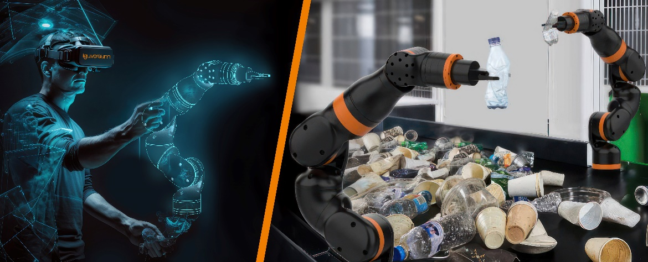
Picture PM1123-1
Play before you pay: Virtually configure the ReBeL in the iguversum, the new igus digital tool and control it remotely – just one of many options that will make it even easier for igus robotics users to get started with Low Cost Automation in the future. (Source: igus GmbH)

PRESS CONTACT:

Alexa Heinzelmann
Head of International Marketing

igus® GmbH
Spicher Str. 1a
51147 Cologne
Tel. 0 22 03 / 96 49-7272
aheinzelmann@igus.net
www.igus.eu/press

ABOUT IGUS:

igus GmbH develops and produces motion plastics. These lubrication-free, high-performance polymers improve technology and reduce costs wherever things move. In energy supplies, highly flexible cables, plain and linear bearings as well as lead screw technology made of tribo-polymers, igus is the worldwide market leader. The family-run company based in Cologne, Germany, is represented in 31 countries and employs 4,900 people across the globe. In 2021, igus generated a turnover of €961 million. Research in the industry's largest test laboratories constantly yields innovations and more security for users. 234,000 articles are available from stock and the service life can be calculated online. In recent years, the company has expanded by creating internal startups, e.g. for ball bearings, robot drives, 3D printing, the RBTX platform for Lean Robotics and intelligent "smart plastics" for Industry 4.0. Among the most important environmental investments are the "chainge" programme – recycling of used e-chains - and the participation in an enterprise that produces oil from plastic waste.

The terms "igus", “Apiro”, "chainflex", "CFRIP", "conprotect", "CTD", “drygear”, "drylin", "dry-tech", "dryspin", "easy chain", "e-chain", "e-chain systems", "e-ketten", "e-kettensysteme", "e-skin", "e-spool”, "flizz", “ibow”, “igear”, "iglidur", "igubal", “kineKIT”, "manus", "motion plastics", "pikchain", "plastics for longer life", "readychain", "readycable", “ReBeL”, "speedigus", "tribofilament“, "triflex", "robolink", “xirodur”, and "xiros" are protected by trademark laws in the Federal Republic of Germany and internationally, where applicable.

