igus investment paves the way for innovative plastics recycling technology
HydroPRS pioneer Mura Technology begins construction of the world's first commercially operated hydrothermal upgrading plastic recycling plant in the UK

Use instead of waste: Hydrothermal Plastic Recycling Solution (HydroPRS), plastic waste that would otherwise pollute the environment, can be reused as a valuable raw material through chemical recycling within 25 minutes. To advance this revolutionary technology worldwide, motion plastics specialist igus is now increasing its investment in Mura Technology to around 5 million euros. Another major industrial partner, KBR, partnered with Mura in January.

It is one of the most pressing challenges of our time: 8 million tonnes of plastic enters the world's oceans every year; much of the plastic is incinerated and only 14 per cent is recycled. This results in an economic loss of 80 billion dollars per year. At the same time, new plastic is continuously being produced from petroleum, which is associated with high CO₂ emissions. This use already accounts for 6 per cent of global oil production, which is expected to increase to 20 per cent by 2050. With the “Hydrothermal Plastic Recycling Solution” (HydroPRS for short) a groundbreaking new technology is waiting in the wings that will enable an entry into a sustainable circular economy for plastics. HydroPRS has the potential to recycle all types of plastic and prevent plastic from being burned or landfilled and polluting the environment. It is estimated that each tonne of plastic processed via advanced recycling could save 1.5 tonnes of CO₂ compared to incineration. To convert plastic waste into valuable chemicals and oil, HydroPRS utilises the Catalytic Hydrothermal Reactor technology (Cat-HTR™) developed by Licella Holdings Limited using water, heat and pressure. This method is particularly interesting where mechanical recycling has not been successful so far, for example, with mixed and contaminated plastics.
Valuable resource instead of harmful waste
This potential has excited motion plastics specialist igus, who last year invested in a company that plans to commission the first commercial HydroPRS plant in 2022. Now igus has increased its investment in Mura Technology to a total of €5 million. "We know about the great possibilities that plastic has. Our tribo-polymers are used millions of times in moving applications all over the world, where they reduce weight, maintenance and lubrication", says Frank Blase, Managing Director of igus. "We're helping to make plastic a material that does not harm our world but helps through almost 100% recycling." Mechanical recycling is an important step in this direction. For example, igus has been regranulating 99 per cent of the plastic waste generated in production for over 50 years. At the end of 2019, igus additionally initiated the chainge programme: igus takes back energy chains at the end of a machine's life, irrespective of the manufacturer, pays a voucher, regranulates the plastic and then processes it again. "In the future, chemical recycling will be able to play out its advantages where classic recycling cannot get anywhere. That is why we are supporting Mura in this start-up phase to help this groundbreaking technology achieve a breakthrough worldwide."

Global success through investment and co-operation
Mura Technology has now also succeeded in appointing KBR as an exclusive licence partner for further expansion. KBR, with its 28,0000 employees, is active in more than 80 countries, among other things as a planner, plant builder and operator of refineries and chemical plants. "We knew that as a start-up company we had developed a highly innovative and promising technology", Oliver Borek, Managing Director Europe at Mura Technology, points out. "However, it was also clear to us that we would never be able to roll it out on a large scale under our own steam. Thanks to igus' investment in this crucial phase, as well as the establishment and expansion of further partnerships, we now have this opportunity." Construction of the first HydroPRS plant by Mura at the UK's Wilton International industrial site has now started and is expected to be operational in the second half of 2022. A total of four Catalytic Hydrothermal Reactors will be built there to process over 80,000 tonnes of plastic waste annually. In addition, further plants are planned in Germany, the USA and Asia.

You can see how plastic can be recycled with HydroPRS in this video:
https://www.youtube.com/watch?v=eouFBpVVGEQ

Caption:

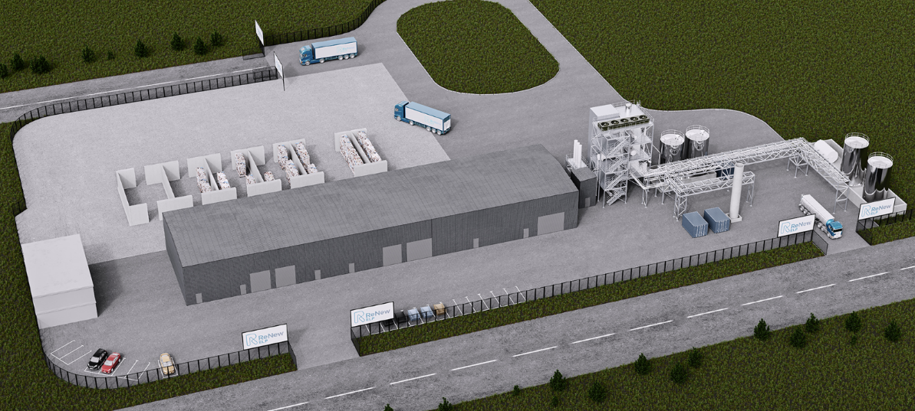
Picture PM1321-1

HydroPRS has the potential to recycle all types of plastic, making it even more sustainable. The world's first HydroPRS system is currently being built at the British industrial site Wilton International. (Source: Mura Technology)

PRESS CONTACT:  Oliver Cyrus  Head of PR and Advertising  Anja Görtz-Olscher  PR and Advertising  igus® GmbH  Spicher Str. 1a  51147 Cologne  Tel. 0 22 03 / 96 49-459 or -7153  Fax 0 22 03 / 96 49-631  ocyrus@igus.net  agoertz@igus.net  www.igus.eu/press | ABOUT IGUS:  igus GmbH develops and produces motion plastics. These lubrication-free, high-performance polymers improve technology and reduce costs wherever things move. In energy supplies, highly flexible cables, plain and linear bearings as well as lead screw technology made of tribo-polymers, igus is the worldwide market leader. The family-run company based in Cologne, Germany, is represented in 35 countries and employs 3,800 people across the globe. In 2019, igus generated a turnover of €764 million. Research in the industry's largest test laboratories constantly yields innovations and more security for users. 234,000 articles are available from stock and the service life can be calculated online. In recent years, the company has expanded by creating internal startups, e.g. for ball bearings, robot drives, 3D printing, the RBTX platform for Lean Robotics and intelligent "smart plastics" for Industry 4.0. Among the most important environmental investments are the "chainge" programme – recycling of used e-chains - and the participation in an enterprise that produces oil from plastic waste. (Plastic2Oil).

The terms "igus", “Apiro”, "chainflex", "CFRIP", "conprotect", "CTD", “drygear”, "drylin", "dry-tech", "dryspin", "easy chain", "e-chain", "e-chain systems", "e-ketten", "e-kettensysteme", "e-skin", "e-spool”, "flizz", “ibow”, “igear”, "iglidur", "igubal", “kineKIT”, "manus", "motion plastics", "pikchain", "plastics for longer life", "readychain", "readycable", “ReBeL”, "speedigus", "tribofilament“, "triflex", "robolink", “xirodur”, and "xiros" are protected by trademark laws in the Federal Republic of Germany and internationally, where applicable. The terms “HydroPRS” and “Cat-HTR” are protected by trademark laws in the United Kingdom and where applicable internationally.

Plastic Oceans UK, https://plasticoceans.uk
The Ellen McArthur Foundation – the New Plastics Economy: Catalysing Action, 2017

