For more sustainable mobility: igus presents the igus:bike concept at 2022 Olympic Rally
As part of the 2022 Olympic Rally Revival, igus presents a concept for sustainable urban mobility

'From ocean plastics to motion plastics' is the goal pursued by the specialist for high-performance plastics with the igus:bike project - the concept of a bicycle that is made from over 90 percent plastic. The highlight of the project is that the bicycle in theory can be made from recycled plastic waste such as discarded fishing nets. This allows the marine plastic of yesterday to create the mobility of tomorrow. For the joint development of a first bicycle model, igus has invested in the Dutch start-up mtrl. The motion plastics specialist is now presenting this model and the concept behind the igus:bike project in the marine conservation city of Kiel at the start of the 2022 Olympic Rally Revival .

Kiel is an interesting topic due to its proximity to the Baltic Sea and marine protection policies. Advocating for a clean future is a concern that the Cologne-based company igus also shares. After all, responsibility towards the environment and the revised handling of plastics does not pass by industry without a trace either. This is a key reason as to why igus pursues the goal of extending the life cycle of products and therfore conserving valuable resources - for example, by recycling disused energy chains. Among other things, the igus:bike project was launched out of this motivation: the concept of a lubrication-free and maintenance-free all-plastic bicycle that can also be made from recycled plastic waste. igus has now presented the first model and the sustainable concept behind the project in Kiel - the starting point of the climate-neutral 2022 Olympic Rally. The modern reinterpretation of the event supports the Bergwaldprojekt e.V. association in the Harz Mountains and is part of the celebrations on the occasion of the 50th anniversary of the 1972 Olympic Games in Munich and Kiel.

Mobility according to the virtually zero waste principle
The igus motion plastics have been used successfully in the mobility sector for decades - whether automotive, shipping, aircraft or bicycle industry. With the igus:bike project, igus is striving for a solution for modern mobility and environmental pollution caused by plastic waste. The concept: an all-plastic bicycle that is completely lubrication-free, rust-free and maintenance-free and can therefore stand outdoors in any weather and is intended to offer transportation for generations of people. If the bicycle reaches the end of its service life at some point or if a new frame size is required, the plastic can be regranulated and a new bicycle can be built from it. The first model was developed together with the Dutch start-up mtrl, which has been producing bicycles with plastic frames and wheels for several years. The first prototype was created in combination with the know-how of igus and the motion plastics components further developed for the new application. The special feature is that a large part of the required raw materials can be covered by recycling plastic waste.

Sustainability - the production process also counts
The start-up mtrl also takes a sustainable approach to the production process, as the plastic can be recycled and reshaped on site with little energy expenditure. To achieve this, mtrl relies entirely on renewable energies in its own laboratory in Nijkerk, for e.g., through solar cells on the roof, in order to keep the CO2 footprint as low as possible. For production, mtrl uses specially built machines with lubrication-free and durable igus components. The plastic is formed by rotomoulding or rotary casting process with low pressure and high temperature, which combines heat and biaxial rotation. The bicycle is made from soft plastics such as, for e.g., polyethylene (PE). The aim is to build local production sites around the world near landfills in the future, thus creating a sustainable and transparent supply chain. The firm mtrl will start production of the mtrl.bike by the end of this year. The market launch in Germany is planned for early 2023.

Know-how platform for plastic bike
But there is even more to the igus:bike concept: with the launch, the doors are open for further partnerships. “With the igus:bike platform, we want to promote know-how about plastics in the global bicycle industry,” explains Alexander Welcker, Bicycle Industry Manager at igus. “This allows us to implement and further develop the concept with many other bicycle and component manufacturers. Our vision is to make plastic a valuable and sustainable resource and to promote the circular economy internationally. The handling of plastic can then also change positively in many other areas."

Caption:

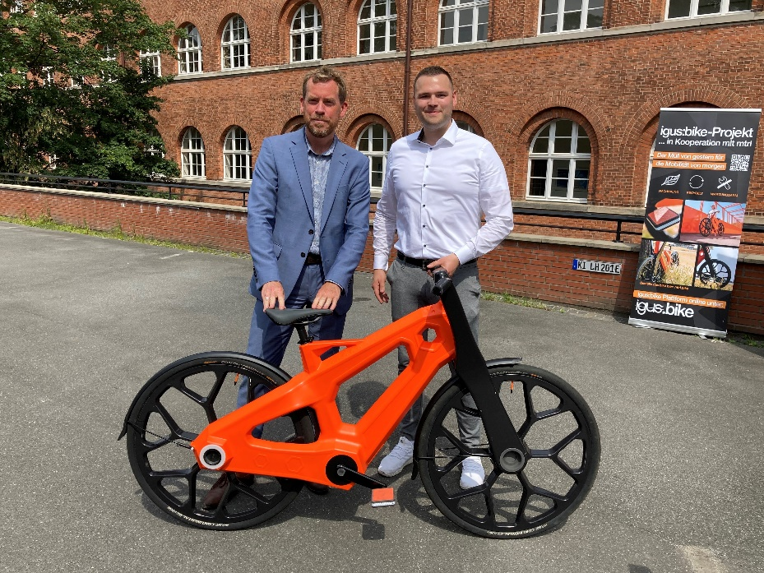
Picture PM4222-1
At the start of the Olympic Rally, Mayor of Kiel Dr. Ulf Kämpfer (left) and Alexander Welcker, Bicycle Industry Manager at igus (right), jointly presented the first model of a bicycle that consists of over 90 percent plastic.
(Source: igus GmbH)

PRESS CONTACT:

Alexa Heinzelmann
Head of International Marketing

igus® GmbH
Spicher Str. 1a
51147 Cologne
Tel. 0 22 03 / 96 49-7272
aheinzelmann@igus.net
www.igus.eu/press

ABOUT IGUS:

igus GmbH develops and produces motion plastics. These lubrication-free, high-performance polymers improve technology and reduce costs wherever things move. In energy supplies, highly flexible cables, plain and linear bearings as well as lead screw technology made of tribo-polymers, igus is the worldwide market leader. The family-run company based in Cologne, Germany, is represented in 35 countries and employs 4,900 people across the globe. In 2021, igus generated a turnover of €961 million. Research in the industry's largest test laboratories constantly yields innovations and more security for users. 234,000 articles are available from stock and the service life can be calculated online. In recent years, the company has expanded by creating internal startups, e.g. for ball bearings, robot drives, 3D printing, the RBTX platform for Lean Robotics and intelligent "smart plastics" for Industry 4.0. Among the most important environmental investments are the "chainge" programme – recycling of used e-chains - and the participation in an enterprise that produces oil from plastic waste.

The terms "igus", “Apiro”, "chainflex", "CFRIP", "conprotect", "CTD", “drygear”, "drylin", "dry-tech", "dryspin", "easy chain", "e-chain", "e-chain systems", "e-ketten", "e-kettensysteme", "e-skin", "e-spool”, "flizz", “ibow”, “igear”, "iglidur", "igubal", “kineKIT”, "manus", "motion plastics", "pikchain", "plastics for longer life", "readychain", "readycable", “ReBeL”, "speedigus", "tribofilament“, "triflex", "robolink", “xirodur”, and "xiros" are protected by trademark laws in the Federal Republic of Germany and internationally, where applicable.

