With anti-crushing effect, new igus clamps reliably secure pneumatic hoses
With the CFX clamp, the cross section is fully maintained and prevents damage occurring due to over-tightening
Classic clamps provide strain relief for pneumatic hoses in energy chains. But if they are over tightened, the hoses can be crushed. This can lead to a loss of performance. The answer from igus: a new CFX series clamp with high holding force, which at the same time makes over-tightening impossible.

Too tight and it breaks off - an age-old saying that applies not only to screws. The same applies to clamps. These clamps relieve the strain on cables and pneumatic hoses in the energy chains of machines and systems during movement and hold them in position. However, if technicians over tighten the clamps, the clamps press into the jacket surfaces and crush them, causing permanent cross-sectional changes. This can lead to uneven compressed air flows in pneumatic hoses and consequently to malfunctions. To avoid this, igus has expanded the CFX series with a new clamp model that does not compress the cables.

Time-consuming testing of the tightening torque is no longer necessary
At the heart of the new CFX clamps are the so-called pneumatic double tubs, blue inserts that enclose the hoses from top and bottom. When the technician turns the screw of the clamp, the clamp jaw does not press directly on the surface of the hose, but on the upper insert of the stacker saddle. As soon as it hits the lower insert, the optimum holding force is automatically achieved. The hose sits securely in position. Time-consuming checks of the tightening torque are no longer necessary. It is also mechanically impossible to accidentally apply too much pressure and damage the hose.

Combining stacker saddles: as easy as plugging in interlocking bricks
To provide protection for as many pneumatic hoses as possible, igus manufactures the blue stacker saddles in several sizes. The inserts, which the company previously produced for the design study using a 3D printer, are now available as cost-effective injection-moulded versions for cable diameters of 4, 6, 8, 10 and 12 millimetres. Additionally, to save space, it is even possible to position two hoses next to each other in a stacker saddle for cables with diameters of 4 and 6 millimetres. Therefore, up to ten hoses can be accommodated in one clamp.

PRESS CONTACT:

Alexa Heinzelmann
Head of International Marketing

igus® GmbH
Spicher Str. 1a
51147 Cologne
Tel. 0 22 03 / 96 49-7272
aheinzelmann@igus.net
www.igus.eu/press

ABOUT IGUS:

igus GmbH develops and produces motion plastics. These lubrication-free, high-performance polymers improve technology and reduce costs wherever things move. In energy supplies, highly flexible cables, plain and linear bearings as well as lead screw technology made of tribo-polymers, igus is the worldwide market leader. The family-run company based in Cologne, Germany, is represented in 35 countries and employs 4,150 people across the globe. In 2020, igus generated a turnover of €727 million. Research in the industry's largest test laboratories constantly yields innovations and more security for users. 234,000 articles are available from stock and the service life can be calculated online. In recent years, the company has expanded by creating internal startups, e.g. for ball bearings, robot drives, 3D printing, the RBTX platform for Lean Robotics and intelligent "smart plastics" for Industry 4.0. Among the most important environmental investments are the "chainge" programme – recycling of used e-chains - and the participation in an enterprise that produces oil from plastic waste.

The terms "igus", “Apiro”, "chainflex", "CFRIP", "conprotect", "CTD", “drygear”, "drylin", "dry-tech", "dryspin", "easy chain", "e-chain", "e-chain systems", "e-ketten", "e-kettensysteme", "e-skin", "e-spool”, "flizz", “ibow”, “igear”, "iglidur", "igubal", “kineKIT”, "manus", "motion plastics", "pikchain", "plastics for longer life", "readychain", "readycable", “ReBeL”, "speedigus", "tribofilament“, "triflex", "robolink", “xirodur”, and "xiros" are protected by trademark laws in the Federal Republic of Germany and internationally, where applicable.
Caption:

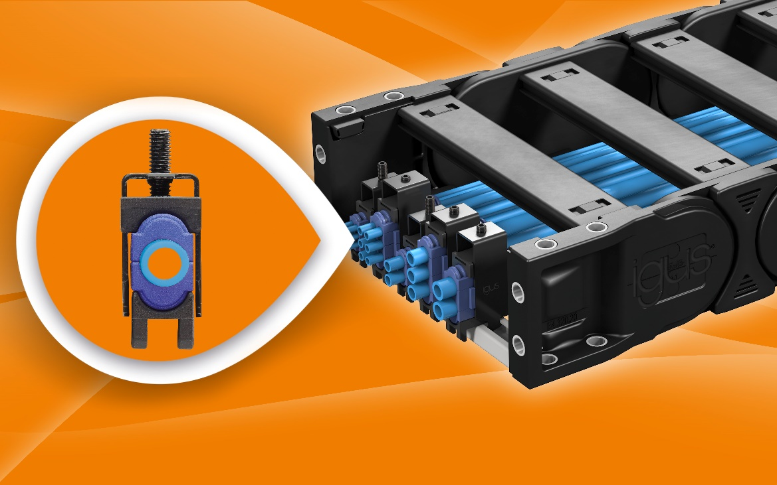
Picture PM0122-1
Clamp hoses without crushing: with the new clamps from igus, pneumatic hoses are reliably held in place. At the same time, their cross section remains fully intact (Source: igus GmbH)

