Lubrication-free rod ends: plastic-metal hybrid for higher loads in the food sector
igubal stainless-steel rod end bearings with iglidur A160 enable lubrication-free dry operation without risk of contamination
Constant relubrication of metallic bearing points in the food industry costs time, money and increases the risk of contamination. Maintenance-free igubal spherical bearings from igus are an economical and safe alternative. Now, the motion plastics specialist is introducing a new model for higher loads. It is equipped with a stainless-steel housing, a self-lubricating polymer inner ring and a stainless-steel spherical ball. This allows for higher-load applications to be converted to future-proof tribo-technology.

Rod ends are an indispensable part of machine and plant engineering for the food industry. They are used everywhere from filling plants to meat-processing machines and packaging systems, where they transmit dynamic forces to pivoting, tilting and rotating movements. In the process, the heads must be relubricated to guarantee low-friction movement between the slide ring and the spherical ball. A job that is not only time-consuming, but also increases the risk of contamination as dirt and dust easily form sticky coatings and solid lumps. "To ease the burden on food-processing plants while improving hygiene in their moving applications, we have expanded our range of igubal rod end bearings", explains igus Product Manager Thomas Preißner. "The new plastic-metal hybrid consists of a steel housing and spherical ball, and an inner ring made of the high-performance plastic iglidur A160, which meets the requirements of both the FDA and EU 10/2011."

Hygienic dry operation thanks to microscopic solid lubricants
As with all iglidur plastics, there is a solid lubricant in iglidur A160, which is released in microscopic amounts over time. It ensures a low-friction dry operation between the inner ring and the stainless-steel spherical ball. The absence of lubrication also significantly speeds up cleaning the rod ends. Without grease, dirt and dust have little chance of settling. To further increase food safety, the high-performance plastic iglidur A160 is designed in blue. This is a colour on which food residues and mould spores can be quickly detected during cleaning inspections. Moreover, the colour is optically detectable. "This high level of hygiene is also confirmed by the approval of the U.S. Food and Drug Administration (FDA), which follows one of the strictest hygiene guidelines in the world", says Preißner. "So does conformity with the EU 10/2011 guideline."

Not only clean, but also robust
However, the new igubal products are not only hygienic, but also robust, even in outdoor applications. They have a higher breaking strength and rigidity compared to a plastic rod end. In addition, they are resistant to moisture, acids, alkalines and UV rays and are suitable for temperatures between -40°C and +90°C. The abrasion resistance of iglidur A160 is also ten times better than that of polyamide according to results in the igus test laboratory - even with fast rotational movements of the mounted shaft. Thomas Preißner: "Users can therefore significantly increase the reliability of their systems with a modest investment." The new rod ends are available in sizes M6, M8, M10, M12, M16 and M20.

Caption:
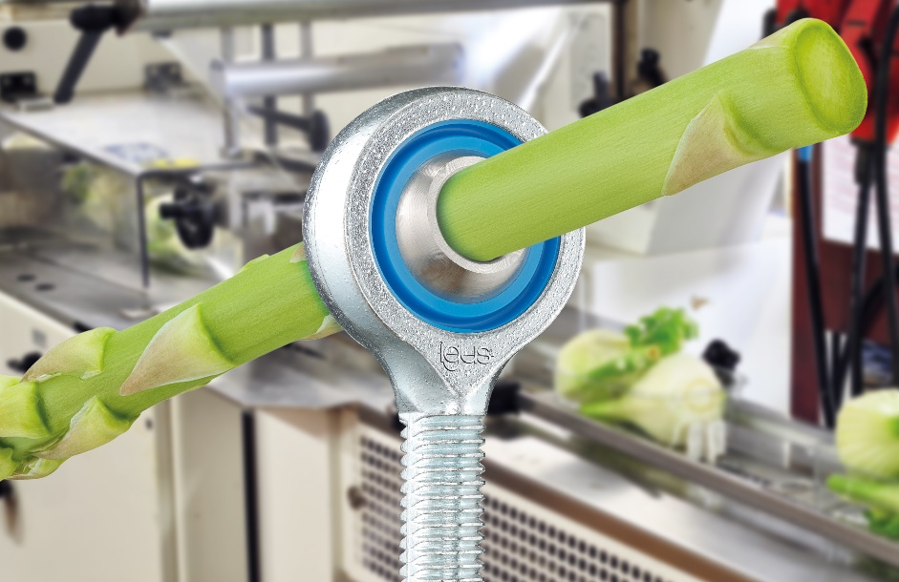
Picture PM0622-1
The lubrication-free and maintenance-free igubal rod end for higher-load applications in the food industry consists of a stainless-steel housing and spherical ball, as well as an inner ring made of the high-performance plastic iglidur A160, which conforms to the FDA and EU 10/2011 requirements. (Source: igus GmbH)
PRESS CONTACT:

Alexa Heinzelmann
Head of International Marketing

igus® GmbH
Spicher Str. 1a
51147 Cologne
Tel. 0 22 03 / 96 49-7272
aheinzelmann@igus.net
www.igus.eu/press

ABOUT IGUS:

igus GmbH develops and produces motion plastics. These lubrication-free, high-performance polymers improve technology and reduce costs wherever things move. In energy supplies, highly flexible cables, plain and linear bearings as well as lead screw technology made of tribo-polymers, igus is the worldwide market leader. The family-run company based in Cologne, Germany, is represented in 35 countries and employs 4,150 people across the globe. In 2020, igus generated a turnover of €727 million. Research in the industry's largest test laboratories constantly yields innovations and more security for users. 234,000 articles are available from stock and the service life can be calculated online. In recent years, the company has expanded by creating internal startups, e.g. for ball bearings, robot drives, 3D printing, the RBTX platform for Lean Robotics and intelligent "smart plastics" for Industry 4.0. Among the most important environmental investments are the "chainge" programme – recycling of used e-chains - and the participation in an enterprise that produces oil from plastic waste.

The terms "igus", “Apiro”, "chainflex", "CFRIP", "conprotect", "CTD", “drygear”, "drylin", "dry-tech", "dryspin", "easy chain", "e-chain", "e-chain systems", "e-ketten", "e-kettensysteme", "e-skin", "e-spool”, "flizz", “ibow”, “igear”, "iglidur", "igubal", “kineKIT”, "manus", "motion plastics", "pikchain", "plastics for longer life", "readychain", "readycable", “ReBeL”, "speedigus", "tribofilament“, "triflex", "robolink", “xirodur”, and "xiros" are protected by trademark laws in the Federal Republic of Germany and internationally, where applicable.

