RBTX marketplace gains leading cobot manufacturer Universal Robots as new partner
RBTX powered by igus continues to drive Low Cost Automation forward and adds UR cobots to its marketplace range

Robots have long been indispensable in the industry. However, small and medium-sized companies in particular are often faced with the question: how can a task be automated cost-effectively with little effort? Since 2019, the RBTX marketplace powered by igus, which brings together robotics providers and users, has been offering simple and inexpensive solutions. RBTX is now also cooperating with Universal Robots, one of the world market leaders for industrial and collaborative lightweight robots.
Flexible automation solutions and quick integration as well as intuitive operation - the RBTX marketplace and the leading cobot manufacturer Universal Robots are pursuing this common goal with their robotics range. To make effective use of synergies, the two companies have now announced the start of their partnership in Germany, Austria and Switzerland at Motek 2022 in Stuttgart as part of the RBTX range from plastics specialist igus. Through RBTX.com, the marketplace now collaborates with 70 companies that offer their robots, gripping systems, camera technology, conveyor belts, software and services on the online platform. The advantage: RBTX provides a compatibility guarantee for the entire range of software and hardware, so that users can always be sure that all components work together. "With Universal Robots, we have now gained another well-known partner through whom we can expand the product range on RBTX.com to include cobots for the first time - apart from igus's own robot ReBeL®," says Alexander Mühlens, Head of Automation Technology and Robotics Business Unit at igus. "Universal Robots is not only a pioneer for cobots, but also groundbreaking when it comes to the intuitive programming of robots. This fits perfectly into the concept of our marketplace for Low Cost Automation solutions, which can be implemented quickly and easily even without any previous knowledge. We are therefore very pleased that we were able to win Universal Robots as a partner." There are already numerous accessories on the marketplace, such as the seventh robot axis from igus, which can be combined with UR cobots.

Overcoming hurdles together
"Universal Robots offers easy-to-integrate automation solutions that enable customers to strengthen their competitiveness and achieve a fast return on investment - this fits in very well with RBTX's approach," says Andrea Alboni, General Manager Western Europe at Universal Robots. Alexander Mühlens adds: "As an open marketplace, we are always interested in new partners, as this allows us to offer even more individual solutions via our platform in the end. After all, we are pursuing the common goal of making automation as accessible as possible." In line with the "build or buy" principle, interested parties can find a ready-made robotics system at a fixed price on RBTX, or can put together individual components for their own solution. The marketplace also offers access to RBTXpert at any time - a remote integrator service for automation solutions at a fixed price. Together with the customer, the RBTXpert checks the feasibility of the planned application in a video chat (first hour free of charge) and shows the advantages of different kinematics. After the consultation, the customer receives a fixed-price offer - always with a focus on finding the most cost-effective working solution. The RBTXpert also helps with commissioning. At RBTX.com, everyone can find the right automation solution for their application within their budget - even without automation experience or programming knowledge. Thanks to the constantly growing partnership network, RBTX offers customers an ever larger Low Cost Automation universe - with the common goal of further reducing hurdles in automation.

Caption:

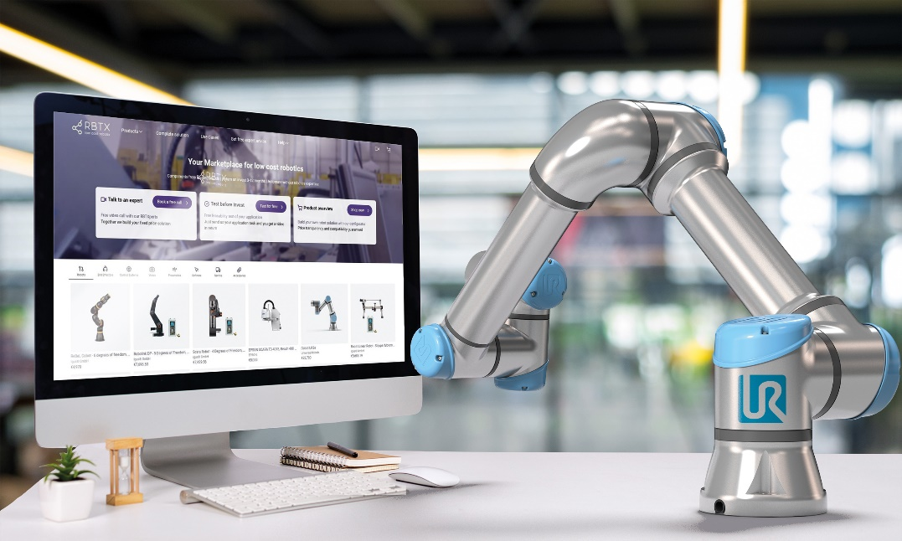
Picture PM5622-1
With Universal Robots, igus's RBTX online marketplace has gained an important partner and, with the UR cobots, now offers an even wider range of simple Low Cost Automation solutions. (Source: igus GmbH)

PRESS CONTACT:

Alexa Heinzelmann
Head of International Marketing

igus® GmbH
Spicher Str. 1a
51147 Cologne
Tel. 0 22 03 / 96 49-7272
aheinzelmann@igus.net
www.igus.eu/press

ABOUT IGUS:

igus GmbH develops and produces motion plastics. These lubrication-free, high-performance polymers improve technology and reduce costs wherever things move. In energy supplies, highly flexible cables, plain and linear bearings as well as lead screw technology made of tribo-polymers, igus is the worldwide market leader. The family-run company based in Cologne, Germany, is represented in 31 countries and employs 4,900 people across the globe. In 2021, igus generated a turnover of €961 million. Research in the industry's largest test laboratories constantly yields innovations and more security for users. 234,000 articles are available from stock and the service life can be calculated online. In recent years, the company has expanded by creating internal startups, e.g. for ball bearings, robot drives, 3D printing, the RBTX platform for Lean Robotics and intelligent "smart plastics" for Industry 4.0. Among the most important environmental investments are the "chainge" programme – recycling of used e-chains - and the participation in an enterprise that produces oil from plastic waste.

The terms "igus", “Apiro”, "chainflex", "CFRIP", "conprotect", "CTD", “drygear”, "drylin", "dry-tech", "dryspin", "easy chain", "e-chain", "e-chain systems", "e-ketten", "e-kettensysteme", "e-skin", "e-spool”, "flizz", “ibow”, “igear”, "iglidur", "igubal", “kineKIT”, "manus", "motion plastics", "pikchain", "plastics for longer life", "readychain", "readycable", “ReBeL”, "speedigus", "tribofilament“, "triflex", "robolink", “xirodur”, and "xiros" are protected by trademark laws in the Federal Republic of Germany and internationally, where applicable.

