A good combination: new linear and pivot guide from igus
drylin W linear guide with a PRT slewing ring bearing provides sliding and rotating adjustments

The new design study from igus can move linearly and rotate simultaneously. With the drylin W linear/pivot guide, armrests, trays and control panels on seats and armchairs, for example, can be easily adjusted as the user pleases. What previously had to be laboriously put together by the customer, is now ready for final assembly. In addition, the lubrication-free polymer sliding elements ensure quiet movements.

Popcorn, nachos, a litre of coke and a comfortable armchair, many people associate these with a cinema performance. To make a visit to the cinema even more varied, some operators rely on digital entertainment media. For example, on extendable tables and stools or on trays in the armrests of furniture. Now igus has developed a new product especially for use in multifunctional armchairs and seats: the drylin W linear/pivot guide. It allows users to move trays or displays forwards and backwards linearly as well as to rotate them using a bearing. "In addition to cinema, theatre and aircraft seats, the new drylin W guide is intended for applications in control cabins, such as in tractors or even on cranes. Wherever operating elements have to be moved flexibly and ergonomically in a compact space", explains Michael Hornung, igus drylin Linear and Drive Technology Product Manager. For the new development, igus simply combined two already existing and successfully proven products: a drylin W linear guide for linear motion with a PRT-04 slewing ring bearing for rotation. The bearing is already integrated in the carriage plate. For the user, this previously meant that both products had to be laboriously installed together. The carriage plate had to be machined to accommodate the slewing ring bearing and the cable feed-through, and all components had to be fitted precisely. Due to the directly coordinated and ready-to-install complete solution, the user saves costs for assembly and rework.

Quiet adjustment
Instead of ball guides, igus uses tribologically optimised high-performance polymers in the sliding elements of the linear carriage and the bearing. They are up to four times quieter than ball guides and at the same time lubrication-free and maintenance-free. By dispensing with additional lubricants and oils, the drylin W linear/pivot guide is insensitive to dust and dirt. Cleanliness is a major advantage for the frequent use of the guide by different people. "In addition to the practical functionality of our new product, we naturally also attached great importance to the design. Light materials such as plastic and aluminium are used. We use a decorative clear anodised coating for the rails", says Michael Hornung. At 40mm, the new design study has a very low-profile system height and can also be equipped with a manual clamp and individual pretension. This way the display stays in place after adjustment. Thanks to the drylin W modular system, the product can be adjusted to any length.

Caption:

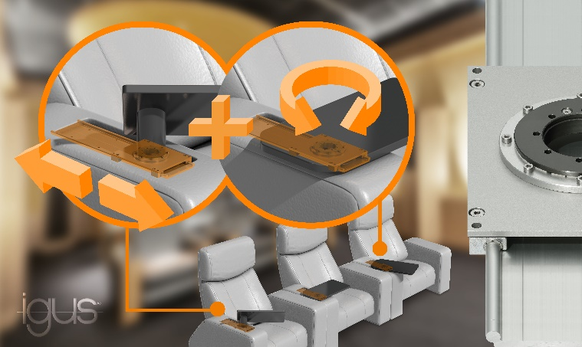
Picture PM2920-1
With the drylin W linear/pivot guide (right), trays on multifunctional armchairs can be adjusted to the user's liking. (Source: igus GmbH)

PRESS CONTACT:  Oliver Cyrus  Head of PR and Advertising  Anja Görtz-Olscher  PR and Advertising  igus® GmbH  Spicher Str. 1a  51147 Cologne  Tel. 0 22 03 / 96 49-459 or -7153  Fax 0 22 03 / 96 49-631  ocyrus@igus.net  agoertz@igus.net  www.igus.eu/press | ABOUT IGUS:  igus GmbH is a global leading manufacturer of energy chain systems and polymer plain bearings. The Cologne-based family business has offices in 35 countries and employs 4,150 people around the world. In 2019, igus generated a turnover of 764 million euros from motion plastics, plastic components for moving applications. igus operates the largest test laboratories and factories in its sector to offer customers quick turnaround times on innovative products and solutions tailored to their needs.

The terms "igus", “Apiro”, "chainflex", "CFRIP", "conprotect", "CTD", “drygear”, "drylin", "dry-tech", "dryspin", "easy chain", "e-chain", "e-chain systems", "e-ketten", "e-kettensysteme", "e-skin", "e-spool”, "flizz", “ibow”, “igear”, "iglidur", "igubal", “kineKIT”, "manus", "motion plastics", "pikchain", "plastics for longer life", "readychain", "readycable", “ReBeL”, "speedigus", "triflex", "robolink", “xirodur”, and "xiros" are protected by trademark laws in the Federal Republic of Germany and internationally, where applicable.

