Wear-resistant & lubrication-free: new igus bar stock for food, continuous operation and high media resistance
Round bars made of tribo-plastics are suitable for maintenance-free special components in a wide variety of environments

The company igus has expanded its wide range of iglidur round bars by no less than four materials; among them two for the food sector: the heat-resistant material iglidur AC500 and the resilient material A250. The extremely hard-wearing material iglidur H3 and the particularly wear-resistant endurance material iglidur E complete the product range. This makes it possible to mill and turn lubrication-free and maintenance-free prototypes and special components for a wide variety of applications.

For the production of special bushings, rollers and other sliding elements that come into contact with food, igus has developed iglidur AC500 - an FDA-compliant high-temperature material for the food industry that withstands extreme temperatures of up to 250°C. Thus, components made of AC500 are suitable, among other things, for sliding elements in baking lines. When a plain bearing made of AC500 rotates on a high-grade stainless-steel shaft, wear is only 0.16 micrometres per kilometre, as tests in the in-house test laboratory showed. In addition, the material has exceptionally high chemical resistance, so that it reliably withstands cleaning agents common to the food industry. Lubrication is not necessary in this case. A double advantage, as the risk of contamination and the maintenance effort are reduced.
Knife edge rollers made of iglidur A250 reduce energy consumption
The new iglidur A250 round bars are also predestined for the food and packaging industry. They are suitable, among other things, for the production of so-called knife edge rollers, which are used in the deflection of conveyor belts. In this function, the material reduces the drive power required and the energy consumption of the belts thanks to its low-friction, lubrication-free dry operation. In addition, the material impresses with its high load-bearing capacity. iglidur A250 is designed in such a way that it can be used for high belt speeds in the food and packaging industry. And just like AC500, A250 also has the approval for direct contact with food. The material complies with the hygiene guidelines of the US Food and Drug Administration (FDA) and EU Regulation 10/2011.
iglidur H3 withstands aggressive media
The H3, a material from which media-resistant components can be manufactured, has also been added to the iglidur bar stock product range. iglidur H3 was developed primarily for contact with aggressive media and the application in pumps, for example in fuel pumps. The material works reliably in these extreme applications thanks to its durability and low moisture absorption combined with a long service life.
iglidur E improves precision movements
The fourth new material is iglidur E. Among other things, this is used to manufacture plain bearings that dampen vibrations in combination with aluminium shafts. This specification improves precise and smooth movements of machines and equipment. The material also shows excellent wear properties in linear pivoting movements in the textile industry, packaging industry, printing industry and vending machinery.

Caption:

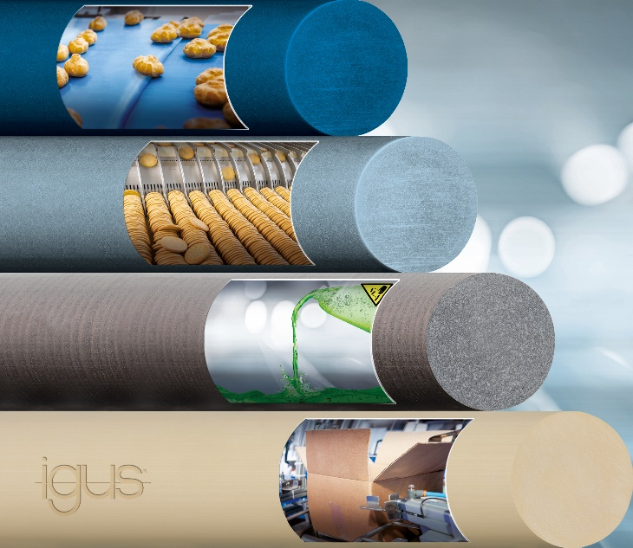
Picture PM0722-1
motion plastics specialist igus has developed four new bar stock products for lubrication-free and maintenance-free special parts in a wide variety of environments. (Source: igus GmbH)

PRESS CONTACT:

Alexa Heinzelmann
Head of International Marketing

igus® GmbH
Spicher Str. 1a
51147 Cologne
Tel. 0 22 03 / 96 49-7272
aheinzelmann@igus.net
www.igus.eu/press

ABOUT IGUS:

igus GmbH develops and produces motion plastics. These lubrication-free, high-performance polymers improve technology and reduce costs wherever things move. In energy supplies, highly flexible cables, plain and linear bearings as well as lead screw technology made of tribo-polymers, igus is the worldwide market leader. The family-run company based in Cologne, Germany, is represented in 35 countries and employs 4,150 people across the globe. In 2020, igus generated a turnover of €727 million. Research in the industry's largest test laboratories constantly yields innovations and more security for users. 234,000 articles are available from stock and the service life can be calculated online. In recent years, the company has expanded by creating internal startups, e.g. for ball bearings, robot drives, 3D printing, the RBTX platform for Lean Robotics and intelligent "smart plastics" for Industry 4.0. Among the most important environmental investments are the "chainge" programme – recycling of used e-chains - and the participation in an enterprise that produces oil from plastic waste.

The terms "igus", “Apiro”, "chainflex", "CFRIP", "conprotect", "CTD", “drygear”, "drylin", "dry-tech", "dryspin", "easy chain", "e-chain", "e-chain systems", "e-ketten", "e-kettensysteme", "e-skin", "e-spool”, "flizz", “ibow”, “igear”, "iglidur", "igubal", “kineKIT”, "manus", "motion plastics", "pikchain", "plastics for longer life", "readychain", "readycable", “ReBeL”, "speedigus", "tribofilament“, "triflex", "robolink", “xirodur”, and "xiros" are protected by trademark laws in the Federal Republic of Germany and internationally, where applicable.

