Harnessing the secrets of nature: the E4Q energy chain from igus wins the German Design Award
The latest energy chain generation design saves weight, increases strength and reduces assembly time by 40 per cent

The E4Q energy chain series was developed by igus to achieve the best possible solution for unsupported and long travels. In the process, shapes inspired by nature ensure very low weight, while a unique tool-free opening concept reduces installation time by 40 per cent. The E4Q has now received the renowned German Design Award for this pioneering design.

After winning a large number of awards in recent years, igus once again proves how progressive design can bring the user concrete benefits. This also applies to the E4Q energy chain. It is striking that igus has taken a new path here. "In order to optimise the material and thus the weight of the energy chain, our developers have been inspired by nature", explains Michael Blaß, head of the e-chain systems division at igus. "The rounded design is very organic and is found on the outside of the chain links and the stop-dogs. This reduces the weight by 10 per cent compared to the previous E4.1 series, and also the drive energy." Despite the material cut-outs, the new development has 20 per cent higher strength and stability. The chain links of this energy chain generation continue to have a completely new crossbar concept with locking straps. These ensure that the series can be opened and closed in seconds without tools. Filling is therefore particularly easy, and the installation time is reduced by 40 per cent.

German Design Award honours innovative design trends
The advantages of the E4Q have now been recognised by the international jury of the German Design Award. In the Excellent Product Design category, the E4Q was awarded as well as the innovative Module Connect Adapter, with which energy chains including cables can be connected to the machine by means of a click system. The German Design Award is the international prize of the German Design Council. Its objective is to discover, present and award prizes for unique design trends. 5,000 products/projects from 60 countries were submitted this year.
Learn more about E4Q in the video: https://youtu.be/6kp3eW7ioMM

Caption:

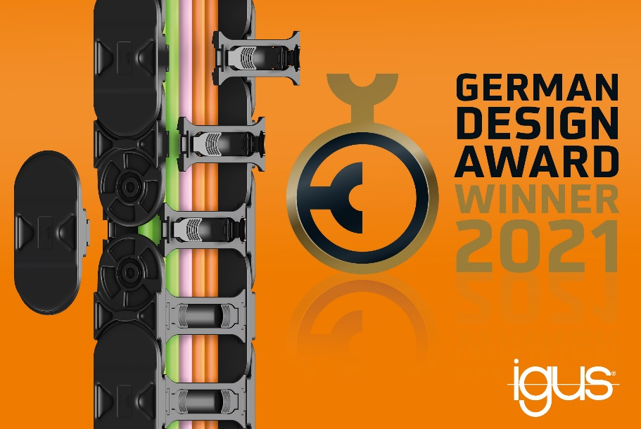
Picture PM5420-1
The E4Q series German Design Award winning design saves weight, increases strength by 20 per cent and reduces assembly time by 40 per cent. (Source: igus GmbH)

PRESS CONTACT:  Oliver Cyrus  Head of PR and Advertising  Anja Görtz-Olscher  PR and Advertising  igus® GmbH  Spicher Str. 1a  51147 Cologne  Tel. 0 22 03 / 96 49-459 or -7153  Fax 0 22 03 / 96 49-631  ocyrus@igus.net  agoertz@igus.net  www.igus.eu/press | ABOUT IGUS:  igus GmbH is a global leading manufacturer of energy chain systems and polymer plain bearings. The Cologne-based family business has offices in 35 countries and employs 4,150 people around the world. In 2019, igus generated a turnover of 764 million euros from motion plastics, plastic components for moving applications. igus operates the largest test laboratories and factories in its sector to offer customers quick turnaround times on innovative products and solutions tailored to their needs.

The terms "igus", “Apiro”, "chainflex", "CFRIP", "conprotect", "CTD", “drygear”, "drylin", "dry-tech", "dryspin", "easy chain", "e-chain", "e-chain systems", "e-ketten", "e-kettensysteme", "e-skin", "e-spool”, "flizz", “ibow”, “igear”, "iglidur", "igubal", “kineKIT”, "manus", "motion plastics", "pikchain", "plastics for longer life", "readychain", "readycable", “ReBeL”, "speedigus", "triflex", "robolink", “xirodur”, and "xiros" are protected by trademark laws in the Federal Republic of Germany and internationally, where applicable.

