Double award: igus wins the 2023 German Brand Award
Campaign for the iguverse VR platform receives an award for exemplary brand management

igus, the Cologne-based plastics specialist, received the renowned German Brand Award in 2023 for communication relating to the iguverse VR platform - in two categories.

Social media channels, landing pages, newsletters, mailings, press work and, to top it all off, a huge trade show stand at the 2023 Hannover Messe: this year, igus went full throttle on all channels with content and dialogue to present the iguverse to hundreds of thousands of customers from industry. igus plans a future in which customers, sales people and engineers from all over the world use virtual-reality headsets to congregate as avatars and implement entire engineering projects - in a faster, securer and more economical way than is possible in physical reality. This effort has now been rewarded. In 2023, igus won the German Brand Award, which the German Brand Institute presents annually, in two categories: "Excellence in Brand Strategy and Creation - Brand Communication - Digital Campaign" and "Excellence in Brand Strategy and Creation - Brand Experience of the Year". "This award is one of the most important German prizes for exemplary brand management and extraordinary marketing projects," says Marco Thull, Senior Marketing Activist at igus. "We are proud to be among the winners in two categories in 2023." Companies, agencies and marketeers from all sectors had participated.

Recognition of excellent brand work
The award ceremony was held on 15th June 2023 in the Verti Music Hall in Berlin. "The German Brand Award makes brand success visible in a unique way," says Lutz Dietzold, CEO of the German Design Council, established as a foundation in 1953 on the initiative of the German Bundestag. Along with GMK Markenberatung, it is one of the two founders of the German Brand Institute and a contributor to the German Design Awards. "If you manage to stand out in a highly competitive market, you have a clear advantage. The German Brand Award is recognition of superb brand work."
Hannover Messe 2023 as a campaign highlight
One of the iguverse campaign's highlights was the digital trade show stand at the 2023 Hannover Messe. Visitors put on virtual-reality headsets and marvelled at what is possible in the igus industrial metaverse. They moved as avatars on the virtual twin of a huge oil platform and observed the e-loop energy chain system at work seemingly up close. "Companies that would like to gain experience with the igus industrial metaverse are invited to join the iguverse as beta testers at low cost," says Thull.

More information about is available at: https://www.igus.eu/info/iguverse.

Caption:

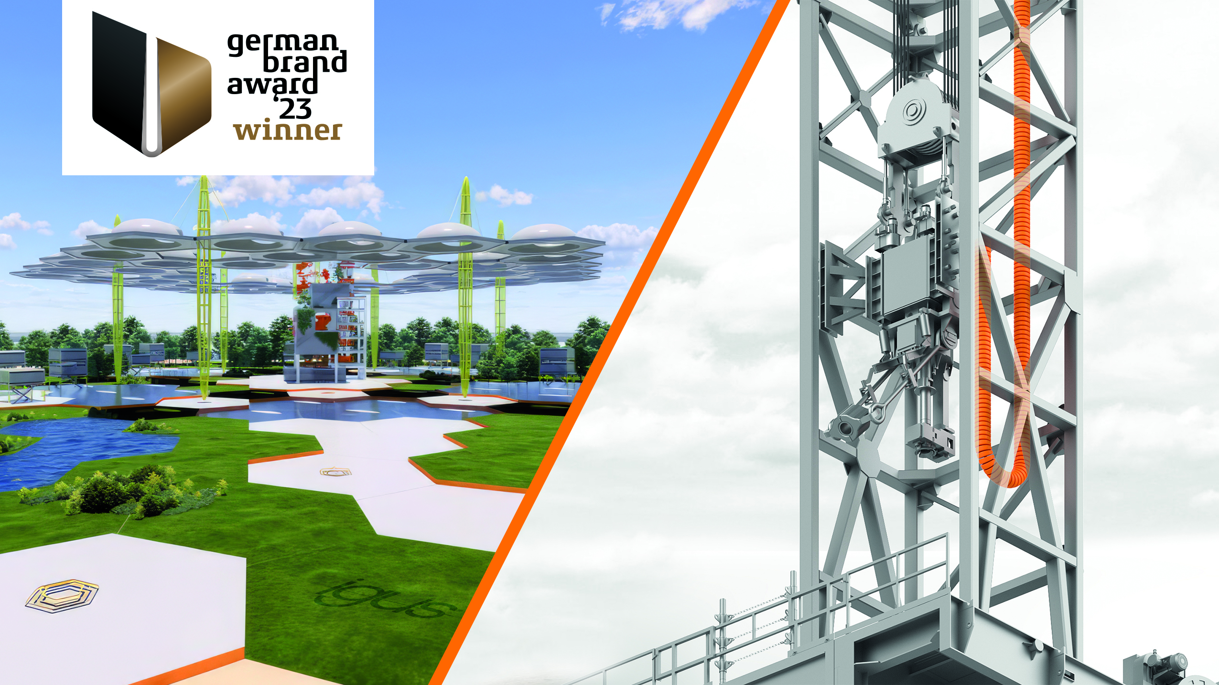
Picture PM4023-1
A robot or an energy chain for a drilling rig: the iguverse can be used to develop products in a more sustainable, cost-effective and efficient way. igus has now received the 2023 German Brand Award in the "Digital Campaign" and "Brand Experience of the Year" categories for the VR platform. (Source: igus GmbH)

PRESS CONTACT:

Alexa Heinzelmann
Head of International Marketing

igus® GmbH
Spicher Str. 1a
51147 Cologne
Tel. 0 22 03 / 96 49-7272
aheinzelmann@igus.net
www.igus.eu/press

ABOUT IGUS:

igus GmbH develops and produces motion plastics. These lubrication-free, high-performance polymers improve technology and reduce costs wherever things move. In energy supplies, highly flexible cables, plain and linear bearings as well as lead screw technology made of tribo-polymers, igus is the worldwide market leader. The family-run company based in Cologne, Germany, is represented in 31 countries and employs 4,600 people across the globe. In 2022, igus generated a turnover of €1,15 billion. Research in the industry's largest test laboratories constantly yields innovations and more security for users. 234,000 articles are available from stock and the service life can be calculated online. In recent years, the company has expanded by creating internal startups, e.g. for ball bearings, robot drives, 3D printing, the RBTX platform for Lean Robotics and intelligent "smart plastics" for Industry 4.0. Among the most important environmental investments are the "chainge" programme – recycling of used e-chains - and the participation in an enterprise that produces oil from plastic waste.

The terms "igus", “Apiro”, "chainflex", "CFRIP", "conprotect", "CTD", “drygear”, "drylin", "dry-tech", "dryspin", "easy chain", "e-chain", "e-chain systems", "e-ketten", "e-kettensysteme", "e-skin", "e-spool”, "flizz", “ibow”, “igear”, "iglidur", "igubal", “kineKIT”, "manus", "motion plastics", "pikchain", "plastics for longer life", "readychain", "readycable", “ReBeL”, "speedigus", "tribofilament“, "triflex", "robolink", “xirodur”, and "xiros" are protected by trademark laws in the Federal Republic of Germany and internationally, where applicable.

