Staying innovative to keep pace with the future: igus expands its management board
The motion plastics specialist reorganises management according to products and important future projects

Progressive digitalisation, a high degree of product innovation, fast delivery times worldwide and a sustainable recycling economy - just a few of the future projects that igus is driving forward this year. The company is now expanding its management board to handle this wide range of tasks. Customers and employees should know that igus can follow its own independent path in every phase and far into the future.

"We want to press ahead with decisive future investments so that customers can access their motion plastics innovations quickly, easily and reliably", promised Frank Blase at the igus annual press conference in May 2020. The igus CEO and entrepreneur sees himself on a good path so far. Digitalisation example: "Our 400 square metre real trade show stand in Cologne has been online since the beginning of May. In the meantime, more than 55,000 interested parties from all over the world have visited the trade show stand virtually and 8,700 discussions were conducted digitally by igus customer consultants there." The focus of the exhibition is on the more than 120 product innovations with which customers can save costs and improve their technology. These include autumn innovations such as the 3D printed smart plain bearing, with which for the first time the tribo-polymer specialist combines Industry 4.0 with 3D printing in just one production step.

In order to maintain and intensify its own path of technology and company culture for a long time to come, igus is expanding its management board. The new directors Gerhard Baus, New Businesses, Michael Blass, e-chain systems, Tobias Vogel, Plain Bearings & Linear Technology, and Artur Peplinski, igus International, now complement the corporate management around Frank Blase. "I am delighted to be working with this team. Together we have 148 years of igus experience. We are united by our enthusiasm for motion plastics." Each of the new directors is responsible for one product area worldwide; one of them is responsible for expanding the companies on site. "This is unusual and at the same time corresponds to our 'solar system organisation', where the customer is at the centre of attention as the provider of energy," says Frank Blase. At the same time, he appointed three new vice presidents for the cable, harnessing and linear technology & low cost automation product areas. In addition there are five new vice presidents for production, purchasing and personnel, who complement their colleagues in IT and finance.

"We have already implemented many new investments this year along with the igus colleagues. These include the further automation of the factory, for example, with robolink low-cost robots, the creation of new test capacities, such as the cleanroom laboratory and transmission test rigs, and the increase in production capacity by more than 560 injection moulding machines and 18 newly installed machines for state-of-the-art toolmaking. At the same time, further investments were made in logistics and information systems to achieve short delivery times. In all this, the issue of sustainability is becoming increasingly important, points out Frank Blase, who invested in the Mura Technologies start-up last year to help the company build the first commercial plant to recycle plastic into crude oil. "In the extended management board, we are all agreed that we will incorporate the ideas of the recycling industry even more strongly into our core business."

Caption:

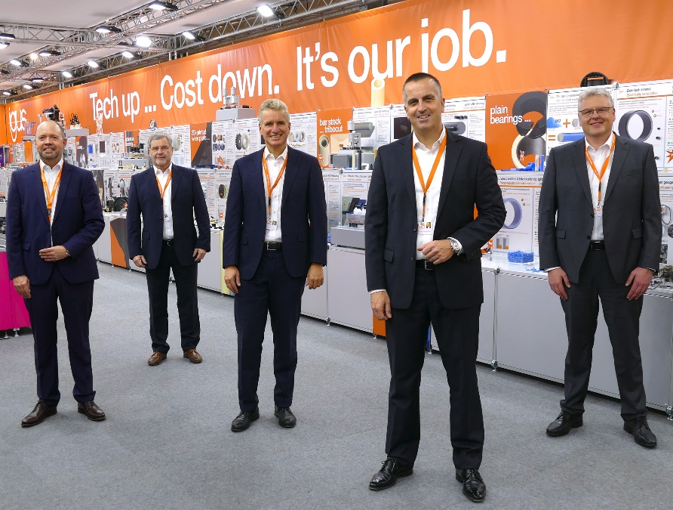
Picture PM6220-1
igus expands its management. From left to right: Michael Blass, Gerhard Baus, Frank Blase, Tobias Vogel and Artur Peplinski. (Source: igus GmbH)

PRESS CONTACT:  Oliver Cyrus  Head of PR and Advertising  Anja Görtz-Olscher  PR and Advertising  igus® GmbH  Spicher Str. 1a  51147 Cologne  Tel. 0 22 03 / 96 49-459 or -7153  Fax 0 22 03 / 96 49-631  ocyrus@igus.net  agoertz@igus.net  www.igus.eu/press | ABOUT IGUS:  igus GmbH develops and produces motion plastics. These lubrication-free, high-performance polymers improve technology and reduce costs wherever things move. In energy supplies, highly flexible cables, plain and linear bearings as well as lead screw technology made of tribo-polymers, igus is the worldwide market leader. The family-run company based in Cologne, Germany, is represented in 35 countries and employs 3,800 people across the globe. In 2019, igus generated a turnover of €764 million. Research in the industry's largest test laboratories constantly yields innovations and more security for users. 234,000 articles are available from stock and the service life can be calculated online. In recent years, the company has expanded by creating internal startups, e.g. for ball bearings, robot drives, 3D printing, the RBTX platform for Lean Robotics and intelligent "smart plastics" for Industry 4.0. Among the most important environmental investments are the "chainge" programme – recycling of used e-chains - and the participation in an enterprise that produces oil from plastic waste. (Plastic2Oil).

The terms "igus", “Apiro”, "chainflex", "CFRIP", "conprotect", "CTD", “drygear”, "drylin", "dry-tech", "dryspin", "easy chain", "e-chain", "e-chain systems", "e-ketten", "e-kettensysteme", "e-skin", "e-spool”, "flizz", “ibow”, “igear”, "iglidur", "igubal", “kineKIT”, "manus", "motion plastics", "pikchain", "plastics for longer life", "readychain", "readycable", “ReBeL”, "speedigus", "tribofilament“, "triflex", "robolink", “xirodur”, and "xiros" are protected by trademark laws in the Federal Republic of Germany and internationally, where applicable.

