A clean performance: igus wins the REINER! Award for modular cleanroom chain
Fraunhofer Purity Technology Award goes to the particle-free and compact e-skin flat energy supply system

High-purity manufacturing environments ensure that electronics also function safely in everyday life. In order for manufacturers to produce in cleanrooms, particle-free machine elements are required. Every year, the Fraunhofer Institute honours the most innovative developments with the REINER! Award. The motion plastics specialist igus is very pleased with the 2nd place award for its e-skin flat energy supply chain. The alternative to the flat belt guide is compact, modular and has cleanroom class 1. The cables can be easily inserted into the chain using the zipper principle and can be quickly replaced in the event of maintenance.

Microchips, flat screens, implants, active pharmaceutical ingredients or micro and nano products would be unthinkable without high-purity manufacturing environments. Memory ICs are very much in demand, especially in home offices, in expanded corporate IT infrastructures and in medical electronics. At the same time, manufacturers are looking for machines and systems that work quickly and safely to meet the growing demand for semiconductors. One of the biggest challenges here is particles that detach from machine elements and contaminate the ambient air. Therefore, new solutions are required that make the production processes economical, even under high safety and hygiene requirements. To honour these new developments, Fraunhofer IPA announces the Fraunhofer Purity Technology Prize REINER! every two years. The award has now been presented to igus for the development of the e-skin flat energy supply system as part of the Digital 365 Cleanroom Process. The motion plastics specialist took 2nd place.

e-skin flat: modular and compact cable guidance system
The e-skin flat is a modular cable guidance system made of high-performance polymer, which shows almost no visible wear and is abrasion-resistant. Energy supply systems can be easily extended with so-called "single pod" profiles. A zipper system allows easy replacement of the cables. In combination with CFCLEAN cable cores for the transmission of energy, motor control, bus and Ethernet signals, the user receives a ready-to-connect energy supply system. Tests by the Fraunhofer Institute for Manufacturing Engineering and Automation IPA have shown that the system achieves Class 1 according to ISO 14644. This means that the e-skin flat meets the strictest cleanroom requirements. The igus range of particle-free energy supply systems has been in production since 2003. Since last year, the company has also been operating a cleanroom laboratory for in-house development, which was installed at the main site in Cologne in co-operation with the Fraunhofer Institute. In this laboratory, igus tests its e-skin flat as well as other motion plastics such as cables and plain bearings.

You can find more information about the e-skin flat at:
https://www.igus.eu/info/e-skin-flat?L=en

Caption:

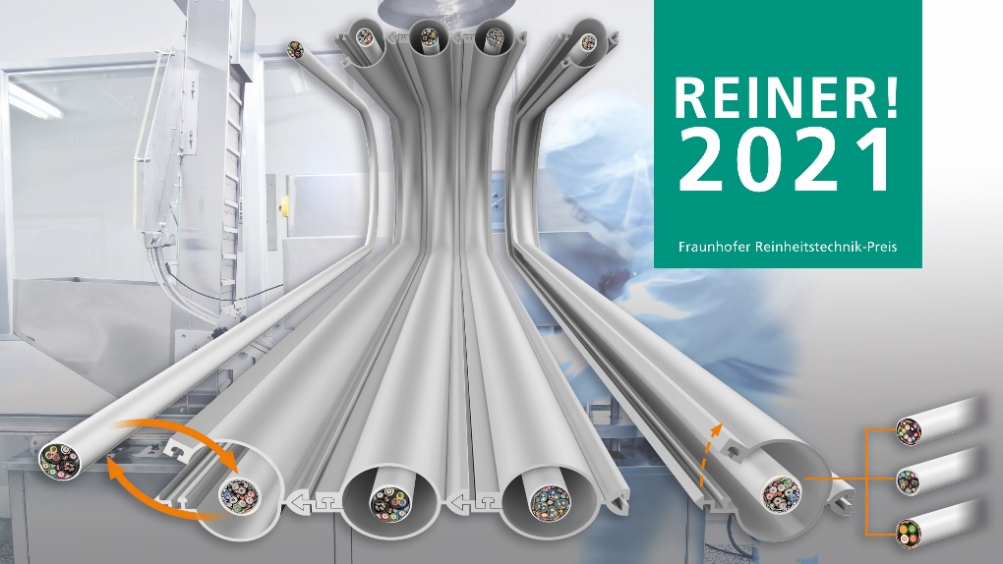
Picture PM1221-1
The motion plastics specialist igus came in 2nd place with the e-skin flat at the REINER! Awards. The special feature of the chain: cable cores such as CFCLEAN can be easily replaced in the event of maintenance. (Source: igus GmbH)

PRESS CONTACT:  Oliver Cyrus  Head of PR and Advertising  Anja Görtz-Olscher  PR and Advertising  igus® GmbH  Spicher Str. 1a  51147 Cologne  Tel. 0 22 03 / 96 49-459 or -7153  Fax 0 22 03 / 96 49-631  ocyrus@igus.net  agoertz@igus.net  www.igus.eu/press | ABOUT IGUS:  igus GmbH develops and produces motion plastics. These lubrication-free, high-performance polymers improve technology and reduce costs wherever things move. In energy supplies, highly flexible cables, plain and linear bearings as well as lead screw technology made of tribo-polymers, igus is the worldwide market leader. The family-run company based in Cologne, Germany, is represented in 35 countries and employs 3,800 people across the globe. In 2019, igus generated a turnover of €764 million. Research in the industry's largest test laboratories constantly yields innovations and more security for users. 234,000 articles are available from stock and the service life can be calculated online. In recent years, the company has expanded by creating internal startups, e.g. for ball bearings, robot drives, 3D printing, the RBTX platform for Lean Robotics and intelligent "smart plastics" for Industry 4.0. Among the most important environmental investments are the "chainge" programme – recycling of used e-chains - and the participation in an enterprise that produces oil from plastic waste. (Plastic2Oil).

The terms "igus", “Apiro”, "chainflex", "CFRIP", "conprotect", "CTD", “drygear”, "drylin", "dry-tech", "dryspin", "easy chain", "e-chain", "e-chain systems", "e-ketten", "e-kettensysteme", "e-skin", "e-spool”, "flizz", “ibow”, “igear”, "iglidur", "igubal", “kineKIT”, "manus", "motion plastics", "pikchain", "plastics for longer life", "readychain", "readycable", “ReBeL”, "speedigus", "tribofilament“, "triflex", "robolink", “xirodur”, and "xiros" are protected by trademark laws in the Federal Republic of Germany and internationally, where applicable.

