C6 e-chain: new design and abrasion-optimised materials for cleanrooms of the highest class
At the Hannover Messe, igus presents the design study of a particle-free and lightweight energy supply system

High abrasion resistance is crucial for machine elements in cleanrooms. igus has therefore now developed the C6, an energy chain designed to meet the highest cleanroom class. The new chain is specially designed for longer unsupported applications on machines and systems, and is based on the successful E6 and E6.1 cleanroom series from igus. A new connector system and a specially tribologically optimised high-performance polymer make the design study from igus even smoother, easier to assemble and virtually free of any particles in motion.

igus has developed a new energy chain under the abbreviation "C6". "C" stands for its place of use: the cleanroom - and "6" for the number of individual parts per chain link. The new energy supply system was developed by igus on the basis of its successful E6 and E6.1 energy chain series, which are used worldwide, and has now been further optimised as a study. With the new energy supply system, cables and hoses are to be guided in an abrasion-resistant and smooth manner even on medium travel distances in cleanrooms such as in electronics production, the semiconductor industry, in packaging machines, medical technology and also in pharmaceutical production. For this, igus relies on a new type of connecting system for the individual chain links, which makes the chain easy to assemble and lightweight, as well as strong and vibration-dampening. "We have reduced the contact surface to a minimum when moving the C6, so we ensure extremely low abrasion and quiet operation", explains Jörg Ottersbach, Business Unit Manager e-chains at igus GmbH. "In addition, with our knowledge of plastics for movement, we have developed a new material specifically for all points that come into contact with the cables. It further minimises friction." The new design saves 74 per cent weight compared to the previous series.

C6 to meet the highest cleanroom class
The idea for the C6 was developed in co-operation with a large electronics manufacturer and the Fraunhofer IPA. "We were pleased to be able to put the chain through rigorous tests and develop it further directly with the experts from industry and cleanroom research", says a delighted Andreas Hermey, Head of Development for igus energy chains. Test series with the new e-chain are currently running in the in-house cleanroom laboratory in Cologne. "The initial tests show the high abrasion resistance of the chain, so we are very optimistic that it will also receive cleanroom class 1", says Hermey "With the design of the C6, we are also prepared for future cleanroom requirements, which will stipulate even fewer particles than ISO class 1."

PRESS CONTACT:  Oliver Cyrus  Head of PR and Advertising  Anja Görtz-Olscher  PR and Advertising  igus® GmbH  Spicher Str. 1a  51147 Cologne  Tel. 0 22 03 / 96 49-459 or -7153  Fax 0 22 03 / 96 49-631  ocyrus@igus.net  agoertz@igus.net  www.igus.eu/press | ABOUT IGUS:  igus GmbH develops and produces motion plastics. These lubrication-free, high-performance polymers improve technology and reduce costs wherever things move. In energy supplies, highly flexible cables, plain and linear bearings as well as lead screw technology made of tribo-polymers, igus is the worldwide market leader. The family-run company based in Cologne, Germany, is represented in 35 countries and employs 3,800 people across the globe. In 2019, igus generated a turnover of €764 million. Research in the industry's largest test laboratories constantly yields innovations and more security for users. 234,000 articles are available from stock and the service life can be calculated online. In recent years, the company has expanded by creating internal startups, e.g. for ball bearings, robot drives, 3D printing, the RBTX platform for Lean Robotics and intelligent "smart plastics" for Industry 4.0. Among the most important environmental investments are the "chainge" programme – recycling of used e-chains - and the participation in an enterprise that produces oil from plastic waste. (Plastic2Oil).

The terms "igus", “Apiro”, "chainflex", "CFRIP", "conprotect", "CTD", “drygear”, "drylin", "dry-tech", "dryspin", "easy chain", "e-chain", "e-chain systems", "e-ketten", "e-kettensysteme", "e-skin", "e-spool”, "flizz", “ibow”, “igear”, "iglidur", "igubal", “kineKIT”, "manus", "motion plastics", "pikchain", "plastics for longer life", "readychain", "readycable", “ReBeL”, "speedigus", "tribofilament“, "triflex", "robolink", “xirodur”, and "xiros" are protected by trademark laws in the Federal Republic of Germany and internationally, where applicable.
Captions:

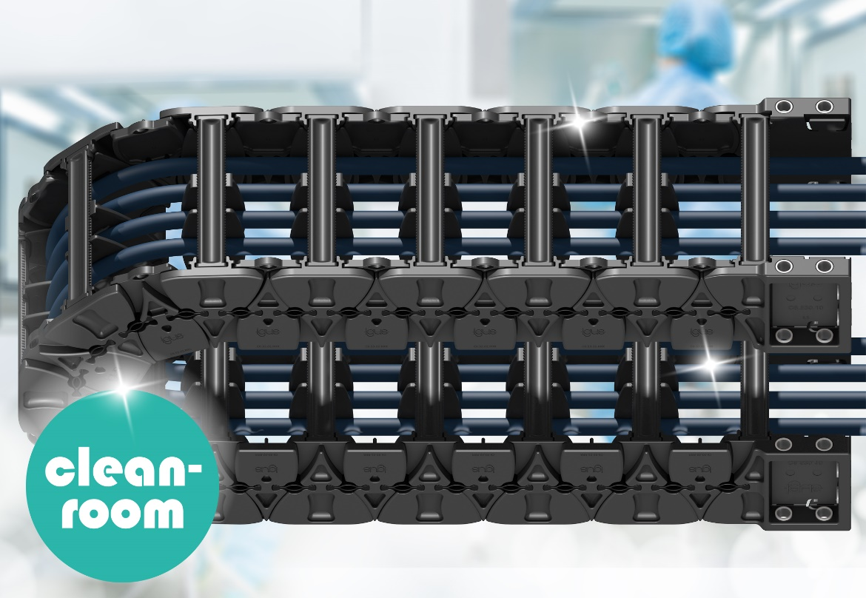

Picture PM1921-1
The new C6 cleanroom chain from igus is characterised by its lightweight design and high abrasion resistance. (Source: igus GmbH)

