Still sceptical? Test the magnetic detectability of food-grade spherical bearings yourself now
New, free igubal Food Contact sample box - including magnet and new double joint

In the food industry, machine components have to meet very high hygiene requirements so as not to pose a safety risk. Since 2019, the motion plastics specialist igus has been offering igubal Food Contact (FC), a special spherical bearing system made from high-performance polymers that comply with FDA and EU 10/2011 for direct contact with food. The company is now expanding this product range with a new double joint. Interested parties who would like to see the advantages and quality of the igubal FC series for themselves in advance can now order a new free sample box.

Food manufacturers are faced with the challenge of constantly improving the reliability of their systems. Detecting the smallest impurities is a particularly decisive safety factor for guaranteeing the purity of the products. By integrating detectable and at the same time food-compliant additives into its high-performance plastics, the motion plastics specialist igus has managed to develop a spherical plain bearing series especially for direct food contact: igubal Food Contact (FC). By using FC, it is possible to significantly minimise the risk of a costly recall as detectors recognise even the smallest parts of the components, which makes the work for quality assurance easier. Furthermore, the materials are also coloured blue to improve optical detectability.

More design freedom with the new double joint
"To give users even more design freedom in such a hygiene-sensitive area, we are now adding another component to our proven igubal FC series. In addition to pillow block and fixed flange bearings, rod ends and clevis joints, the product range now also includes a double joint," explains Dennis Steffen, Product Manager for igubal Spherical Bearings at igus. Like all igubal FC products, it contains an optically and magnetically detectable housing made of the FDA-compliant igumid FC material. Thanks to the high-performance polymers used, the new spherical bearing is also lubrication-free and maintenance-free, vibration-dampening, corrosion-free and, in combination with a spherical ball, suitable for compensating for misalignments. "When selecting the right spherical ball, customers can choose between several materials, depending on their needs," says Steffen. "The insert made of the material iglidur A181 can be used to comply with the strict FDA guidelines. The material iglidur FC180 guarantees 100% detectability. Both also meet the EU 10/2011 standard for direct food contact. If a higher tightening torque is required due to the spherical ball, customers can also choose a stainless-steel version." As with all igus products, they work without external lubricants, which rules out contamination. In addition, cleaning processes can be carried out regardless of the bearings.

Try it yourself: new Food Contact sample box
If you want to hold the igubal FC spherical bearings in your hands before you buy them and would like to convince yourself of the materials' quality and advantages - such as magnetic detectability - you can order a free sample box. The new box contains samples from all product areas: pillow block bearings, fixed flange bearings, rod ends, clevis joints and double joints. The entire spherical bearing system is characterised by a long service life and chemical resistance. This was proven by numerous tests in our own test laboratory - the largest in the industry for tribopolymers. The igubal FC also beats the conventional spherical plain bearings made of stainless steel in terms of costs. A cost advantage of up to 85% can be achieved compared to stainless-steel solutions. The igus product also requires less maintenance due to the self-lubricating specifications of the bearing material.

Caption:

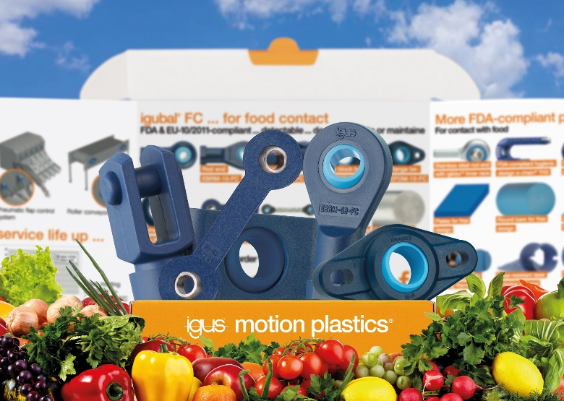
Picture PM1823-1
With the free igubal FC sample box - including the new double joint - interested parties can see for themselves the advantages of the lubrication-free spherical bearing system for the food industry. (Source: igus GmbH)

PRESS CONTACT:

Alexa Heinzelmann
Head of International Marketing

igus® GmbH
Spicher Str. 1a
51147 Cologne
Tel. 0 22 03 / 96 49-7272
aheinzelmann@igus.net
www.igus.eu/press

ABOUT IGUS:

igus GmbH develops and produces motion plastics. These lubrication-free, high-performance polymers improve technology and reduce costs wherever things move. In energy supplies, highly flexible cables, plain and linear bearings as well as lead screw technology made of tribo-polymers, igus is the worldwide market leader. The family-run company based in Cologne, Germany, is represented in 31 countries and employs 4,900 people across the globe. In 2021, igus generated a turnover of €961 million. Research in the industry's largest test laboratories constantly yields innovations and more security for users. 234,000 articles are available from stock and the service life can be calculated online. In recent years, the company has expanded by creating internal startups, e.g. for ball bearings, robot drives, 3D printing, the RBTX platform for Lean Robotics and intelligent "smart plastics" for Industry 4.0. Among the most important environmental investments are the "chainge" programme – recycling of used e-chains - and the participation in an enterprise that produces oil from plastic waste.

The terms "igus", “Apiro”, "chainflex", "CFRIP", "conprotect", "CTD", “drygear”, "drylin", "dry-tech", "dryspin", "easy chain", "e-chain", "e-chain systems", "e-ketten", "e-kettensysteme", "e-skin", "e-spool”, "flizz", “ibow”, “igear”, "iglidur", "igubal", “kineKIT”, "manus", "motion plastics", "pikchain", "plastics for longer life", "readychain", "readycable", “ReBeL”, "speedigus", "tribofilament“, "triflex", "robolink", “xirodur”, and "xiros" are protected by trademark laws in the Federal Republic of Germany and internationally, where applicable.

