# Wound tribo plain bearings from igus reduce wear in heavy-duty applications

# Lubrication-free and maintenance-free heavy-duty material iglidur TX2 shows a 3.5-fold improvement in wear behaviour in tests

**Especially for heavy-duty applications in the construction machinery or agricultural industry, igus now has the new tribo-material iglidur TX2 in its product range, which works without lubrication. Because even small excavators still need 50 litres of lubricant every year. The wound plain bearing bushings withstand very strong forces and increase wear resistance by a factor of 3.5 in load ranges with more than 100 MPa surface pressure.**

Machines and agricultural vehicles: the construction or mining industries are exposed to challenging environmental conditions every day. Cold, heat, dust and dirt have a strong effect on the bearing points. The motion plastics specialist igus offers an alternative to frequently used metallic solutions with its plain bearing technology. Another material combination for wound bushings complements the range of injection-moulded bearings in the heavy-duty range.

**High load, low wear**

The tribo plain bearings made of high-strength filament fabric are used where very high loads occur.Here, the extremely strong filament in its specially interwoven design ensures maximum resistance and enables a maximum permissible compressive strength of 400 MPa. The newly developed material was extensively tested on the indoor and outdoor test rigs in the 3,800 square metre igus test laboratory. Pivot tests on hard-chrome shafts showed that iglidur TX2 is around 3.5 times more wear-resistant than the standard heavy-duty material TX1. Like all iglidur plain bearings, iglidur TX2 is self-lubricating and operates dry. This prevents dirt from adhering to the bearing points. This reduces maintenance and repair costs, as well as machine failures due to insufficient lubrication. As the material is also very resistant to temperature, chemicals and moisture, plain bearings made of iglidur TX2 can be used in many other areas. Due to the freedom from corrosion and seawater resistance, they can also be used, for example, in moving applications in the maritime sector. Diameters of up to 2,800 millimetres are feasible. In any case, the application of iglidur TX2 takes into account increased sustainability requirements, both underwater and onshore. "For example, according to the operators, even a small excavator needs between 50 and 60 litres of lubricants per year", clarifies Stefan Loockmann-Rittich, head of the iglidur Plain Bearing Technology Business Unit at igus. "Since the iglidur TX2 bearings do not need lubrication, the customer benefits threefold: not only saving costs for oil or grease and maintenance time, but also no lubricant is released into the environment." iglidur TX2 is available from May as a standard product range in the diameters 20 to 80 millimetres directly from stock.



**Caption:**

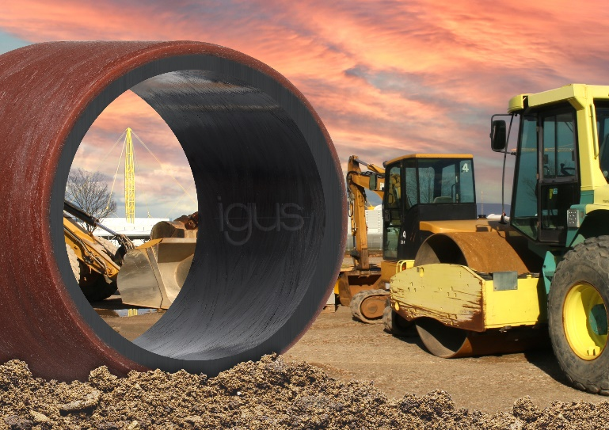

**Picture PM2421-1**

Lubrication-free, heavy-duty, wear-resistant: the new heavy-duty material iglidur TX2 saves costs and extends the service life in construction and agricultural machinery. (Source: igus GmbH)

|  |  |
| --- | --- |
| **PRESS CONTACT:**  Oliver Cyrus  Head of PR and Advertising  Anja Görtz-Olscher  PR and Advertising  igus® GmbH  Spicher Str. 1a  51147 Cologne  Tel. 0 22 03 / 96 49-459 or -7153  Fax 0 22 03 / 96 49-631  ocyrus@igus.net  agoertz@igus.net  www.igus.eu/press | **ABOUT IGUS:**  igus GmbH develops and produces motion plastics. These lubrication-free, high-performance polymers improve technology and reduce costs wherever things move. In energy supplies, highly flexible cables, plain and linear bearings as well as lead screw technology made of tribo-polymers, igus is the worldwide market leader. The family-run company based in Cologne, Germany, is represented in 35 countries and employs 3,800 people across the globe. In 2019, igus generated a turnover of €764 million. Research in the industry's largest test laboratories constantly yields innovations and more security for users. 234,000 articles are available from stock and the service life can be calculated online. In recent years, the company has expanded by creating internal startups, e.g. for ball bearings, robot drives, 3D printing, the RBTX platform for Lean Robotics and intelligent "smart plastics" for Industry 4.0. Among the most important environmental investments are the "chainge" programme – recycling of used e-chains - and the participation in an enterprise that produces oil from plastic waste. (Plastic2Oil). |

The terms "igus", “Apiro”, "chainflex", "CFRIP", "conprotect", "CTD", “drygear”, "drylin", "dry-tech", "dryspin", "easy chain", "e-chain", "e-chain systems", "e-ketten", "e-kettensysteme", "e-skin", "e-spool”, "flizz", “ibow”, “igear”, "iglidur", "igubal", “kineKIT”, "manus", "motion plastics", "pikchain", "plastics for longer life", "readychain", "readycable", “ReBeL”, "speedigus", "tribofilament“, "triflex", "robolink", “xirodur”, and "xiros" are protected by trademark laws in the Federal Republic of Germany and internationally, where applicable.