Next-level recycling with digital innovations: Cologne-based plastics processor igus invests in start-up cirplus
Recycling platforms designed by igus and cirplus jointly promote the regenerative plastics industry of the future

Plastic products have many uses and have become indispensable for everyday life. But when they reach the end of their service life, they often end up in the incinerator. Conserving valuable resources and protecting the environment requires a sustainable plastics industry. The Cologne-based plastics specialist igus is pursuing this conservation goal with its "Chainge" recycling platform. The company has now invested in cirplus, a start-up based in Hamburg. The companies have a joint vision of closing the plastics cycle and initiating a revolution in the trade of recycled materials from technical and standard thermoplastics.

The igus "Chainge" program has proven that circular economy can be easily achieved, it just needs new recyclate material options. From as early as 2019, igus recognised this requirement and has been enabling customers to have disused energy chains recycled, regardless of manufacturer. In October 2022, the "Chainge" online platform was created to provide easy digital access to recycling. The marketplace can now be used to add technical plastics to the circular economy that were previously not able to be accepted. It also enables processing companies to purchase recycled plastics with guaranteed quality standards. This change makes it easier to achieve announced recycling quotas. To further advance the digital circular economy, igus has now invested in a circular start-up, cirplus.

Shaping the future of recycled plastics with digital technology
While igus has had successes with technical plastics, cirplus is mainly active in the markets for standard thermoplastics. The Hamburg start-up offers disposal companies, recyclers, and product manufacturers a digital marketplace through which they can buy standardised recyclates in a reliable, traceable, cost-effective manner – worldwide. The team of technology and digital experts are therefore promoting the networking of the plastics and recycling industries. Cirplus was responsible for initiating DIN SPEC 91446 and DIN SPEC 91481 as the world's first standards for high-quality plastics recycling. The motivation was to build reliable, transparent supply chains for plastic recyclates through the combination of digitalisation and standardisation. DIN SPEC 91446 was also awarded the DIN Prize 2022 by the German Institute for Standardization e.V. in the categories of climate protection and innovation. The common goal of making the regenerative use of plastics easier than ever before has brought igus and cirplus together.

An investment with many opportunities
"Chainge" offers igus customers quick and easy access to technical plastics recycling. In cirplus, igus now has a strong partner for the digital standard recyclates industry. In the future, customers will benefit from a network that links the recyclate trade in technical and standard thermoplastics and makes it possible to obtain everything easily and transparently from a single source. igus has 60 years of plastics experience, so it has developed a global network and offers access to consistent material flows. Add cirplus' experience and software expertise, and the path is clear for the next level of digital recyclate trading. The two companies are looking forward to the possibilities of a strategic partnership that offers potential for building the world's largest AI platform for circular plastics. "Our efforts to expand our activities and make them usable for everyone led us to join forces with cirplus" says Michael Blass, CEO e-chain systems at igus. With this investment, we are setting an example for people to think about sustainability and to create a network in order to be able to move more.” Christian Schiller, cirplus CEO, adds, "In igus, we have found a partner who shares our values and works with us to advance digitalisation in the plastics industry with the aim of closing the cycle completely. igus' experience in the field of technical plastics coupled with our expertise in the field of digitalisation and standard thermoplastics is the ideal starting point for pursuing a closed circular economy – across all industries."

Caption:

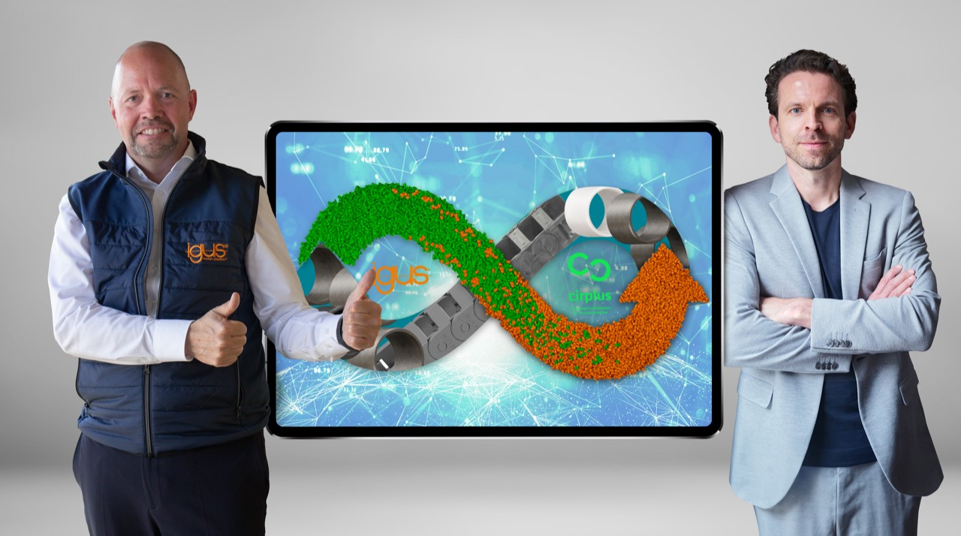
Picture PM3023-1
With their cooperation, igus and cirplus are jointly setting the course for the next level of digital recyclate trading in technical and standard plastics. Michael Blass, CEO e-chain systems at igus GmbH (left) and Christian Schiller, cirplus CEO (right), are happy about the cooperation. (Source: igus GmbH)

PRESS CONTACT:

Alexa Heinzelmann
Head of International Marketing

igus® GmbH
Spicher Str. 1a
51147 Cologne
Tel. 0 22 03 / 96 49-7272
aheinzelmann@igus.net
www.igus.eu/press

ABOUT IGUS:

igus GmbH develops and produces motion plastics. These lubrication-free, high-performance polymers improve technology and reduce costs wherever things move. In energy supplies, highly flexible cables, plain and linear bearings as well as lead screw technology made of tribo-polymers, igus is the worldwide market leader. The family-run company based in Cologne, Germany, is represented in 31 countries and employs 4,600 people across the globe. In 2022, igus generated a turnover of €1,15 billion. Research in the industry's largest test laboratories constantly yields innovations and more security for users. 234,000 articles are available from stock and the service life can be calculated online. In recent years, the company has expanded by creating internal startups, e.g. for ball bearings, robot drives, 3D printing, the RBTX platform for Lean Robotics and intelligent "smart plastics" for Industry 4.0. Among the most important environmental investments are the "chainge" programme – recycling of used e-chains - and the participation in an enterprise that produces oil from plastic waste.

The terms "igus", “Apiro”, "chainflex", "CFRIP", "conprotect", "CTD", “drygear”, "drylin", "dry-tech", "dryspin", "easy chain", "e-chain", "e-chain systems", "e-ketten", "e-kettensysteme", "e-skin", "e-spool”, "flizz", “ibow”, “igear”, "iglidur", "igubal", “kineKIT”, "manus", "motion plastics", "pikchain", "plastics for longer life", "readychain", "readycable", “ReBeL”, "speedigus", "tribofilament“, "triflex", "robolink", “xirodur”, and "xiros" are protected by trademark laws in the Federal Republic of Germany and internationally, where applicable.

