STS container cranes: fit for the future thanks to the new igus heavy-duty rol e-chain
P4HD.56.R: suitable for long travels, high speeds, heavy cable loads and Industry 4.0

Container cranes in ports around the world will be even more powerful and fail-safe in the future. This is due to the fact that igus is launching P4HD.56.R - a new heavy-duty energy chain prepared for long travels, high speeds, heavy cable loads and Industry 4.0.

If your waistline expands, you need a new pair of trousers. Something similar is happening in ports around the world. Modern container ships are huge - take the Ever Ace, which is 400m long, 62m wide and loads almost 24,000 containers. The new trousers in our comparison are a larger ship-to-shore (STS) crane that loads and unloads the containers. This enlargement also affects the energy chains that guide the energy and data cables for the crane trolley on the crane bridge. They have to withstand unprecedented loads: travels of over 130m, cable weights of up to 10kg/m (over 20kg/m for motor-driven trolleys) and accelerations of more than 1m/sec² are standard for Triple E-class STS cranes. In other applications, travel distances of several hundred meters, cable loads of up to 50kg/m and accelerations of 8m/sec² and more can be achieved. "We have developed the new P4HD.56.R heavy-duty energy chain for these extreme requirements," says Theo Diehl, Industry Manager for Cranes at igus. "The energy chain is particularly robust and, thanks to its sensor technology, prepared for Industry 4.0 trends, such as predictive maintenance. This combination significantly increases STS crane reliability."
The heavy-duty energy chain is to run trouble-free for up to 15 years
The engineers have come up with special design features to achieve a long service life in STS cranes under high loads. "A special fork-tab principle ensures even greater stability at higher additional loads, while a pin/bore connection made of tribologically optimised plastic minimises wear," says Diehl. Furthermore, rollers are mounted in the inner radius of the chain links. If the e-chain folds, the upper run rolls on the lower run instead of sliding. Thanks to the low coefficient of friction, payload and acceleration can be increased without changing the push/pull force. Long-term tests in igus's in-house laboratory prove that P4HD.56.R, the heavy-duty design, achieves a 50% longer service life than the normal P41.56R variant. "Our goal is for the e-chain systems to run on any STS crane for up to 15 years - trouble-free and with minimal maintenance," says Diehl. A nice side effect: the rolling movement reduces the required drive energy by 57%. This is another advantage in times of rising energy prices. Since crane systems also require robust cables that can be used to realise long travels with high dynamics, igus also offers CFCRANE, a chainflex cable range that has been specifically developed for crane applications.

Fit for Industry 4.0
But the new P4HD.56.R is not only robust, durable and energy-saving. The heavy-duty energy chain is also suitable for Industry 4.0. For example, it allows predictive maintenance. With the help of i.Sense monitoring sensors, the chain link status can be continuously transmitted to the i.Cee:plus communication module. i.Cee allows usage-based and condition-based maintenance, extending inspection intervals. Maintenance is necessary only when the system sends a signal to that effect. Operators of STS cranes can use the i.Cee system to greatly increase system availability and extend energy chain service life. Holiday shut-downs and other planned downtimes are automatically taken into account in the i.Cee service life calculation, and the forecast is constantly checked with sensors. All these advantages do not limit usable inner width because the condition sensors and their electronics are integrated into the rol e-chain links to save space. No additional cables are necessary because data is transmitted via radio. "The new P4HD.56.R-series e-chains thus meet all the requirements that apply to STS cranes of the next generation and the generation after that," says Theo Diehl.

Caption:

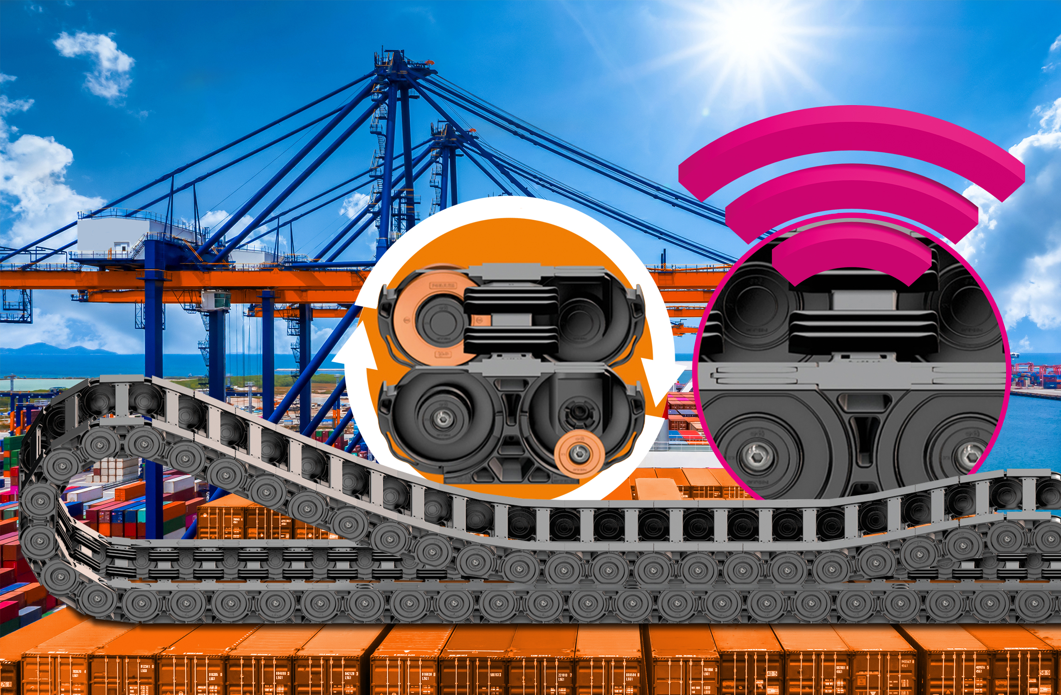
Picture PM4122-1
Longer and longer travels, higher dynamics, short load cycles, zero failures: the new P4HD.56R fulfils these requirements - and offers maximum economic efficiency. (Source: igus GmbH)

PRESS CONTACT:

Alexa Heinzelmann
Head of International Marketing

igus® GmbH
Spicher Str. 1a
51147 Cologne
Tel. 0 22 03 / 96 49-7272
aheinzelmann@igus.net
www.igus.eu/press

ABOUT IGUS:

igus GmbH develops and produces motion plastics. These lubrication-free, high-performance polymers improve technology and reduce costs wherever things move. In energy supplies, highly flexible cables, plain and linear bearings as well as lead screw technology made of tribo-polymers, igus is the worldwide market leader. The family-run company based in Cologne, Germany, is represented in 35 countries and employs 4,900 people across the globe. In 2021, igus generated a turnover of €961 million. Research in the industry's largest test laboratories constantly yields innovations and more security for users. 234,000 articles are available from stock and the service life can be calculated online. In recent years, the company has expanded by creating internal startups, e.g. for ball bearings, robot drives, 3D printing, the RBTX platform for Lean Robotics and intelligent "smart plastics" for Industry 4.0. Among the most important environmental investments are the "chainge" programme – recycling of used e-chains - and the participation in an enterprise that produces oil from plastic waste.

The terms "igus", “Apiro”, "chainflex", "CFRIP", "conprotect", "CTD", “drygear”, "drylin", "dry-tech", "dryspin", "easy chain", "e-chain", "e-chain systems", "e-ketten", "e-kettensysteme", "e-skin", "e-spool”, "flizz", “ibow”, “igear”, "iglidur", "igubal", “kineKIT”, "manus", "motion plastics", "pikchain", "plastics for longer life", "readychain", "readycable", “ReBeL”, "speedigus", "tribofilament“, "triflex", "robolink", “xirodur”, and "xiros" are protected by trademark laws in the Federal Republic of Germany and internationally, where applicable.

