As fine as a human hair: new igus micro gears with 0.2 module
The micro gears' delicate teeth make them suitable for very precise applications in small installation spaces

From microdrives to microscopes to precision engineering, engineers around the world are building increasingly compact products. igus now produces microgears for them with modules as small as 0.2. Tooth dimensions are very close to those of a human hair. Thanks to high-performance plastics, the teeth still allow precise, low-wear movement for high-quality products.

When a photographer zooms his camera, a gearbox consisting of tiny gears spanning just a few millimetres moves inside the lens. Their teeth are much smaller and scarcely visible to the naked eye. "Such precision-engineering applications require microgears that are still strong and wear-resistant enough to operate reliably for years," says Steffen Schack, Head of Business Unit iglidur Gears at igus. "For this reason, we have optimised our production to mechanically manufacture microgears with a module as small as 0.2 from high-performance plastic." The company uses iglidur bar stock, including iglidur A180 and iglidur A500. These materials are tribologically optimised: not only are they robust, they also have very good friction and wear specifications. At the same time, they are much lighter than metal gears.

Teeth as fine as a human hair
With modules as small as 0.2, igus has further pushed the limits of its mechanical production. "The capability of manufacturing gear teeth that can hardly be seen with the naked eye sets us apart from many competitors on the market," says Schack. "Despite their size, the teeth have excellent mechanical specifications. They allow reliable, highly precise movements in precision engineering."

Economical pricing even for small quantities
igus now offers customer-specific production of microgears made of high-performance plastics. "Our mechanical production from iglidur bar stock allows economical pricing even for small quantities. We can produce large quantities with injection moulding - for automobile series production, for instance," says Schack. The gears are suitable for a wide range of applications that require finely coordinated movements in very small installation spaces, for instance microscopes and other optical instruments, miniature motors and microdrives.

Caption:
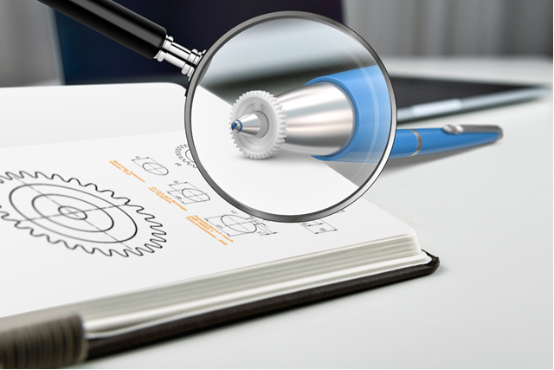
Picture PM4723-1
For very precise applications, igus now offers wear-resistant microgears made of high-performance plastics. (Source: igus GmbH)

PRESS CONTACT:

Alexa Heinzelmann
Head of International Marketing

igus® GmbH
Spicher Str. 1a
51147 Cologne
Tel. 0 22 03 / 96 49-7272
aheinzelmann@igus.net
www.igus.eu/press

ABOUT IGUS:

igus GmbH develops and produces motion plastics. These lubrication-free, high-performance polymers improve technology and reduce costs wherever things move. In energy supplies, highly flexible cables, plain and linear bearings as well as lead screw technology made of tribo-polymers, igus is the worldwide market leader. The family-run company based in Cologne, Germany, is represented in 31 countries and employs 4,600 people across the globe. In 2022, igus generated a turnover of €1,15 billion. Research in the industry's largest test laboratories constantly yields innovations and more security for users. 234,000 articles are available from stock and the service life can be calculated online. In recent years, the company has expanded by creating internal startups, e.g. for ball bearings, robot drives, 3D printing, the RBTX platform for Lean Robotics and intelligent "smart plastics" for Industry 4.0. Among the most important environmental investments are the "chainge" programme – recycling of used e-chains - and the participation in an enterprise that produces oil from plastic waste.

The terms "igus", “Apiro”, "chainflex", "CFRIP", "conprotect", "CTD", “drygear”, "drylin", "dry-tech", "dryspin", "easy chain", "e-chain", "e-chain systems", "e-ketten", "e-kettensysteme", "e-skin", "e-spool”, "flizz", “ibow”, “igear”, "iglidur", "igubal", “kineKIT”, "manus", "motion plastics", "pikchain", "plastics for longer life", "readychain", "readycable", “ReBeL”, "speedigus", "tribofilament“, "triflex", "robolink", “xirodur”, and "xiros" are protected by trademark laws in the Federal Republic of Germany and internationally, where applicable.

