New igus energy supply system for SCARA robots in cleanrooms
Clean SCARA Cable Solution works almost particle-free according to ISO Class 2

igus is launching a new energy supply system for SCARA robots in cleanrooms: the Clean SCARA Cable Solution is made of tribologically optimised high-performance plastics and works almost particle-free according to ISO Class 2 even in high-speed applications. It is also stronger and more user-friendly than classic corrugated hoses.

In the Hollywood blockbuster Deep Impact, a comet 2.5 kilometres in diameter impacts the earth, causing global destruction. Electronics production experiences the same kind of disasters, but these play out in much smaller dimensions. They involve tiny particles, invisible to the naked eye, that ruin electronic components, semiconductors and displays. Therefore, it is important for machines and systems to have as little friction as possible and so as not to contaminate the surrounding air. This isn't easy, especially with SCARA robots, which resemble a human arm that moves rapidly along four axes with cycle times of well under a second. There is always a risk that particles become detached from corrugated hoses and tubes in high-speed applications. "Finding a way to guide cables and hoses on a SCARA robot in a cleanroom is a science in itself. Fast movements are pure stress for the material, which releases unwelcome abrasion particles," says Matthias Meyer, Head of the triflex and Robotics Business Unit at igus. For this reason, igus has added a variant for cleanrooms to the SCARA Cable Solution energy supply system, which it developed in 2020. "The new Clean SCARA Cable Solution is a cleanroom-compatible energy supply system for high-speed applications - reliable, compact, easy to use and quick to retrofit," says Meyer.

ISO Class 2: hardly any particles in the surrounding air, even with the wildest movements
The core of the new cleanroom energy supply system is the e-skin soft, a modular energy chain that guides cables and hoses in a sag from the robot's vertical arm to the end effector. Its separable upper and lower shells can be combined to form a closed, dust-proof, water-resistant tube. This ensures that particles from the cables and hoses do not get into the surrounding air from the inside - even during the wildest movements. "To reduce stress on the cables and increase their durability, we have provided a rotating mount for the connections to the fixed and moving ends of the energy supply system," says Meyer. "That is what is special about the energy supply system. At the same time, the rotary bearings are designed to be almost particle-free, even during the most dynamic movements." The e-chain itself is also especially abrasion-resistant thanks to tribologically optimised high-performance plastic. Its ISO certification by Fraunhofer Institute experts confirms this. The Clean SCARA Cable Solution has ISO Class 2, meaning that it is so abrasion-resistant that a maximum of 100 particles up to a size of 0.1 microns can be found in one cubic meter of air during operation. For comparison, a sheet of paper is 80 microns thick, or 800 times as thick as such a particle.

Clean SCARA Cable Solution as an alternative to classic corrugated hoses
With its new energy supply system, igus offers an alternative to classic corrugated hoses, which has two other advantages in addition to cleanroom compatibility. First: the thin corrugated hoses most often used with the SCARA have hardly any inherent rigidity and are therefore susceptible to kinking. There is no bearing to absorb torsion, so they can tear easily. "Unlike corrugated hoses, the Clean SCARA Cable Solution supports itself and has a unique rotary bearing. This makes it ideal for short unsupported lengths and highly dynamic applications," says Meyer. "The oval chain geometry is especially advantageous when lateral forces are applied, since it offers additional strength." The second advantage over the corrugated hose is that the zipper principle makes the Clean SCARA Cable Solution easy to open, enabling users to insert cables and hoses quickly. An optional interior separation provides additional protection that corrugated hoses cannot. Upon request, the customer can receive the new energy chain for cleanrooms as a ready-to-connect complete system with chainflex cables." More than 900 highly flexible cables of IPA Class 1 are available.

You can find more information about the Clean SCARA Cable Solution here.

Caption:
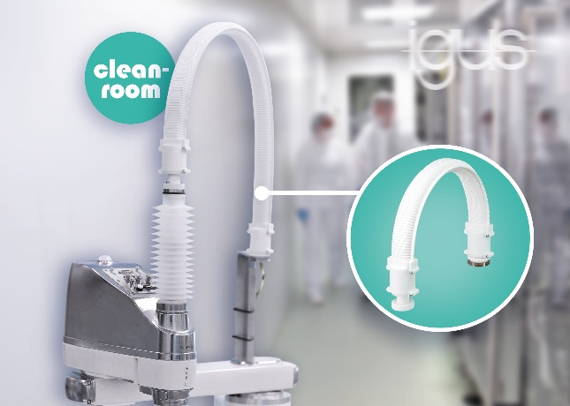
Picture PM4323-1
The Clean SCARA Cable Solution ensures particle-free energy supply, even with highly dynamic movements. (Source: igus GmbH)

PRESS CONTACT:

Alexa Heinzelmann
Head of International Marketing

igus® GmbH
Spicher Str. 1a
51147 Cologne
Tel. 0 22 03 / 96 49-7272
aheinzelmann@igus.net
www.igus.eu/press

ABOUT IGUS:

igus GmbH develops and produces motion plastics. These lubrication-free, high-performance polymers improve technology and reduce costs wherever things move. In energy supplies, highly flexible cables, plain and linear bearings as well as lead screw technology made of tribo-polymers, igus is the worldwide market leader. The family-run company based in Cologne, Germany, is represented in 31 countries and employs 4,600 people across the globe. In 2022, igus generated a turnover of €1,15 billion. Research in the industry's largest test laboratories constantly yields innovations and more security for users. 234,000 articles are available from stock and the service life can be calculated online. In recent years, the company has expanded by creating internal startups, e.g. for ball bearings, robot drives, 3D printing, the RBTX platform for Lean Robotics and intelligent "smart plastics" for Industry 4.0. Among the most important environmental investments are the "chainge" programme – recycling of used e-chains - and the participation in an enterprise that produces oil from plastic waste.

The terms "igus", “Apiro”, "chainflex", "CFRIP", "conprotect", "CTD", “drygear”, "drylin", "dry-tech", "dryspin", "easy chain", "e-chain", "e-chain systems", "e-ketten", "e-kettensysteme", "e-skin", "e-spool”, "flizz", “ibow”, “igear”, "iglidur", "igubal", “kineKIT”, "manus", "motion plastics", "pikchain", "plastics for longer life", "readychain", "readycable", “ReBeL”, "speedigus", "tribofilament“, "triflex", "robolink", “xirodur”, and "xiros" are protected by trademark laws in the Federal Republic of Germany and internationally, where applicable.

