A toast to summer! New robot with igus linear guide taps beer in seconds
One Two Beer GmbH develops automatic beer tap with hygienic, lubrication-free drylin linear technology

Festival season is in full swing. To keep the queues at the beer to reasonable lengths, One Two Beer GmbH has developed an automatic beer tap. Its core is a mobile tap head that moves to the bottom of the cup, which it fills in five seconds without foam-over - built with a lubrication-free, hygienic, durable lead screw from the igus dryspin series.

Festival season in Germany. Your favourite band is playing, a gentle breeze is blowing, the mood is great. All you need now is a cold beer. So off you go to the beer tent. However, a nasty surprise awaits you there: the queue is so long that you miss three songs. One Two Beer GmbH from Vienna would like to spare concert-goers this annoyance. Therefore, it has developed an automatic beer tap. Two plastic cups are placed side by side - much like a coffee machine. At the touch of a button, dispensing heads move to the bottom of each cup. The beer flows. Tapping from the bottom eliminates foam-over. The beer is tapped in just five seconds, so concert-goers don't have to wait long. Beer vendors enjoy machine support in times of labour shortages.

They wanted no lubrication
As simple and elegant as the beer robot may appear, building it was a technical challenge. "For tapping in a matter of seconds, one necessary item was a fast linear guide with as little friction as possible," says Tamás Kozma, Chief Information Officer at One Two Beer GmbH. The system needed to work to within a tenth of a millimetre. It needed to be as compact as possible to allow quick transport. And it had to be insensitive to the harsh festival environment, which includes dust, high temperatures and condensation. "Since our machine works in the food sector, a 100% lubrication-free application with FDA conformity was also crucial for us." After a long search, the company's engineers finally came across igus, where they found a system that meets these requirements: a complete linear guide unit consisting of a compact dryspin-series lead screw and lead screw nut and a suitable stepper motor.
High-performance plastic and stainless steel allow hygienic, trouble-free dry operation
This is how the linear guide works: the tap is mounted on a flange lead screw nut from the dryspin JFRM series. When the NEMA 23 lead screw stepper motor rotates the lead screw, the tap moves up or down. The system is fairly simple. However, there are some special features: the lead screw nut is made of FDA-compliant high-performance plastic, a self-lubricating material that allows for low-friction dry operation. The advantage is obvious: unlike lubricated versions made of metal, the polymer nut will not become a dirt magnet due to lubricating grease. It is easy to clean with water or high pressure. The linear guide is hygienic, and its mechanical system works flawlessly. The pairing of plastic and stainless steel also prevents corrosion. As there is no need for relubrication, there is also no necessity for any maintenance.

Lead screw achieves an efficiency of 82%
However, resistance to corrosion and dirt are not all that result in a long linear guide service life. igus has also enlarged the nut's thread edges by a factor of 1.3 for dryspin technology. The lead screw's thread pitch is also broader. Enlarged thread flanks mean more high-performance plastic for power transmission and thus more material that is tribologically optimised (that is, optimised for friction and wear). "This asymmetry has enabled us to extend service life to about 30% longer than that of symmetrical trapezoidal threads", says Hendricks, Head of dryspin Lead Screw Drive Business Unit at igus. We have also flattened the flank angles of the lead screw nut and lead screw. "This gives us an efficiency of 82%, which is above average."

See One Two Beer in action: https://youtu.be/iOvOOd8lioo

Caption:
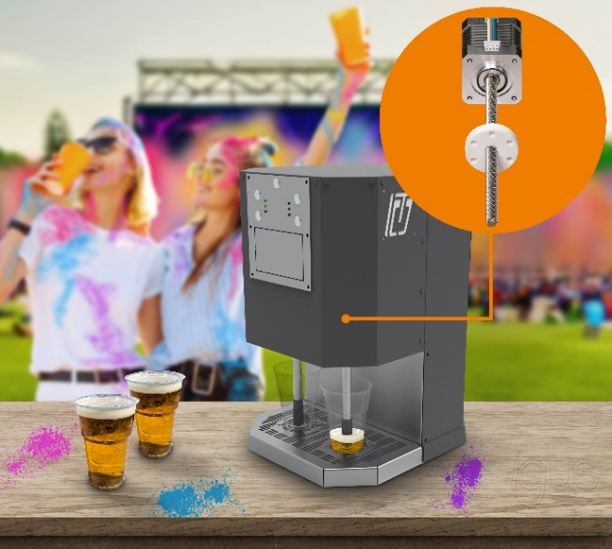
Picture PM4223-1
Hygienic, lubrication-free igus spindles allow for a refreshing and fast drink of beer. (Source: igus GmbH & One Two Beer GmbH)

PRESS CONTACT:

Alexa Heinzelmann
Head of International Marketing

igus® GmbH
Spicher Str. 1a
51147 Cologne
Tel. 0 22 03 / 96 49-7272
aheinzelmann@igus.net
www.igus.eu/press

ABOUT IGUS:

igus GmbH develops and produces motion plastics. These lubrication-free, high-performance polymers improve technology and reduce costs wherever things move. In energy supplies, highly flexible cables, plain and linear bearings as well as lead screw technology made of tribo-polymers, igus is the worldwide market leader. The family-run company based in Cologne, Germany, is represented in 31 countries and employs 4,600 people across the globe. In 2022, igus generated a turnover of €1,15 billion. Research in the industry's largest test laboratories constantly yields innovations and more security for users. 234,000 articles are available from stock and the service life can be calculated online. In recent years, the company has expanded by creating internal startups, e.g. for ball bearings, robot drives, 3D printing, the RBTX platform for Lean Robotics and intelligent "smart plastics" for Industry 4.0. Among the most important environmental investments are the "chainge" programme – recycling of used e-chains - and the participation in an enterprise that produces oil from plastic waste.

The terms "igus", “Apiro”, "chainflex", "CFRIP", "conprotect", "CTD", “drygear”, "drylin", "dry-tech", "dryspin", "easy chain", "e-chain", "e-chain systems", "e-ketten", "e-kettensysteme", "e-skin", "e-spool”, "flizz", “ibow”, “igear”, "iglidur", "igubal", “kineKIT”, "manus", "motion plastics", "pikchain", "plastics for longer life", "readychain", "readycable", “ReBeL”, "speedigus", "tribofilament“, "triflex", "robolink", “xirodur”, and "xiros" are protected by trademark laws in the Federal Republic of Germany and internationally, where applicable.

