New igus SLS material for electrostatically conductive wear-resistant parts from the 3D printer
Lubrication-free tribo-polymer iglidur I8-ESD enables the cost-effective manufacture of durable special parts with no minimum order quantity

For safe and reliable production in the electronics and semiconductor industry, components are required that have electrostatically conductive properties. This is because even a small electric shock can destroy expensive production lines. igus has now developed a new stable material for the SLS method so that users can make their wearing parts with ESD properties flexibly and cost-effectively. The lubrication-free special parts made of iglidur I8-ESD can be printed and shipped within just few days.

Wear-resistant parts in the electronics and semiconductor industry are not only required to have a long service life but must also be electrostatically conductive, because a surge of electrostatic charge that is not dissipated by an insulating material can easily destroy the product. For the fast additive manufacture of electrostatically conductive special parts, igus has now developed a new iglidur tribo-polymer. iglidur I8-ESD is the third material that igus offers for the SLS method. The advantages of this method are evident: the user has a great deal of design freedom and can make the component without any tool costs. Moreover, no plastic waste is produced as the excess powder can be used several times and printed parts can be recycled. The parts made of the new SLS powder - like all igus materials - need no additional lubrication and are very structurally stable. "With iglidur I8-ESD, we now include a tribo-polymer in our product range that has a resistance of 3x10⁷ Ω x cm. In addition, the material is inherently black. As a result, subsequent colouring is not necessary, whereby costs are lowered and the delivery time is improved", explains Tom Krause, Head of Business Unit Additive Manufacturing at igus GmbH. "The user receives a very durable component that comes with all the desirable ESD properties."

iglidur I8-ESD convinces with high wear resistance
The igus tribo-polymers undergo numerous tests in the igus 3,800 square-metre test laboratory. Here a pivoting test showed that the abrasion resistance of a sintered iglidur I8-ESD wear-resistant part is twice as great as that of a PA12 sintered component. iglidur I8-ESD was also convincing in a linear wear test. igus currently offers iglidur I8-ESD in the webshop as SLS powder for processing in the customer's own facility or for manufacture of a component in the igus 3D printing service. For the latter purpose, the user can simply send the STEP file for the part required to igus. Here, the product is printed and shipped within three days, and there is no minimum order quantity. Interested parties can now order a free sample part at igus.eu/i8-esd-sample.

PRESS CONTACT:  Oliver Cyrus  Head of PR and Advertising  Anja Görtz-Olscher  PR and Advertising  igus® GmbH  Spicher Str. 1a  51147 Cologne  Tel. 0 22 03 / 96 49-459 or -7153  Fax 0 22 03 / 96 49-631  ocyrus@igus.net  agoertz@igus.net  www.igus.eu/press | ABOUT IGUS:  igus GmbH is a global leading manufacturer of energy chain systems and polymer plain bearings. The Cologne-based family business has offices in 35 countries and employs 4,150 people around the world. In 2018, igus generated a turnover of 748 million euros from motion plastics, plastic components for moving applications. igus operates the largest test laboratories and factories in its sector to offer customers quick turnaround times on innovative products and solutions tailored to their needs.

The terms "igus", “Apiro”, "chainflex", "CFRIP", "conprotect", "CTD", "drylin", "dry-tech", "dryspin", "easy chain", "e-chain", "e-chain systems", "e-ketten", "e-kettensysteme", "e-skin", "e-spool”, "flizz", “ibow”, “igear”, "iglidur", "igubal", “kineKIT”, "manus", "motion plastics", "pikchain", "plastics for longer life", "readychain", "readycable", “ReBeL”, "speedigus", "triflex", "robolink", “xirodur”, and "xiros" are protected by trademark laws in the Federal Republic of Germany and internationally, where applicable.

Captions:

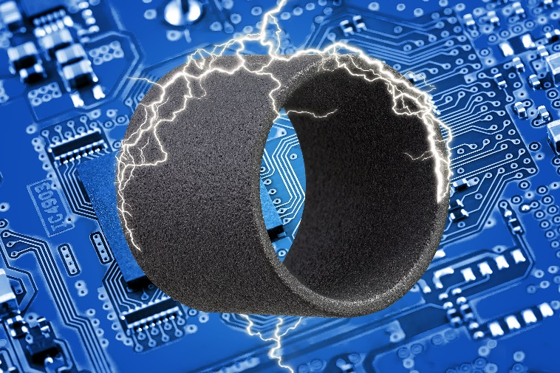
Picture PM2220-1
iglidur I8-ESD: electrostatically conductive SLS material for durable and abrasion-resistant 3D printed components in the electronics industry (Source: igus GmbH)

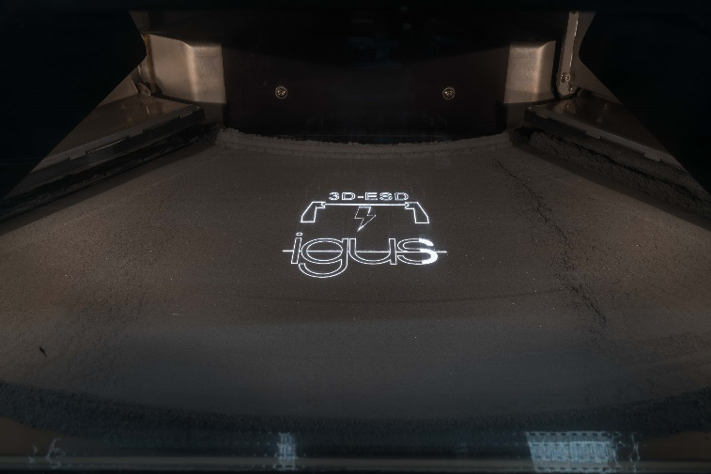
Picture PM2220-2
With the SLS method, the new black high-performance polymer can be processed in a very short time. (Source: igus GmbH)

