University meets industry: developing innovative business models for the digital future together
igus sponsors the first InnoHub Hackathon and supports students from TH Köln in developing digital service models for Industry 4.0

The digital transformation in industry requires new business models for more flexible, efficient production. Technologies such as artificial intelligence and the internet of things are creating new opportunities to address customers with smart products and services. In the spirit of open innovation, igus, the motion plastics specialist, uses ideas from young talent to develop new solutions and has now participated in the first Hackathon by Innovation Hub Bergisches RheinLand e.V. As part of the project, TH Köln students developed concepts for use-based igus smart plastics business models.

igus GmbH's smart plastics for intelligent condition monitoring and predictive maintenance for moving machine components offers users the hardware they need to enable Industry 4.0 on their systems. As industry becomes increasingly digital, new potential is also emerging for data-based smart services, such as pay-per-use models that can be tailored to the needs and requirements of customers, creating great added value. Therefore, igus is adding use-based service models to their range of smart sensors. To fully exploit the innovation potential, igus relies on support from external partners, such as the Technische Hochschule Köln and Innovation Hub Bergisches RheinLand e.V., which organised the first InnoHub Hackathon together - an event in which igus also participated.

A win-win scenario for companies and students
The InnoHub Hackathon was part of TH Köln's interdisciplinary project weeks and was held in cooperation with companies and start-ups in the area. Engineering and computer science students had the opportunity to tackle a practical challenge at a regional company. They received methodical coaching and benefited from project representatives' technical expertise. The goal was to develop solutions, ideas, concepts or prototypes for specific problems - or, as was the case with igus, new business models for smart plastics that go beyond simple sales. "We want to consciously promote young talent and encourage them to help shape the digital future of industry," says Richard Habering, Head of Business Unit smart plastics at igus. "In return, we get a fresh, out-of-the-box perspective and new ideas. It's a win-win scenario. The students gave us really helpful input for customer-oriented after-sales services." Dr. Eike Permin, Professor of Digital Production at the Faculty of Computer Science and Engineering Science at TH Köln, adds, "The students were able to gain valuable experience and demonstrate their skills during the hackathon. In addition to intensive project work, there was enough space for exchange, specialist knowledge and fun. Formats like this offer a lot of potential for the joint development of innovative solutions for the digital future."

Next-level maintenance with superwise
The students' concepts show how much potential there is in a use-based range of services. At the 2023 Hannover Messe, igus introduced a concept that combines igus product service with the latest sensor technology: superwise - igus smart service. By evaluating customer application or project data systematically and with AI support, igus can offer a whole range of advantages with superwise. The digital service encompasses three service packages - Basic, i.Sense and i.Cee - and protects users from unexpected energy chain failures. Customers can sit back and relax because igus assumes responsibility and proactively informs customers when action is needed - when an energy chain is approaching the end of its service life or an unforeseeable event endangers production, for instance. If something unforeseen should happen, smart plastics components protect the application and prevent its total failure by switching it off at lightning speed. This means that customers can focus on their core business and benefit from maximum system availability.

Caption:

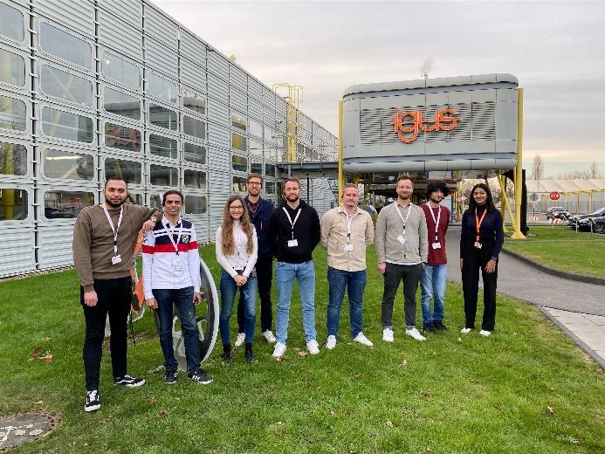
Picture PM2923-1
igus sponsors the first Innovation Hub Bergisches RheinLand e.V. Hackathon and supports students from TH Köln in developing digital service models for Industry 4.0. (Source: igus GmbH)

PRESS CONTACT:

Alexa Heinzelmann
Head of International Marketing

igus® GmbH
Spicher Str. 1a
51147 Cologne
Tel. 0 22 03 / 96 49-7272
aheinzelmann@igus.net
www.igus.eu/press

ABOUT IGUS:

igus GmbH develops and produces motion plastics. These lubrication-free, high-performance polymers improve technology and reduce costs wherever things move. In energy supplies, highly flexible cables, plain and linear bearings as well as lead screw technology made of tribo-polymers, igus is the worldwide market leader. The family-run company based in Cologne, Germany, is represented in 31 countries and employs 4,600 people across the globe. In 2022, igus generated a turnover of €1,15 billion. Research in the industry's largest test laboratories constantly yields innovations and more security for users. 234,000 articles are available from stock and the service life can be calculated online. In recent years, the company has expanded by creating internal startups, e.g. for ball bearings, robot drives, 3D printing, the RBTX platform for Lean Robotics and intelligent "smart plastics" for Industry 4.0. Among the most important environmental investments are the "chainge" programme – recycling of used e-chains - and the participation in an enterprise that produces oil from plastic waste.

The terms "igus", “Apiro”, "chainflex", "CFRIP", "conprotect", "CTD", “drygear”, "drylin", "dry-tech", "dryspin", "easy chain", "e-chain", "e-chain systems", "e-ketten", "e-kettensysteme", "e-skin", "e-spool”, "flizz", “ibow”, “igear”, "iglidur", "igubal", “kineKIT”, "manus", "motion plastics", "pikchain", "plastics for longer life", "readychain", "readycable", “ReBeL”, "speedigus", "tribofilament“, "triflex", "robolink", “xirodur”, and "xiros" are protected by trademark laws in the Federal Republic of Germany and internationally, where applicable.

