igus wins the "Going Circular" recycling competition held by the Cologne Chamber of Industry and Commerce
igus had two finalists in the competition: the "Chainge" recycling program and the igus:bike

Rescuing plastics from incineration and integrating them into a circular economy: the unique "Chainge" program for recycling technical plastics won first place for igus in the "Going Circular" competition held by the Cologne Chamber of Industry and Commerce. The igus:bike, made entirely from recycled plastic, also made it to the finals.

igus has two reasons to be happy: the Cologne-based plastics specialist has two "Going Circular" finalists. It was the third time that the Cologne Chamber of Industry and Commerce organized the competition, working with VDI Cologne, VDE Cologne, the :metabolon research and innovation centre and its patron Mona Neubaur, North Rhine-Westphalia Minister for Economics. In the final round, the "Chainge" recycling program prevailed over six competitors. "We are proud of this award. It reflects the work of a strong team and shows us once again that we are on the right track. By returning engineering plastics to an environmentally friendly circular economy, we can conserve valuable resources," says Michael Blass, CEO e-chain Systems at igus. The recycling program also won the Rhineland Business Prize in September of 2022. "It is the innovative power of entrepreneurs that finds, applies and passes on solutions. This is how global climate protection can succeed," said Sven Gebhard, Vice President of the Cologne Chamber of Industry and Commerce, during his laudatory speech. The contest, he said, is aimed at raising awareness of the circular economy mega-issue and motivating other companies to look for ways to conserve resources themselves.

Digital platform makes it even easier to recycle plastics
"What happens to our products at the end of their service life?" This question was the impetus for igus to launch the "Chainge" program in 2019. For so-called post-consumer plastics, there are often still no options for sustainable reuse, so they end up being incinerated. igus hopes to end this linear economy with "Chainge". Since the initiative began, customers have been able to send their worn-out energy chains, regardless of manufacturer, to igus and have them recycled into material for new products. One example is the igus E2.1.CG cradle-chain, the first energy chain made from recycled plastic. To accelerate the move to a circular economy, igus added the "Chainge" online platform to its range of services in October 2022. Users can transfer not only energy chains, but also other components made of other technical plastics such as PA, POM and PBT to the circular economy. The platform also offers a digital marketplace that provides access for purchasing selected recycled material. "Since the start in 2019, more and more companies have been using our recycling program," says Lena Naumann, Head of the Chainge Business Unit. "We have now rescued about 85 tons of plastic from incineration and returned it to the circular economy. We are also trying to integrate more locations and expand our recycling network. This will give us additional capacity that we can use to make an even greater contribution to the sustainable circular economy."

Caption:

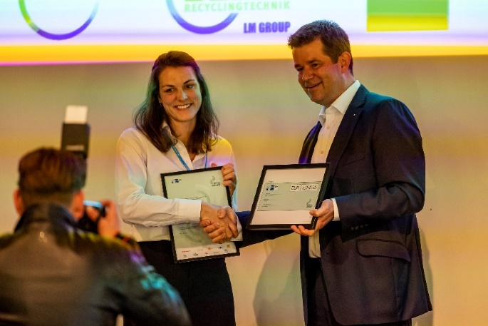
Picture PM2823-1
Reason to celebrate: the first place in the "Going Circular" competition held by the Cologne Chamber of Industry and Commerce goes to the igus "Chainge" recycling program. Lena Naumann, Head of the Chainge Business Unit, accepted the award from Sven Gebhard, the Vice President of the Cologne Chamber of Industry and Commerce. (Source: igus GmbH)

PRESS CONTACT:

Alexa Heinzelmann
Head of International Marketing

igus® GmbH
Spicher Str. 1a
51147 Cologne
Tel. 0 22 03 / 96 49-7272
aheinzelmann@igus.net
www.igus.eu/press

ABOUT IGUS:

igus GmbH develops and produces motion plastics. These lubrication-free, high-performance polymers improve technology and reduce costs wherever things move. In energy supplies, highly flexible cables, plain and linear bearings as well as lead screw technology made of tribo-polymers, igus is the worldwide market leader. The family-run company based in Cologne, Germany, is represented in 31 countries and employs 4,600 people across the globe. In 2022, igus generated a turnover of €1,15 billion. Research in the industry's largest test laboratories constantly yields innovations and more security for users. 234,000 articles are available from stock and the service life can be calculated online. In recent years, the company has expanded by creating internal startups, e.g. for ball bearings, robot drives, 3D printing, the RBTX platform for Lean Robotics and intelligent "smart plastics" for Industry 4.0. Among the most important environmental investments are the "chainge" programme – recycling of used e-chains - and the participation in an enterprise that produces oil from plastic waste.

The terms "igus", “Apiro”, "chainflex", "CFRIP", "conprotect", "CTD", “drygear”, "drylin", "dry-tech", "dryspin", "easy chain", "e-chain", "e-chain systems", "e-ketten", "e-kettensysteme", "e-skin", "e-spool”, "flizz", “ibow”, “igear”, "iglidur", "igubal", “kineKIT”, "manus", "motion plastics", "pikchain", "plastics for longer life", "readychain", "readycable", “ReBeL”, "speedigus", "tribofilament“, "triflex", "robolink", “xirodur”, and "xiros" are protected by trademark laws in the Federal Republic of Germany and internationally, where applicable.

