RBTX Online Marketplace 2.0: Low Cost Automation is now even easier
The intuitive design offers you an immediate overview of the right components and more than 100 cost-effective automation solutions

If you are looking for an individual, cost-effective automation solution, you don't have to look far thanks to the igus RBTX Online Marketplace. Instead of purchasing components from many different sources, interested parties can find low-cost robotic components from different manufacturers here - all with price and compatibility guarantees. To make selecting suitable individual parts or a finished system even easier, igus is now presenting Robotics Marketplace 2.0 with a new design and new functions.

Collecting all low-cost robotics options on one platform and making automation as easily accessible as possible is the goal of igus. The motion plastics specialist launched its RBTX.com robotics marketplace in 2019. The online platform brings users and providers of low-cost robotics together quickly and easily. That way, interested parties can find the individual components or complete solutions for their automation concepts that exactly meet their requirements and budget. "There are now 76 partners on our RBTX marketplace. RBTX is available in nine countries, and interested parties currently have 259 different products to choose from - from robots, software, control systems, and power electronics to cameras, grippers, sensors, or motors," says Alexander Mühlens, Head of Automation Technology and Robotics Business Unit at igus. All components are combined and tested in advance so that they work together perfectly. "We want to continuously add partners and products to our online marketplace so that users always have access to a wide range of up-to-date offers in this rapidly growing market segment," says Mühlens.

Reach your goal faster thanks to an improved user experience
One of the igus corporate goals is to "become the easiest company to deal with." This also applies to the usability of our online tools and platforms, such as RBTX. "We have analysed our website and obtained feedback from our customers to find out how we can further optimise the online marketplace and user experience. We hope that the new design creates even more clarity and a marketplace-like character, and allows for an even more intuitive use. That way, anyone interested can find a suitable robotics solution as quickly and easily as possible," says Mühlens. On the platform, customers can also find over 100 ready-made low-cost complete solutions and application examples with compatibility guarantee and parts list. For example, several bonding applications are available starting at €6,010. The new design allows users to filter results by application or industry, making searches even easier. There are now also other product categories, such as software. This also makes it easy to find G-code or CSV file converters and complete LabVIEW, MATLAB, and ROS node interfaces.

Get the best advice at every step of the way with RBTxpert
If you don't know exactly which automation solution is the right one or which components are required for your automation concept, you can get help from the RBTXpert. This service is now available to users at every step on the website and can be booked directly for a consultation appointment. The service is provided by experienced igus automation experts who offer advice and assistance to interested parties, helping them find the right solution for any application. It involves a free video consultation, after which interested parties receive an individual fixed-price offer. In a 400-square-metre customer testing area, the experts provide live video consulting every day and work with the customer to test the feasibility of the planned automation application. With "Test before you invest," customers can easily submit their automation tasks. The robotics specialists then test the robot installation with the customer's workpiece, free of charge, within an hour. "This service is being used more and more. In Germany, we currently have around ten tests per week. Customers then receive a handling test video with a fixed-price offer for the components they will need if they want to implement the application," says Mühlens, adding, "Since the beginning, we have supported over 1,200 projects, and we advise an average of 25 customers per week in Germany alone. We provide interested parties with ideas and apply our entire expertise so that absolutely everyone can easily find a suitable robotics solution without being slowed down by costs."

Caption:

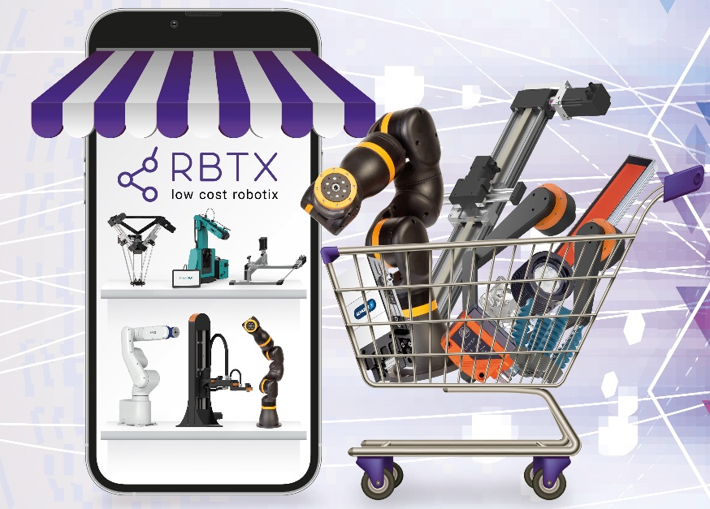
Picture PM6622-1
All low-cost robotics options in one place: on RBTX.com, it is now even easier to find ready-made robotics solutions and numerous individual components from different manufacturers. (Source: igus GmbH)

PRESS CONTACT:

Alexa Heinzelmann
Head of International Marketing

igus® GmbH
Spicher Str. 1a
51147 Cologne
Tel. 0 22 03 / 96 49-7272
aheinzelmann@igus.net
www.igus.eu/press

ABOUT IGUS:

igus GmbH develops and produces motion plastics. These lubrication-free, high-performance polymers improve technology and reduce costs wherever things move. In energy supplies, highly flexible cables, plain and linear bearings as well as lead screw technology made of tribo-polymers, igus is the worldwide market leader. The family-run company based in Cologne, Germany, is represented in 31 countries and employs 4,900 people across the globe. In 2021, igus generated a turnover of €961 million. Research in the industry's largest test laboratories constantly yields innovations and more security for users. 234,000 articles are available from stock and the service life can be calculated online. In recent years, the company has expanded by creating internal startups, e.g. for ball bearings, robot drives, 3D printing, the RBTX platform for Lean Robotics and intelligent "smart plastics" for Industry 4.0. Among the most important environmental investments are the "chainge" programme – recycling of used e-chains - and the participation in an enterprise that produces oil from plastic waste.

The terms "igus", “Apiro”, "chainflex", "CFRIP", "conprotect", "CTD", “drygear”, "drylin", "dry-tech", "dryspin", "easy chain", "e-chain", "e-chain systems", "e-ketten", "e-kettensysteme", "e-skin", "e-spool”, "flizz", “ibow”, “igear”, "iglidur", "igubal", “kineKIT”, "manus", "motion plastics", "pikchain", "plastics for longer life", "readychain", "readycable", “ReBeL”, "speedigus", "tribofilament“, "triflex", "robolink", “xirodur”, and "xiros" are protected by trademark laws in the Federal Republic of Germany and internationally, where applicable.

