igus launches first UL-listed motor cable for cable tray and e-chain
chainflex cable CF33.UL ensures safe cable guidance in energy chains and cable rack with a four-year guarantee

With the new chainflex cable CF33.UL, igus has developed the world's first motor cable for energy chains and cable trays with UL approval and a four-year functional guarantee in the energy chain. This allows the cable to be laid seamlessly from the energy chain to the cable tray without a plug connection in between. The CF33.UL also adds a shielded PVC motor cable to the chainflex range.
Cables are not exactly the most exciting products. Without a cable, however, you wouldn't be able to read this text. After all, they are essential for supplying us with electricity and data every day. A failing cable leads to considerable damage, especially in production. Cables have to withstand a wide variety of loads, such as heat, cold, high dynamics, UV radiation or even flames. Test certificates from Underwriters Laboratories (UL for short) are also required for uncomplicated export of machines and systems to the USA and Canada. igus has now developed the CF33.UL motor cable especially for cables in energy chains and cable trays. What makes them special is their UL listing ("Flexible Motor Supply Cable according to UL 2277"). Usually, UL-listed cables are only intended for fixed installation or occasional movement. UL approval for continuously moving energy chain cables has not existed up to now. "With the new motor cable, we are offering our customers a cable type that is suitable for both chains and cable trays. A plug connection is no longer necessary," explains Rainer Rössel, Vice President and Head of the chainflex Cables Business Unit at igus. Users also avoid duplicated stock of cables for the chain and fixed installation.

igus offers guarantee
"We also rely on the service life guarantee for our new motor cable. We provide our customers with tested and certified safety," so Rössel. To this end, igus puts its cables through their paces in its own 3,800-square-metre laboratory. Thanks to this series of tests and 30 years of experience in the field of moving cables, igus has recently extended the guarantee on the new motor cable to four years or ten million double strokes. igus also uses the data from the laboratory for its online tools, such as the chainflex service life calculator. Here, customers can determine the cables' durability in their applications online. That way, chainflex cables allow customers to further improve the sustainability of their applications. The reason is that a cable that is replaced too soon or breaks entails a correspondingly high CO₂ impact due to producing and transporting a substitute.

You can find more information about the CF33.UL online at:
https://www.igus.eu/info/cf33-ul

Caption:

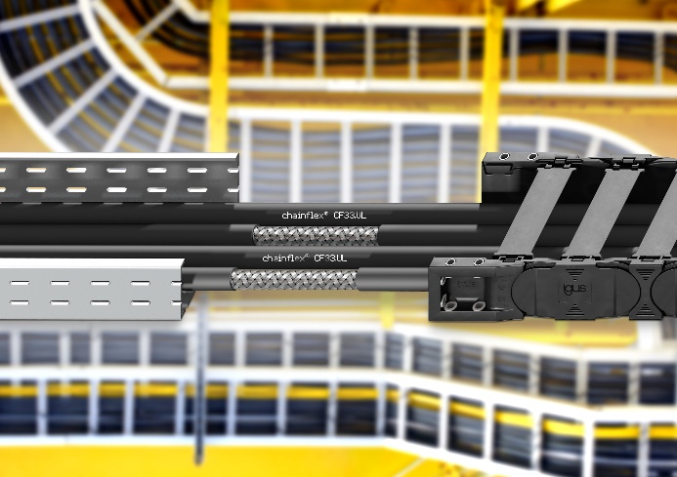
Picture PM6723-1
The chainflex cable CF33.UL is the world's first motor cable for energy chains and cable trays with UL approval and a four-year functional guarantee. (Source: igus GmbH)

PRESS CONTACT:

Alexa Heinzelmann
Head of International Marketing

igus® GmbH
Spicher Str. 1a
51147 Cologne
Tel. 0 22 03 / 96 49-7272
aheinzelmann@igus.net
www.igus.eu/press

ABOUT IGUS:

igus GmbH develops and produces motion plastics. These lubrication-free, high-performance polymers improve technology and reduce costs wherever things move. In energy supplies, highly flexible cables, plain and linear bearings as well as lead screw technology made of tribo-polymers, igus is the worldwide market leader. The family-run company based in Cologne, Germany, is represented in 31 countries and employs 4,600 people across the globe. In 2022, igus generated a turnover of €1,15 billion. Research in the industry's largest test laboratories constantly yields innovations and more security for users. 234,000 articles are available from stock and the service life can be calculated online. In recent years, the company has expanded by creating internal startups, e.g. for ball bearings, robot drives, 3D printing, the RBTX platform for Lean Robotics and intelligent "smart plastics" for Industry 4.0. Among the most important environmental investments are the "chainge" programme – recycling of used e-chains - and the participation in an enterprise that produces oil from plastic waste.

The terms "igus", “Apiro”, "chainflex", "CFRIP", "conprotect", "CTD", “drygear”, "drylin", "dry-tech", "dryspin", "easy chain", "e-chain", "e-chain systems", "e-ketten", "e-kettensysteme", "e-skin", "e-spool”, "flizz", “ibow”, “igear”, "iglidur", "igubal", “kineKIT”, "manus", "motion plastics", "pikchain", "plastics for longer life", "readychain", "readycable", “ReBeL”, "speedigus", "tribofilament“, "triflex", "robolink", “xirodur”, and "xiros" are protected by trademark laws in the Federal Republic of Germany and internationally, where applicable.

