New igus xiros ball bearing materials stand up to chemicals and temperatures of 150°C
More reliability in the chemical and semiconductor industries with the xirodur F500 cage material or zirconium oxide balls

Things are heating up, especially in battery production for the automotive industry. Machines and systems have to withstand temperatures above 100°C and aggressive chemicals. For more machine reliability and less maintenance, igus has developed the lubrication-free xiros A500 deep groove ball bearing specifically for chemical and temperature resistance. To offer customers even more solutions, igus is adding two new materials to its range of ball bearings for high-temperature use. Users now also have access to the xirodur F500 cage material and balls made of zirconium oxide.

Heat and highly aggressive chemicals in multi-shift operation: conditions in the chemical and semiconductor industries lead to frequent replacement of such machine components as ball bearings. The risk of material failure, which leads to expensive system downtimes, is always present. "Increasing customer requests for a particularly durable solution have prompted us to use new materials for our proven xiros A500 polymer ball bearing. They withstand the special requirements of the chemical industry and of semiconductor and battery production in the automotive industry, for example," says Marcus Semsroth, Head of Business Unit xiros Polymer Ball Bearings at igus. "That's why we now offer customers even more options when they are looking for the right cage or ball material for their application."

Ceramic balls - extremely robust and resistant to thermal shock
This is how the deep groove ball bearing is constructed: the inner and outer rings are made of the tried-and-tested xirodur A500 high-performance plastic. In addition to stainless-steel and glass balls, igus now offers ceramic balls made of zirconium oxide - also known as ceramic steel. The advantage is that ceramic balls are almost indestructible. They are characterised by outstanding strength, high breaking resistance and low abrasion. They also feature high thermal shock resistance.

New F500 cage material with 50% longer service life
"We have also developed a new high-temperature cage material: xirodur F500. It was based on our iglidur J3 cage material, which was developed for standard temperatures and has already proven its wear resistance," says Semsroth. The F500 cage not only allows the lubrication-free ball bearings to stand up to continuous temperatures of 150°C, but also makes them resistant to many chemicals. That is not all, however: the xiros ball bearings are put through their paces on various test rigs in the in-house igus laboratory. Tests show that the reinforced xirodur F500 cage material achieves up to 50% longer service life than comparable A500 ball bearing cages. Since xiros ball bearings are made of high-performance plastics, they are also up to 50% lighter than conventional stainless-steel ball bearings. Solid lubricants integrated into the polymers allow for hygienic, low-friction dry operation without maintenance or a single drop of lubricating oil. "The A500 ball bearing with ceramic balls or the new cage gives users an ideal bearing solution that works reliably even in aggressive and hot environments in the chemical and semiconductor industries. Users benefit from much longer maintenance cycles and greater reliability," says Semsroth.

Caption:

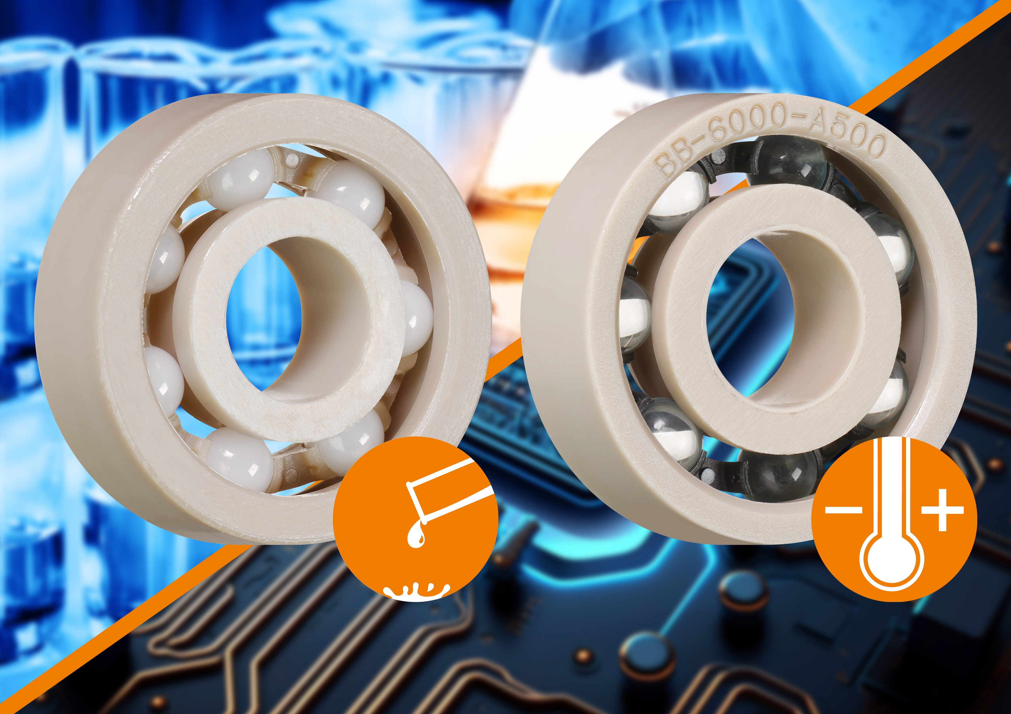
Picture PM2723-1
The new igus cage and ball materials for the high-temperature range allow for longer maintenance cycles and greater reliability in the chemical and semiconductor industries. (Source: igus GmbH)

PRESS CONTACT:

Alexa Heinzelmann
Head of International Marketing

igus® GmbH
Spicher Str. 1a
51147 Cologne
Tel. 0 22 03 / 96 49-7272
aheinzelmann@igus.net
www.igus.eu/press

ABOUT IGUS:

igus GmbH develops and produces motion plastics. These lubrication-free, high-performance polymers improve technology and reduce costs wherever things move. In energy supplies, highly flexible cables, plain and linear bearings as well as lead screw technology made of tribo-polymers, igus is the worldwide market leader. The family-run company based in Cologne, Germany, is represented in 31 countries and employs 4,600 people across the globe. In 2022, igus generated a turnover of €1,15 billion. Research in the industry's largest test laboratories constantly yields innovations and more security for users. 234,000 articles are available from stock and the service life can be calculated online. In recent years, the company has expanded by creating internal startups, e.g. for ball bearings, robot drives, 3D printing, the RBTX platform for Lean Robotics and intelligent "smart plastics" for Industry 4.0. Among the most important environmental investments are the "chainge" programme – recycling of used e-chains - and the participation in an enterprise that produces oil from plastic waste.

The terms "igus", “Apiro”, "chainflex", "CFRIP", "conprotect", "CTD", “drygear”, "drylin", "dry-tech", "dryspin", "easy chain", "e-chain", "e-chain systems", "e-ketten", "e-kettensysteme", "e-skin", "e-spool”, "flizz", “ibow”, “igear”, "iglidur", "igubal", “kineKIT”, "manus", "motion plastics", "pikchain", "plastics for longer life", "readychain", "readycable", “ReBeL”, "speedigus", "tribofilament“, "triflex", "robolink", “xirodur”, and "xiros" are protected by trademark laws in the Federal Republic of Germany and internationally, where applicable.

