reguse: igus trainees breathe new life into discarded electrical appliances
Trainees transform old computers into functional devices for private use - igus honoured as best MINT employer

A win-win situation for employees and the environment: in the company "reguse", founded by igus trainees themselves, disused electrical appliances are processed and offered to colleagues in their own webshop at a low cost for private use. The proceeds will be donated to sustainable projects. The programme is another example of how igus actively promotes young talent initiatives. For this, the motion plastics specialist has now been awarded as one of the best MINT employers.

"Reduce, reuse, recycle" - this is what the igus trainees have independently taken up with their "reguse" project. This is because the newly established trainee business unit is working on turning the electrical waste produced at igus back into functional electrical appliances for private use. The IT trainees deal with the technology, the industrial business trainees handle the legal issues and a media designer trainee takes care of marketing. Everything from laptops and PCs up to monitors is reconditioned and then offered for sale to igus employees in Cologne at a reasonable price. Alternatively, the so-called refurbished devices and all proceeds are donated to sustainable and charitable projects.

150 euros for a laptop, 50 euros for a monitor
The trainees offer the purchase via their own web shop. "In just a few weeks, we were able to generate sales of over 4,000 euros and are currently sold out", says Matthias Mollerus, Industrial Business Trainee at igus. "The response from colleagues to the project has been great." Felix Franke, Training Manager at igus, is also pleased with the new monitor: "What our trainees have come up with is a really good idea. I bought a second monitor from reguse for my wife, who is starting her own business. The used device works perfectly and is very cost-effective." But the successful start of the project is not over: the trainees are currently refurbishing more devices, because the demand as well as their motivation is high. They are considering turning the business unit into a real company to increase the learning effect even more.

Award for best employer in the MINT sector
reguse is one of many young talent projects within and outside the company that igus promotes. The best known is the young engineers support (yes). With that igus® supports pupil and student projects with free samples, sponsorships and consultations. Amongst other things, yes sponsors various Formula Student Teams in Germany and around the world with its lightweight and lubrication-free plain bearing technology. For its activities, igus was recently named one of the most attractive employers in the MINT sector by the technology magazine "Technology Review". Out of around 20,000 companies surveyed, igus is among the top 385 and ranks second in the "Chemical Products" category with 83.8 points.

Caption:

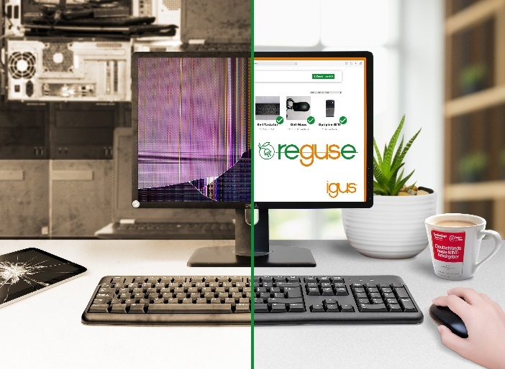
Picture PM3021-1
Discarded PCs and monitors become usable again: the trainees at igus refurbish the devices and sell them to their colleagues at a reasonable price. The income from the reguse project is donated to social and sustainable projects. (Source: igus GmbH)
PRESS CONTACT:  Oliver Cyrus  Head of PR and Advertising  Anja Görtz-Olscher  PR and Advertising  igus® GmbH  Spicher Str. 1a  51147 Cologne  Tel. 0 22 03 / 96 49-459 or -7153  Fax 0 22 03 / 96 49-631  ocyrus@igus.net  agoertz@igus.net  www.igus.eu/press | ABOUT IGUS:  igus GmbH develops and produces motion plastics. These lubrication-free, high-performance polymers improve technology and reduce costs wherever things move. In energy supplies, highly flexible cables, plain and linear bearings as well as lead screw technology made of tribo-polymers, igus is the worldwide market leader. The family-run company based in Cologne, Germany, is represented in 35 countries and employs 3,800 people across the globe. In 2019, igus generated a turnover of €764 million. Research in the industry's largest test laboratories constantly yields innovations and more security for users. 234,000 articles are available from stock and the service life can be calculated online. In recent years, the company has expanded by creating internal startups, e.g. for ball bearings, robot drives, 3D printing, the RBTX platform for Lean Robotics and intelligent "smart plastics" for Industry 4.0. Among the most important environmental investments are the "chainge" programme – recycling of used e-chains - and the participation in an enterprise that produces oil from plastic waste. (Plastic2Oil).

The terms "igus", “Apiro”, "chainflex", "CFRIP", "conprotect", "CTD", “drygear”, "drylin", "dry-tech", "dryspin", "easy chain", "e-chain", "e-chain systems", "e-ketten", "e-kettensysteme", "e-skin", "e-spool”, "flizz", “ibow”, “igear”, "iglidur", "igubal", “kineKIT”, "manus", "motion plastics", "pikchain", "plastics for longer life", "readychain", "readycable", “ReBeL”, "speedigus", "tribofilament“, "triflex", "robolink", “xirodur”, and "xiros" are protected by trademark laws in the Federal Republic of Germany and internationally, where applicable.

